|  |  |
| --- | --- |
|  | **MINISTRY OF EDUCATION AND TRAINING** |

|  |
| --- |
| **FPT UNIVERSITY** |
| Capstone Project Document |
| Building an application to manage motorbikes accessories and repair business of Thanh Huy store in Ho Chi Minh City. |

|  |  |
| --- | --- |
| **GFA23SE48** | |
| **Group Members** | Bùi Hùng Trọng Nghĩa - SE150448  Nguyễn Tấn Trung - SE151136  Nguyễn Nguyên An - SE150166  Trần Quang Trường - SE150461 |
| **Supervisor** | Nguyễn Trí Thông - ThongNT@fe.edu.vn |
| **Ext Supervisor** | N/A |
| **Capstone Project code** | FA23SE058 |

– Ho Chi Minh, November 2023 –

Contents

[Acknowledgement 5](#_Toc153058852)

[Definition and Acronyms 6](#_Toc153058853)

[I. Project Introduction 7](#_Toc153058854)

[1. Overview 7](#_Toc153058855)

[2. Product Background 7](#_Toc153058856)

[3. Existing Systems 7](#_Toc153058857)

[4. Business Opportunity 9](#_Toc153058858)

[5. Software Product Vision 9](#_Toc153058859)

[6. Project Scope & Limitations 10](#_Toc153058860)

[6.1. Major Features 10](#_Toc153058861)

[6.2 Limitations & Exclusions 11](#_Toc153058862)

[II. Project Management Plan 12](#_Toc153058863)

[1. Overview 12](#_Toc153058864)

[1.1 Scope & Estimation 12](#_Toc153058865)

[1.2 Project Objectives 13](#_Toc153058866)

[1.3 Project Risks 13](#_Toc153058867)

[2. Management Approach 15](#_Toc153058868)

[2.1 Project Process 15](#_Toc153058869)

[2.2 Quality Management 15](#_Toc153058870)

[2.3 Training Plan 16](#_Toc153058871)

[3. Project Deliverables 16](#_Toc153058872)

[4. Responsibility Assignments 17](#_Toc153058873)

[5. Project Communications 17](#_Toc153058874)

[6. Configuration Management 18](#_Toc153058875)

[6.1 Document Management 18](#_Toc153058876)

[6.2 Source Code Management 18](#_Toc153058877)

[6.3 Tools & Infrastructures 18](#_Toc153058878)

[III. Software Requirement Specification 19](#_Toc153058879)

[1. Product Overview 19](#_Toc153058880)

[2. User Requirements 19](#_Toc153058881)

[2.1 Actors 19](#_Toc153058882)

[2.2 Use Cases 20](#_Toc153058883)

[3. Functional Requirements 23](#_Toc153058884)

[3.1 System Functional Overview 23](#_Toc153058885)

[3.2 Entity Relationship Diagram 33](#_Toc153058886)

[4. Non-Functional Requirements 34](#_Toc153058887)

[4.1 External Interfaces 34](#_Toc153058888)

[4.2 Quality Attributes 34](#_Toc153058889)

[5. Requirement Appendix 36](#_Toc153058890)

[5.1 Business Rules 36](#_Toc153058891)

[5.2 Common Requirements 38](#_Toc153058892)

[5.3 Application Messages List 38](#_Toc153058893)

[IV. Software Design Description 41](#_Toc153058894)

[1. System Design 41](#_Toc153058895)

[1.1 System Architecture 41](#_Toc153058896)

[1.2 Package Diagram 41](#_Toc153058897)

[2. Database Design 42](#_Toc153058898)

[3. Detailed Design 52](#_Toc153058899)

[3.1 Authentication feature. 52](#_Toc153058900)

[3.2 Owner Manage Product 53](#_Toc153058901)

[3.3 Owner Manage Service 54](#_Toc153058902)

[3.4 Owner Manage Discount 55](#_Toc153058903)

[3.5 Manage Staff/ Teller 57](#_Toc153058904)

[3.6 Manage Order 59](#_Toc153058905)

[3.7 Manage Cart 60](#_Toc153058906)

[3.8 Manage booking 62](#_Toc153058907)

[3.9 Notification 63](#_Toc153058908)

[3.10 Ghn service 64](#_Toc153058909)

[3.11 Activity Diagram 65](#_Toc153058910)

[3.12 State Machine Diagram 68](#_Toc153058911)

[V. Software Testing Documentation 71](#_Toc153058912)

[1. Scope of Testing 71](#_Toc153058913)

[2. Test Strategy 71](#_Toc153058914)

[2.1 Testing Types 71](#_Toc153058915)

[2.2 Test Levels 71](#_Toc153058916)

[2.3 Supporting Tools 72](#_Toc153058917)

[3. Test Plan 72](#_Toc153058918)

[3.1 Human Resources 72](#_Toc153058919)

[3.2 Test Environment 72](#_Toc153058920)

[3.3 Test Milestones 73](#_Toc153058921)

[4. Test Cases 74](#_Toc153058922)

[5. Test Reports 74](#_Toc153058923)

[VI. Release Package & User Guides 76](#_Toc153058924)

[1. Deliverable Package 76](#_Toc153058925)

[2. Installation Guides 76](#_Toc153058926)

[2.1 System Requirements 76](#_Toc153058927)

[2.2 Installation Instruction 77](#_Toc153058928)

[3. User Manual 83](#_Toc153058929)

[3.1 Overview 83](#_Toc153058930)

[3.2 Application Usage 83](#_Toc153058931)

# Acknowledgement

We express our sincere gratitude to our supervisor, Teacher Nguyễn Trí Thông, for his invaluable guidance and unwavering support throughout our capstone project. He has consistently inspired and encouraged us, providing constructive feedback and useful suggestions. His generosity with time and expertise, always being available to address our questions and concerns, is truly appreciated. We are grateful for his mentorship and professionalism.

Our thanks also go to the other members of the capstone committee, Teacher NguyenTT, Teacher HoangNT, Teacher NhanDT, Teacher LamNN, and Teacher VanVTT, for their insightful comments and helpful advice. Their challenges have motivated our team to enhance the quality and clarity of our work. We value their time and effort in reviewing our project and providing constructive criticism.

Finally, we acknowledge the unwavering support of our family and friends, who have been with us throughout this journey. Their motivation has propelled our team to pursue our goals and overcome challenges. They have shared in our joys and frustrations, celebrating our achievements with us. This project is dedicated to them.

Best regards,

ARTHS Team.

# Definition and Acronyms

|  |  |
| --- | --- |
| **Acronym** | **Definition** |
| PWM | Psychology website |
| AWS | Amazon Web Services |
| BA | Business Analysis |
| BR | Business Rule |
| ERD | Entity Relationship Diagram |
| GUI | Graphical User Interface |
| PM | Project Manager |
| SDD | Software Design Description |
| SPMP | Software Project Management Plan |
| SRS | Software Requirement Specification |
| UAT | User Acceptance Test |
| UC | Use Case |
| API | Application Program Interface |

*Table 1 - Definition and Acronyms*

# I. Project Introduction

## 1. Overview

1.1 Project Information

* Project name: Building an application to manage motorbikes accessories and repair business of Thanh Huy store in Ho Chi Minh City.
* Project code: FA23SE058
* Group code: GFA23SE48
* Software type: Web, Mobile App

1.2 Project Team

|  |  |  |  |
| --- | --- | --- | --- |
| **Full Name** | **Role** | **Email** | **Mobile** |
| Nguyễn Trí Thông | Lecturer | ThongNT@fe.edu.vn | 0907973989 |
| Bùi Hùng Trọng Nghĩa | Leader | nghiabhtse150448@fpt.edu.vn | 0972707132 |
| Nguyễn Tấn Trung | Member | trungntse151136@fpt.edu.vn | 0969920894 |
| Trần Quang Trường | Member | truongtqse150461@fpt.edu.vn | 0936886831 |
| Nguyễn Nguyên An | Member | annnse150166@fpt.edu.vn | 0868558709 |

*Table 2 - Project Team*

## 2. Product Background

In today's dynamic urban landscape, motorbikes remain a primary mode of transportation for many. With their popularity comes an influx of aftermarket accessories and repair needs. The city of Ho Chi Minh witnesses a growing demand for high-quality, reliable motorbike accessory retailers and repair services. However, while several shops aim to provide these, there lacks a streamlined digital platform to manage the multifaceted operations of such businesses and to cater to the modern consumer's preference for online interactions and purchases. Recognizing this gap, the idea for the ARTHS application was conceived. Designed to serve both the Thanh Huy store and its customers, ARTHS aspires to transform the way motorbike accessory and repair businesses operate by offering an integrated management solution while enhancing the shopping and service experience for customers.

## 3. Existing Systems

**3.1. Shop2banh**

Description: Shop2banh stands as a prominent digital marketplace tailored for motorbike enthusiasts and users. Addressing the growing e-commerce needs in the motorbike sector, it offers an optimised platform for product sales. Its interface seamlessly categorises products and provides detailed information insights, ensuring that users can quickly find and select products that best suit their needs.

Link:

Web: <https://shop2banh.vn> || <https://2banh.vn>

Pros:

* Website optimised for product sales with clear categorization (e.g., new products, items on big sale).
* Provides keyword suggestions based on popular searches and user interest.
* Offers product recommendations based on items frequently bought together and related items.
* Clear indications on products about which vehicles they're compatible with.
* Maintenance orders treated as individual products, ensuring personalised follow-up with users.

Cons:

* Lacks online payment options.
* Exclusively web-based without support for mobile platforms.
* Missing user authentication feature, potentially affecting user security and personalised experiences.
* Cannot view order history and warranty information

**3.2. Yamaha Parts Catalog VNM**

**Description:** Yamaha Parts Catalog VNM, a dedicated mobile application by Yamaha Motor Vietnam, stands as a comprehensive resource for Yamaha motorcycle enthusiasts. Aimed at providing detailed insights into components, spare parts, and accessories, the application ensures that Yamaha bike owners have real-time access to the latest updates. By offering an extensive collection of information, from documents and images related to maintenance and repair to a platform for quickly searching for parts by their codes, the app enhances the overall ownership experience of a Yamaha motorcycle.

**Link:**

* Website: <https://yamaha-motor.com.vn/catalogue/>
* CHPlay: <https://ymhvn.com/app-CHPlay>
* AppleStore: <https://ymhvn.com/app-IOS>

**Pros:**

* Provides real-time monitoring capabilities for a vehicle's status, including maintenance and service schedules.
* Enables users to quickly search for motorcycle parts using individual part codes.
* Delivers comprehensive documents and visual guides for vehicle maintenance and repair.

**Cons:**

* The application's user experience could use further optimization; minor glitches have been reported.
* Price lists and ordering functionalities are restricted only to authorised Yamaha dealers.
* Lacks an integrated online payment system for users.
* Service scheduling is not supported
* Unfriendly user interface

**3.3. Nam Tien Motor**

**Description:** Nam Tien Motorcycle System prides itself on its all-inclusive stores, each featuring state-of-the-art maintenance and repair areas. Their commitment to excellence is reflected in their dedicated team of expert technicians who uphold high standards of professionalism and service. Nam Tien promises its customers a genuine product experience – every item, whether sold wholesale or retail, guarantees authenticity. Moreover, all products come with warranties and maintenance services that strictly adhere to the Factory's stipulations.

**Link:**

* Website: <https://xemaynamtien.vn/>
* Android: <https://play.google.com/store/apps/details?id=vn.namtienmotor>
* IOS: <https://apps.apple.com/vn/app/id1566977695>

**Pros:**

* Both web and mobile app platforms are available for users.
* Exclusively sells motorcycles and related parts.
* Offers a multitude of user-centric benefits, including promotions, vehicle maintenance services, motorbike rescue operations, and a loyalty point system for service payments.
* The app provides diverse payment options, including online payments, in-store payments, and Cash On Delivery.

**Cons:**

* Limited product range: only supports spare parts for Honda and Yamaha brands.
* The user interface has some errors

## 4. Business Opportunity

In the bustling cityscape of Ho Chi Minh City, motorbikes dominate the transportation scene. This ubiquity results in a consistent demand for accessories and repair services. While many businesses offer these services, there's a noticeable gap: the lack of a unified, digital platform that simplifies the process for motorbike users and streamlines business operations for store owners. Current market solutions either target specific niches or fall short in providing a holistic experience. Moreover, users often face challenges in identifying genuine parts, finding reasonable prices, and securing prompt repair services. ARTHS seizes this business opportunity by offering a comprehensive platform, allowing users to seamlessly browse, purchase, and book services. For businesses, it transforms operations, enhancing efficiency and customer relations. Aligned with the global trend towards digitization and the local need for efficient motorbike care, ARTHS stands poised to redefine the motorbike accessory and repair market in Ho Chi Minh City.

## 5. Software Product Vision

For motorcycle users in Ho Chi Minh City, ARTHS is a comprehensive digital platform that simplifies and enhances the experience of purchasing motorcycle parts and booking repair services. Through ARTHS, users, ranging from daily commuters to enthusiasts, can easily explore products, schedule appointments, and manage their transactions. Simultaneously, shop owners gain powerful tools to streamline their business operations. In the future, supported by ARTHS, the journey from product discovery to after-sales services becomes efficient, with users at the center. Unlike other market solutions, ARTHS provides a unified platform that bridges the current gap between motorcycle users and businesses, fostering trust, efficiency, and growth.

## 6. Project Scope & Limitations

### 6.1. Major Features

**6.1.1. Admin Website**

* FE-01: View list of accounts
* FE-02: Create account (Owner, Staff, Teller)
* FE-03: Lock/unlock account (Customer)

**6.1.2. Owner Website**

* FE-01: Manage staff/ teller:
  + View list of staff/ teller
  + Filter staff/ teller
* FE-02: Manage product:
  + Create product
  + View list of products
  + Filter product
  + Update product
  + Delete product
* FE-03: Manage service
  + Create service
  + View list of services
  + Filter service
  + Update service
  + Delete service
* FE-04: Mange discount
  + Create discount
  + View list of discount
  + Filter discount
  + Update discount
  + Delete discount
* FE-05: View order
* FE-06: View feedback
* FE-07: View revenue statistics

**6.1.3.** **Mobile application for Staff**

* FE-01: View repair order
* FE-02: Confirm successful repair
* FE-03: View booking order

**6.1.4.** **Teller website**

* FE-01: View list of repair services
* FE-02: View list of products
* FE-03: Manage in store order
  + Create order
  + Filter order
  + Update order
  + Cancel order
* FE-04: Manage online order
  + View order
  + Update information order (weight, length, height, width)
  + Send order to the third-party delivery service
* FE-05: Manage booking
  + View booking
  + Update booking (Date Time, status)
* FE-06: Export bill for customers
* FE-07: Update warranty information for customers.

**6.1.5.** **Mobile application for Customer**

* FE-01: Sign Up
* FE-02: Filter Product
* FE-03: View All Products
* FE-04: Add Product to Cart
* FE-05: View Cart
* FE-06: Update Cart
* FE-07: Remove Products from Cart
* FE-08: Create Order Online
* FE-09: Cancel Order Online
* FE-10: Tracking Order
* FE-11: Order Detail
* FE-12: View Order History
* FE-13: View Services
* FE-14: Feedback Products
* FE-15: Create repair booking
* FE-16: Payment

**6.1.6. Authorized user**

* FE-01: Sign In
* FE-02: Sign Out
* FE-03: View Profile Details
* FE-04: Update Profile Information
* FE-05: Change Password
* FE-06: Reset Password

### 6.2 Limitations & Exclusions

**LI-01:** ARTHS app on IOS is not available.

**LI-02:** Limited Payment Gateways: with prepayment options, ARTHS only supports VNPay.

**LI-03:** Geographic Restriction - ARTHS has been developed with the primary focus on serving customers in Ho Chi Minh City. It will not cater to requests or deliveries outside of this region.

# II. Project Management Plan

## 1. Overview

### 1.1 Scope & Estimation

|  |  |  |  |
| --- | --- | --- | --- |
| **#** | **WBS Item** | **Complexity** | **Est. Effort (man-days)** |
| **1** | **Admin Website** |  | **3** |
| 1.1 | View List of Accounts | ***Simple*** | 1 |
| 1.2 | Create Account | ***Simple*** | 1 |
| 1.3 | Lock/Unlock Account | ***Simple*** | 1 |
| **2** | **Owner Website** |  | **23** |
| 2.1 | Manage staff/ teller | ***Complex*** | 3 |
| 2.2 | Manage product | ***Complex*** | 6 |
| 2.3 | Manage service | ***Complex*** | 6 |
| 2.4 | Mange discount | ***Complex*** | 5 |
| 2.5 | View Orders | ***Simple*** | 1 |
| 2.6 | View Feedback | ***Simple*** | 1 |
| 2.7 | View Revenue Statistics | ***Simple*** | 1 |
| **3** | ***Mobile application for Staff*** |  | **4** |
| 3.1 | View repair order | ***Simple*** | 1 |
| 3.2 | Confirm successful repair | ***Medium*** | 3 |
| **4** | **Teller website** |  | **21** |
| 4.1 | View list of repair services | ***Simple*** | 1 |
| 4.2 | View list of products | ***Simple*** | 1 |
| 4.3 | Manage in store order | ***Complex*** | 6 |
| 4.4 | Manage online order | ***Complex*** | 5 |
| 4.5 | Manage booking | ***Complex*** | 5 |
| 4.6 | Export bill for customers | ***Medium*** | 3 |
| **5** | **Mobile application for Customer** |  | **29** |
| 5.1 | Sign Up | ***Medium*** | 3 |
| 5.2 | Filter Product | ***Simple*** | 1 |
| 5.3 | View All Products | ***Medium*** | 3 |
| 5.4 | Add Product to Cart | ***Simple*** | 1 |
| 5.5 | View Cart | ***Simple*** | 1 |
| 5.6 | Update Cart | ***Simple*** | 1 |
| 5.7 | Remove Products from Cart | ***Medium*** | 3 |
| 5.8 | Create Order Online | ***Simple*** | 1 |
| 5.9 | Tracking Order | ***Simple*** | 2 |
| 5.10 | Order Detail | ***Complex*** | 2 |
| 5.11 | View Order History | ***Complex*** | 3 |
| 5.12 | View Services | ***Medium*** | 2 |
| 5.13 | Feedback Products | ***Medium*** | 1 |
| 5.14 | Create repair booking | ***Simple*** | 2 |
| 5.15 | Payment | ***Complex*** | 5 |
| **6** | **Authorized user** |  | **12** |
| 6.1 | Sign In | ***Simple*** | 1 |
| 6.2 | Sign Out | ***Simple*** | 1 |
| 6.3 | View Profile Details | ***Simple*** | 1 |
| 6.4 | Update Profile Information | ***Medium*** | 2 |
| 6.5 | Change Password | ***Complex*** | 3 |
| 6.6 | Reset Password | ***Complex*** | 4 |
| ***Total Estimated Effort (man-days)*** | | | ***92*** |

Table 3- Scope & Estimation

### 1.2 Project Objectives

|  |  |  |  |  |
| --- | --- | --- | --- | --- |
| **#** | **Testing Stage** | **No. of Defects** | **% of Defect** | **Notes** |
| 1 | Reviewing | 9 | 29.03% | Focus on code quality and standards. |
| 2 | Unit Test | 6 | 19.35% | Test individual components/functions for correctness. |
| 3 | Integration Test | 4 | 12.90% | Test the interaction between integrated units. |
| 4 | System Test | 7 | 22.58% | Validate the complete system's functionality. |
| 5 | Acceptance Test | 5 | 16.14% | Ensure the application meets user/business needs. |
| **Total** | | **31** | **100%** |  |

Table 4 - Project Objectives

### 1.3 Project Risks

|  |  |  |  |  |
| --- | --- | --- | --- | --- |
| **#** | **Risk Description** | **Impact** | **Possibility** | **Response Plans** |
| 1 | Technical complexities or unforeseen technical issues. | Delays in delivery | Medium | Allocate buffer time in the project timeline. Schedule regular technical reviews. |
| 2 | Data breaches or security threats. | Damage to reputation, legal consequences | High | Implement rigorous security protocols and regular vulnerability assessments. |
| 3 | Changes in project requirements or scope. | Increased time, delays | Medium | Implement a change management protocol. Prioritize changes based on their urgency. |
| 4 | Insufficient testing leading to undetected bugs. | Reduced product quality | Medium | Allocate adequate time for thorough testing. Implement automated testing. |
| 5 | Communication gaps among team members. | Misunderstandings, delays | Low | Schedule regular team meetings. Use efficient communication tools. |
| 6 | Inaccurate estimation of time and costs. | Overrunning budget or timeline | Medium | Regularly review and adjust estimates based on actuals. Use experienced estimators. |
| 7 | Low user adoption after deployment. | ROI not met | Medium | Conduct beta testing with actual users. Gather feedback and refine the product. |
| 8 | Server downtimes or crashes. | Service disruption | Low | Opt for reliable hosting services. Implement real-time monitoring. |
| 9 | Regulatory or compliance changes. | Legal implications | Low | Stay updated with local regulations. Seek legal counsel for compliance checks. |

*Table 5 - Project Risks*

## 2. Management Approach

### 2.1 Project Process

*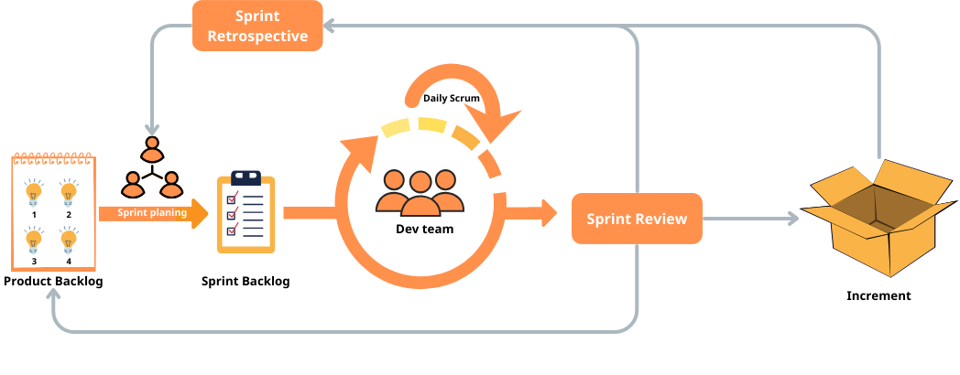*

*Figure 1 - Project Process*

This project was developed using the Scrum model, which is part of the Agile framework for project development, for the following reasons:

* The planning and documentation phases in advance allow large or changing teams to stay informed and work towards a common goal.
* The force is structured and disciplined.
* Is simple to understand, follow and organize the tasks.
* Allows for easy implementation of early specification or design changes.
* Clearly define milestones and deadlines.
* Face to face meeting, online meeting.
* Work together to define and unify solutions.

### 2.2 Quality Management

|  |  |  |  |
| --- | --- | --- | --- |
| **Approach** | **Description** | **When** | **Waiver Criteria** |
| **Defect Prevention** | Implement best practices during development to prevent defects from arising in the first place. This includes proper training, use of established coding standards, and automated tools to catch common errors. | From the start of coding phase and throughout the project lifecycle. | Mandatory |
| **Reviewing** | Conduct regular code and design reviews to ensure adherence to standards and catch potential issues early. Peer reviews can identify areas that need improvement. | After every major module or feature development. | Mandatory |
| **Unit Testing** | Test individual components or units of the software to ensure they function as intended. Automated unit tests can rapidly verify that small, isolated parts of the system work correctly. | After completing each module or functionality. | Mandatory |
| **Integration Testing** | Test the interactions between integrated units or components to ensure they work seamlessly together. This checks if data is flowing correctly between modules and if integrated parts produce the expected outcomes. | After integrating two or more units/modules. | Mandatory |
| **System Testing** | Test the entire system as a whole to ensure it meets the specified requirements. This is a high-level testing where the system's overall functionality and compatibility are checked. | After all modules are integrated and before UAT (User Acceptance Testing). | Mandatory |

*Table 6 - Quality Management*

### 2.3 Training Plan

|  |  |  |  |
| --- | --- | --- | --- |
| **Training Area** | **Participants** | **When, Duration** | **Waiver Criteria** |
| .NET | Trung, Nghĩa | 2W | Mandatory |
| Git, Github | Everyone | 2W | Mandatory |
| ReactJS, React native | An, Trường | 2W | Mandatory |
| Unit test | Nghĩa, An | 2W | Mandatory |

*Table 7 - Training Plan*

## 3. Project Deliverables

|  |  |  |  |
| --- | --- | --- | --- |
| **#** | **Deliverable** | **Due Date** | **Notes** |
| 1 | Report 1  (Project Introduction Document) | 14-9-2023 |  |
| 2 | Report 2  (Project Management Plan) | 14-9-2023 |  |
| 3 | Report 3  (Software Requirement Specification) | 16-10-2023 |  |
| 4 | Report 4  (Software Design Document) | 17-10-2023 |  |
| 5 | Report 5  (Test Documentation) | 1-11-2023 |  |
| 6 | Report 6  (Software User Guides) | 20-11-2023 |  |
| 8 | Report 7  (Final Project Report) | 20-11-2023 |  |

*Table 8 - Project Deliverables*

## 4. Responsibility Assignments

D~Do; R~Review; S~Support; I~Informed; <blank>- Omitted

|  |  |  |  |  |  |
| --- | --- | --- | --- | --- | --- |
| **Responsibility** | **Thon**  **g**  **NT** | **Nghia** | **Trung** | **Truong** | **An** |
| Project Planning & Tracking | I | D | R | R | R |
| Prepare Project Introduction Document | I | D | R | R | S |
| Prepare SRS Document | I | D | S | S | R |
| Prepare SDD Document | I | D | S | S | R |
| Prepare Software Test Document | I | D | R | S | S |
| Prepare SUG Document | I | D | S | R | R |
| Prepare Final Project Report | I | D | R | R | R |

*Table 9 - Responsibility Assignments*

## 5. Project Communications

|  |  |  |  |  |
| --- | --- | --- | --- | --- |
| **Communication Item** | **Who/ Target** | **Purpose** | **When, Frequency** | **Type, Tool, Method(s)** |
| Offline | Team member & Supervisor | Task report, Q&A | 2 days/week | FPT University Campus Ho Chi Minh |
| Offline | Team member | Discussion  Task report  Working together | 2 days/week | Outside |
| Online | Team member | Working together | 3 day/week | Google Meet |

*Table 10 - Project Communications*

## 6. Configuration Management

### 6.1 Document Management

To discuss and archive the project documents, and information, we are using Google Drive, And Trello Software

● Google Drive:  All project documents will need to upload on the general project drive, and every addition or change with version will need to be updated inside of the documents.

● Jira: used for listing out all the tickets (task, subtask) and assigning specific team members to track the work.

### 6.2 Source Code Management

● The source code local must be updated (fetch/pull) when starting to work.

● When working on new features / fixing bugs, the new changes must be in a separate branch based on the main branch.

● The separate branch needs to create a pull request and needs to be reviewed by at least one team member and pass the CI/CD process before merging into the main branch.

● Each branch and pull request must be based on the ticket code on JIRRA, and every PR must define the description: what has changed, request payload, and response.

### 6.3 Tools & Infrastructures

|  |  |
| --- | --- |
| **Category** | **Tools / Infrastructure** |
| **Technology** | HTML5, CSS, Javascript, Tailwind, ReactJS (FrontEnd), React native (Mobile App), .Net (BackEnd) |
| **Database** | MySQL Server, FireBase |
| **IDEs/Editors** | Visual Studio Code, Visual Studio |
| **Diagramming** | Draw.IO, Lucid.app |
| **Documentation** | Ms Office, Google Docs/Sheets/Slides |
| **Version Control** | GitHub (Source Codes), Google Drive (Documents) |
| **Deployment server** | Microsoft Azure |
| **Project management** | jira(task management) |

*Table 11 - Tools & Infrastructures*

# III. Software Requirement Specification

## 1. Product Overview

The ARTHS is a digital platform designed to address the growing needs of the motorbike accessory and repair market in Ho Chi Minh City. Serving as a bridge between the Thanh Huy store and its customers, ARTHS provides a streamlined approach to product management, order processing, feedback collection, and repair services. It aims to enhance the shopping experience for customers while offering a robust management solution for the store.

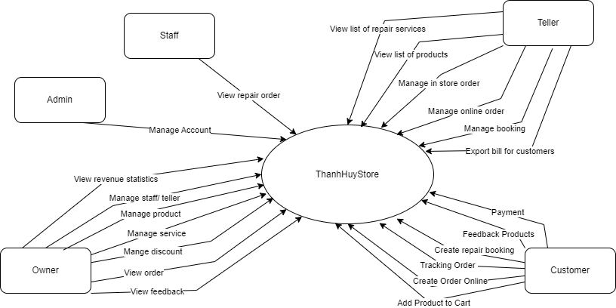

*Figure 2 - Product Overview Diagram*

## 2. User Requirements

### 2.1 Actors

|  |  |  |
| --- | --- | --- |
| **#** | **Actor** | **Description** |
| 1 | Admin | Oversees the overall system functionalities. Manages users in the system and is responsible for the account management, such as viewing the list of accounts, creating accounts, and locking/unlocking accounts. |
| 2 | Owner | Primarily manages the store operations, including product and staff management, promotions, repair services, viewing feedback, revenue statistics. Interacts with the system to optimize store operations and respond to business metrics. |
| 3 | Staff | Engages directly with customers and handles order processes, repair costs, feedback viewing, and other store tasks. They are the frontline operators interfacing the system with customer needs. The staff also has the ability to manage order statuses, track orders, and ensure services like warranties are provided to the customers. |
| 4 | Teller | Interact directly with both in-store systems and customers. Responsibilities include viewing repair lists, product lists, managing work status, viewing order history, creating and updating orders in the store, confirming orders, and issuing invoices to customers. Update order information online and send it to the shipping unit. Manage bookings and contact customers directly to update and confirm bookings. |
| 5 | Customer | End users interact with the system to explore products, order services, provide feedback, place orders and track the status of their orders, create repair bookings. They rely on ARTHS to facilitate their purchasing journey and after-sales services. |

*Table 12 - Actors*

### 2.2 Use Cases

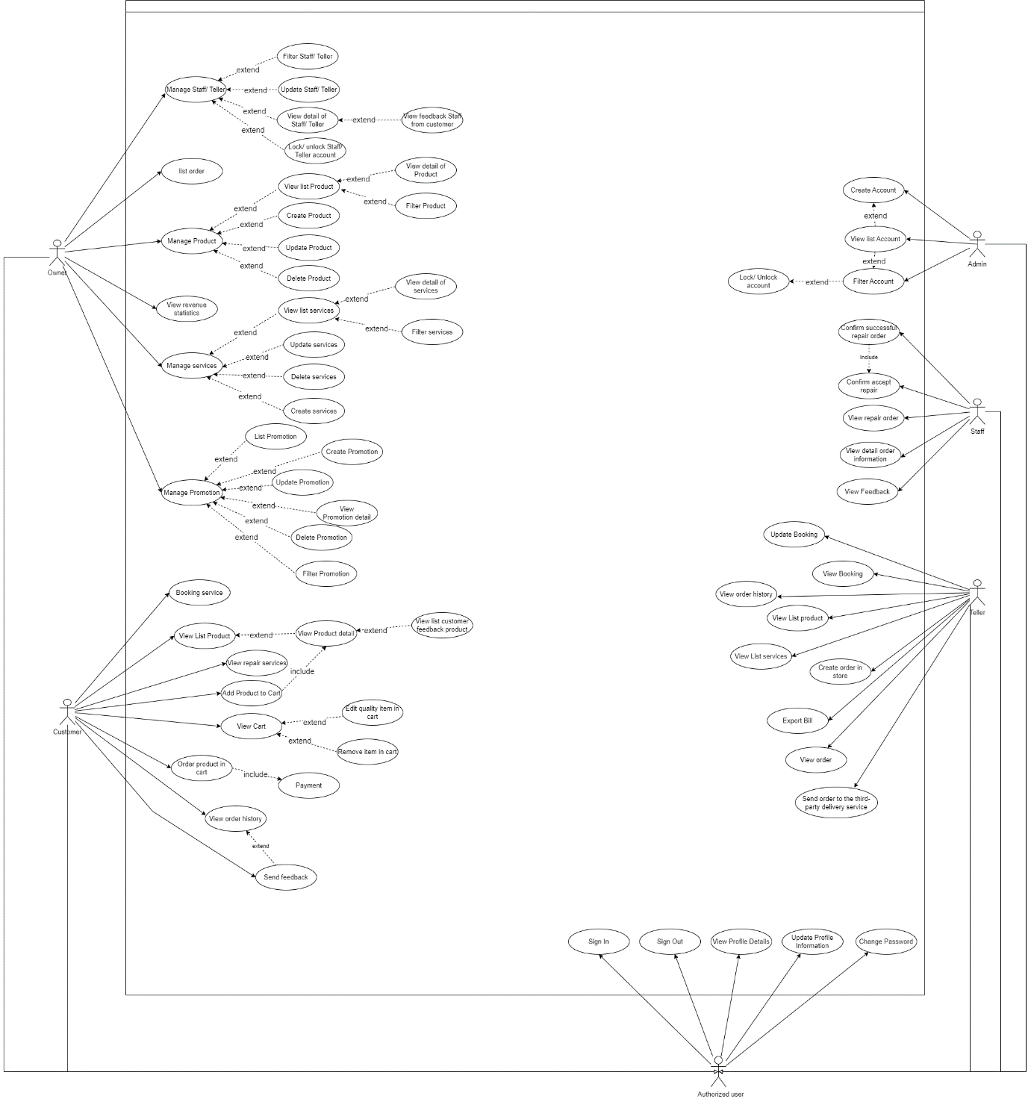 *Figure 3 - Use Cases*

|  |  |  |  |
| --- | --- | --- | --- |
| **ID** | **Use Case** | **Actor** | **Description** |
| UC-01 | Register | Customer | Customer register for account |
| UC-02 | View list Account | Admin | This feature allows admin view all accounts |
| UC-03 | Create Account | Admin | This feature allows admin create owner accounts |
| UC-04 | Fillter Account | Admin | This feature allows admin fillter by name, phone number, role account |
| UC-05 | Lock/ Unlock Account | Admin | This feature allows admin lock/ unlock account customer |
| UC-06 | Manage Staff/ Teller | Owner | This feature allows owner create, update, fillter, view detail, lock/ unlock teller |
| UC-07 | List order | Owner, Teller | This feature allows owner view list online, offline order |
| UC-08 | Manage Product | Owner | This feature allows owner create, update, fillter, view detail, delete product |
| UC-09 | Manage Service | Owner | This feature allows owner create, update, fillter, view detail, delete service |
| UC-10 | Manage discount | Owner | This feature allows owner create, update, fillter, view detail, delete discount |
| UC-11 | View revenue statistics | Owner | This feature allows owner View revenue statistics |
| UC-12 | View List products | Teller, Owner, Customer | This feature enables the Teller, Owner, Customer to view list of products for adding to the order. |
| UC-13 | View List services | Teller, Owner, Customer | This feature enables the Teller, Owner, Customer to view list of services for adding to the order. |
| UC-14 | Create an in-store order | Teller | This feature allows Teller Create an in-store order |
| UC-15 | Send the order online to the third-party delivery service | Teller | This feature enables the teller to Send the order online to the third-party delivery service. |
| UC-16 | Export Bill | Teller | This feature enables the teller Export Bill order. |
| UC-17 | View order history | Teller | This feature enables the teller View order history. |
| UC-18 | Update warranty information for customers | Teller | This feature enables the teller Update warranty information for customers. |
| UC-19 | View booking | Teller | This feature enables the teller View booking all customer. |
| UC-20 | Update booking | Teller | This feature enables employees to update the date and time, status of customer bookings. |
| UC-21 | View repair order | Staff | This feature allows employees to view list of repair orders that the teller has assigned for staff to work on. |
| UC-22 | View detail order information | Staff | This feature enables employees to view detailed information on repair orders assigned by the teller for their execution. The staff member receives the repair task, confirms its successful completion, and then sends a notification to the teller. |
| UC-23 | View booking | Staff | This feature allows staff to view the list of repair schedules that customers have assigned to staff. |
| UC-24 | View booking detail | Staff | This feature allows staff to view detailed information about customers and the content of bookings. |
| UC-25 | View booking | Customer | This feature allows Customer to view the list of repair schedules that customers have assigned to customer. |
| UC-26 | Create booking | Customer | This feature allows Customer Create booking. |
| UC-27 | View booking detail | Customer | This feature allows Customer view detailed information booking and customer can be cancel booking. |
| UC-28 | Add Product to Cart | Customer | This feature allows Customer Add Product to Cart. |
| UC-29 | View Cart | Customer | This feature allows Customers to View the list of products in the Shopping Cart and customers can update the quantity and remove products from the shopping cart. |
| UC-30 | Order product in cart | Customer | This feature allows Customers to Order product in cart and Payment. |
| UC-31 | View order history | Customer | This feature allows Customers to View order history and tracking order. |
| UC-32 | Send feedback | Customer | This feature allows Customers to Send feedback when order successful |
| UC-33 | Change Password | All | Authenticated User Change Password. |
| UC-34 | Update Profile Information | All | Authenticated User Update Profile Information |
| UC-35 | View Profile Details | All | Authenticated User View Profile Details |
| UC-36 | Sign Out | All | Authenticated User Sign Out |
| UC-37 | Login | All | Unauthenticated User login to ThanhHuyStore to verify role, and give them access to more features in the system |

*Table 13 - Use Case Description*

## 3. Functional Requirements

### 3.1 System Functional Overview

**3.1.1 Screens Flow**

1. Web admin

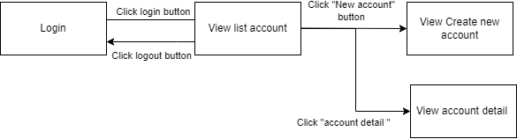

*Figure 4 - Web admin*

1. Web owner

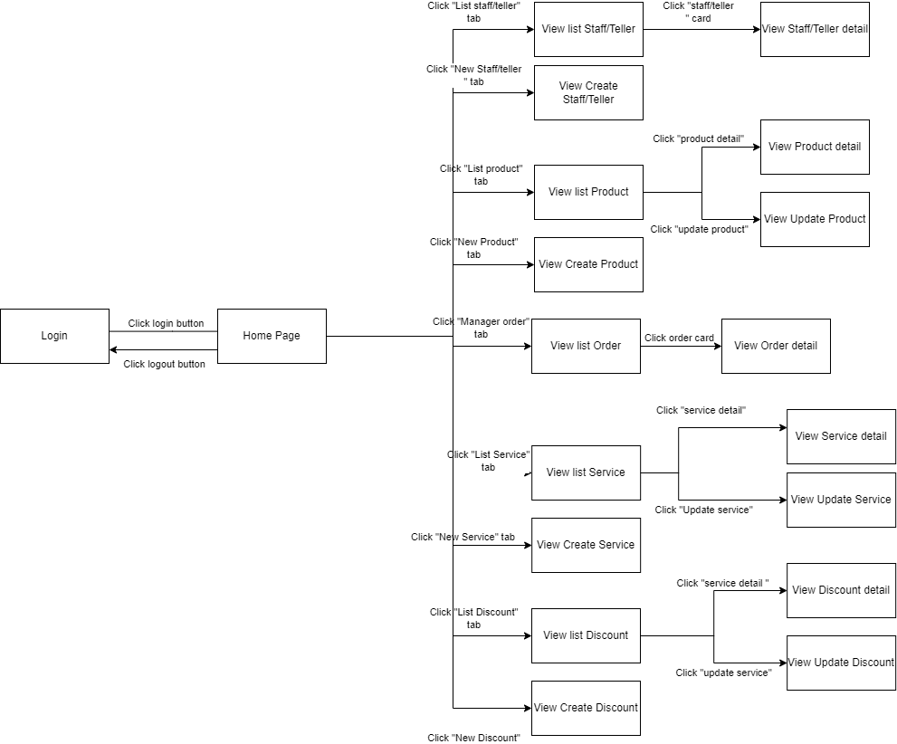

*Figure 5 - Web owner*

1. Web teller

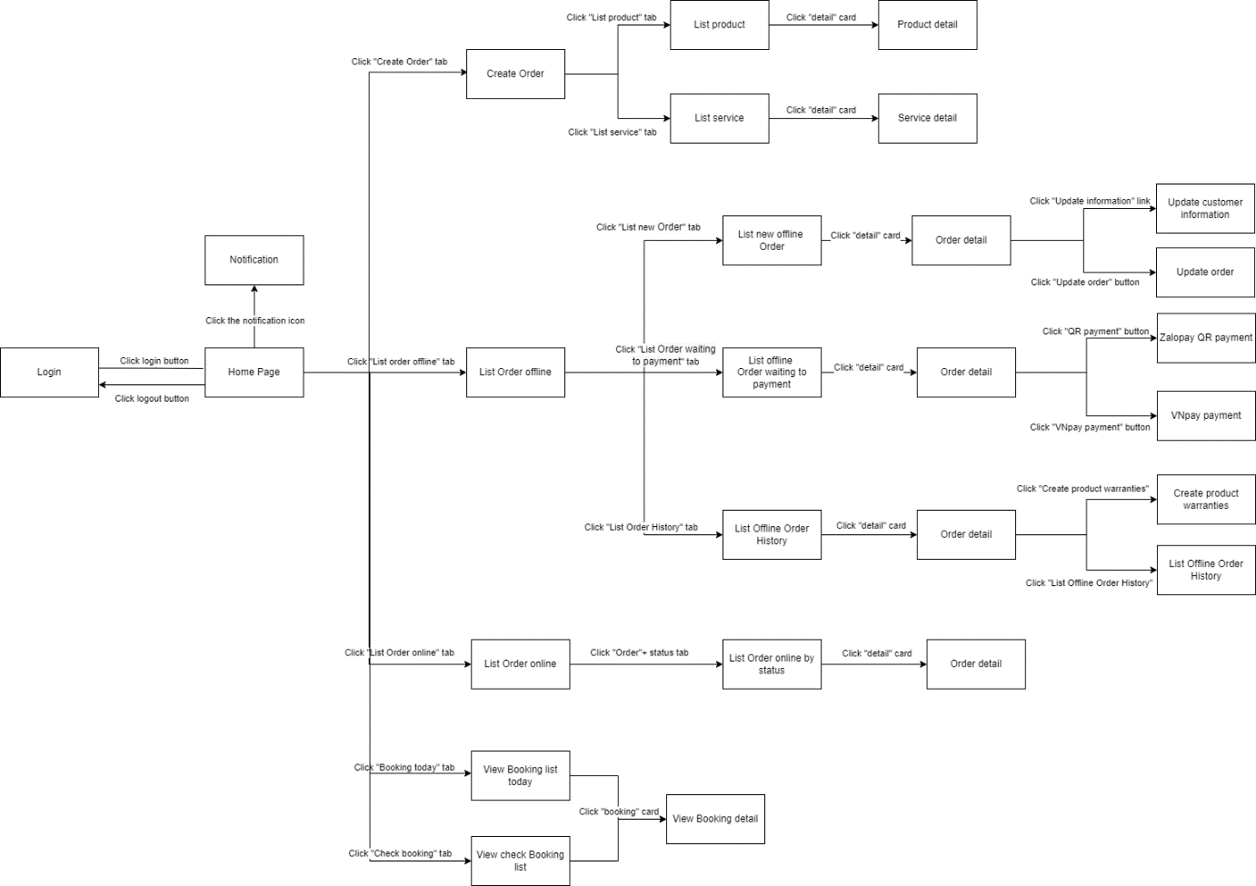

*Figure 6 - Web teller*

1. Mobile staff

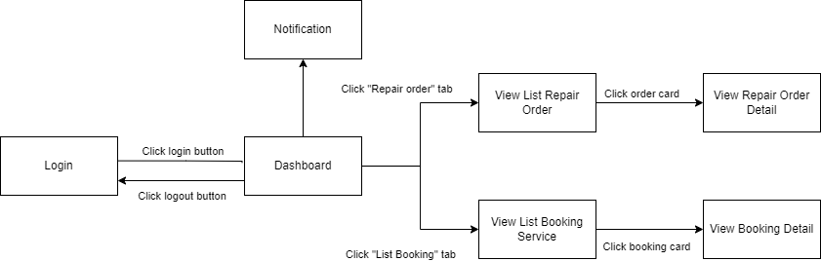

*Figure 7 – Mobile staff*

1. Mobile Customer

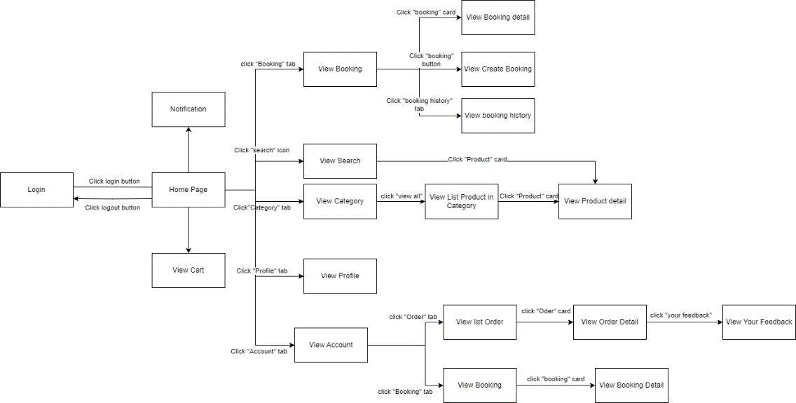

*Figure 8 – Mobile customer*

**3.1.2 Functional requirements**

**3.1.2.1 Admin functional requirements**

|  |  |  |  |  |  |
| --- | --- | --- | --- | --- | --- |
| **No** | **Actor** | **Function Name** | **Data requirements** | **Data validation** | **Business Rules** |
| 1 | Admin | View list account | fullName, gender, avatar, phoneNumber, address, role, status, createAt | fullName: Text Field (string), gender: Text Field (string), avatar: Text Field (string), phoneNumber: Text Field (string), address: Text Field (string), role : Text Field (string), status : Text Field (string), createAt: DateTime | BR-06, BR-07, BR-08, BR-77 |
| 2 | Admin | Create New Account | fullName, gender, phoneNumber, avatar | fullName: Text Field (string), gender: Text Field (string), phoneNumber: Text Field (string), avatar: Text Field (string), | BR-06, BR-07, BR-08, BR-09, BR-10, BR-11, BR-13, BR-19, BR-20, BR-75, BR-76, BR-78 |
| 3 | Admin | View Account detail | fullName, gender,  phoneNumber, avatar | fullName: Text Field (string), gender: Text Field (string), phoneNumber: Text Field (string), avatar: Text Field (string), | BR-02, BR-03, BR-05, BR-17, BR-18 |
| 4 | Admin | Lock/ unlock Account | id, status | id: Guid, status: Text Field (string) | BR-04, BR-06, BR-77, BR-78 |

*Table 14 - Admin functional requirements*

**3.1.2.2 Owner functional requirements**

|  |  |  |  |  |  |
| --- | --- | --- | --- | --- | --- |
| **No** | **Actor** | **Function Name** | **Data requirements** | **Data validation** | **Business Rules** |
| 1 | Owner | View list staff/ teller | fullName, gender, avatar, phoneNumber, address, role, status | fullName: Text Field (string),  gender: Text Field (string),  avatar: Text Field (url),  phoneNumber: Text Field (number),  address: Text Field (string),  role: Text Field (string),  status: Text Field (string) | BR-01, BR-06, BR-07 |
| 2 | Owner | staff/ teller detail | fullName, gender, avatar, phoneNumber, address, role, status, feedback | fullName: Text Field (string),  gender: Text Field (string),  avatar: Text Field (url),  phoneNumber: Text Field (number),  address: Text Field (string),  role: Text Field (string),  status: Text Field (string) feedback: array | BR-02, BR-03, BR-05, BR-06, BR-07, BR-17, BR-18 |
| 3 | Owner | Create staff/ telller account | fullName, gender, avatar, phoneNumber, | fullName: Text Field (string),  gender: Text Field (string),  avatar: Text Field (url),  phoneNumber: Text Field (number), | BR-07, BR-09, BR-10, BR-11, BR-13, BR-19, BR-20, BR-74, BR-75, BR-76 |
| 4 | Owner | View list Product | Name, Create at, type, price, status | Name: Text Field (string) ,  Create at: Date,  type: Text Field (string),  price: Number(int),  status: Text Field (string) | BR-22, BR-23, BR-25, BR-26, BR-27, BR-28 |
| 5 | Owner | Create Product | name, priceCurrent, quantity, description, installationFee, discountId, warrantyId, categoryId, vehiclesId, images. | name: Text Field (string) , priceCurrent: Number(int), quantity: Number(int), description: Text Field (string) , installationFee: Number(int), discountId: Text Field (Guid) , warrantyId: Text Field (Guid) , categoryId: Text Field (Guid) , vehiclesId: array(Guid), images: array(url) | BR-22, BR-23, BR-24, BR-25, BR-26, BR-27 |
| 6 | Owner | Product detail | name, installationFee, quantity, warrantyDuration, description, status, category, discount, feedbackProducts, images, vehicles | name: Text Field (string), price: Number(int), installationFee: Number(int), quantity: Number(int), warrantyDuration: Number(int), description: Text Field (string) , status: Text Field (string) , category: Text Field (string), discount: Number(int) feedbackProducts: array images: array, vehicles: array | BR-22, BR-23, BR-24, BR-25, BR-26, BR-27, BR-28, BR-71 |
| 7 | Owner | Update Product | name, priceCurrent, quantity, description, installationFee, discountId, warrantyId, categoryId, vehiclesId, images. | name: Text Field (string) , priceCurrent: Number(int), quantity: Number(int), description: Text Field (string) , installationFee: Number(int), discountId: Text Field (Guid) , warrantyId: Text Field (Guid) , categoryId: Text Field (Guid) , vehiclesId: array(Guid), images: array(url) | BR-22, BR-23, BR-24, BR-25, BR-26, BR-20 |
| 8 | Owner | Delete Product | Id ,name. | id: Text Field (guid), name: Text Field (string) | BR-20 |
| 9 | Owner | View list Service | Name, Create at, price, status | Name: Text Field (string) ,  Create at: Date,  price: Number(int),  status: Text Field (string) | BR-29, BR-30, BR-31, BR-32, BR-33 |
| 10 | Owner | Create Service | name, price, duration, reminderInterval, description, warrantyDuration, discountId, images | name: Text Field (string),  price: Number(int), duration: Number(int), reminderInterval: Number(int), description: Text Field (string),  warrantyDuration: Number(int), discountId: Text Field (guid),  images: array | BR-29, BR-30, BR-25 |
| 11 | Owner | Service detail | name, price, duration, reminderInterval, description, warrantyDuration, discountId, images | name: Text Field (string),  price: Number(int), duration: Number(int), reminderInterval: Number(int), description: Text Field (string),  warrantyDuration: Number(int), discountId: Text Field (guid),  images: array | BR-29, BR-30, BR-31, BR-33 |
| 12 | Owner | Update Service | name, price, duration, reminderInterval, description, warrantyDuration, discountId, images | name: Text Field (string),  price: Number(int), duration: Number(int), reminderInterval: Number(int), description: Text Field (string),  warrantyDuration: Number(int), discountId: Text Field (guid),  images: array | BR-29, BR-30, BR-31, BR-33, BR-20 |
| 13 | Owner | Delete Service | Id ,name. | id: Text Field (guid), name: Text Field (string) | BR-20 |
| 14 | Owner | View list discount | image Name, DiscountNumber, startDate, endDate, status | Image: text field(url)  Name: Text Field (guid),  DiscountNumber: Number(int),  startDate: DateTime,   endDate: DateTime,   status: Text Field (guid), | BR-34, BR-35, BR-36, BR-37, BR-38 |
| 15 | Owner | Create discount | Image, Name, DiscountNumber, startDate, endDate, Product, Service | Image: text field(url)  Name: Text Field (guid),  DiscountNumber: Number(int),  startDate: DateTime,   endDate: DateTime,   Product: array Service: array | BR-34, BR-35, BR-36, BR-37, BR-38 |
| 16 | Owner | Discount detail | Image, Name, DiscountNumber, startDate, endDate, Product, Service | Image: text field(url)  Name: Text Field (guid),  DiscountNumber: Number(int),  startDate: DateTime,   endDate: DateTime,   Product: array Service: array | BR-34, BR-35, BR-36, BR-37, BR-38 |
| 17 | Owner | Update discount | Image, Name, DiscountNumber, startDate, endDate, Product, Service | Image: text field(url)  Name: Text Field (string),  DiscountNumber: Number(int),  startDate: DateTime,   endDate: DateTime,   Product: array Service: array | BR-34, BR-35, BR-36, BR-37, BR-38, BR-20 |
| 18 | Owner | Delete discount | id | Id: Guid | BR-20 |
| 19 | Owner | View list Order | orderid, customerName, createAt, phoneNumber, typeOrder, totalPrice, status | orderid: Text Field (string),  customerName: Text Field (string),  createAt: Date,  phoneNumber: Text Field (number),  typeOrder: Text Field (string),  totalPrice: Number(int),  status: Text Field (string) | BR-40, BR-41, BR-42, BR-43, BR-44, BR-56, BR-59, BR-60, BR-61 |
| 20 | Owner | View Order detail | createAt, typePayment, typeOrder, customerName, phoneNumber, address MotobikeProduct | createAt: Date,  typePayment: Text Field (string),  typeOrder: Text Field (string),  customerName: Text Field (string),  phoneNumber: Text Field (number),  address: Text Field (string), MotobikeProduct: array | BR-40, BR-41, BR-42, BR-43, BR-44, BR-46, BR-47, BR-48 |
| 21 | Owner | View revenue statistics | id, orderId, totalAmount, type, paymentMethod, status, transactionDate, orderType | id: Guid,  orderId,: Guid  totalAmount: int,  type: Text Field (string),,  paymentMethod: Text Field (string),, status: Text Field (string),,  transactionDate: Date,  orderType: Text Field (string), | BR-43, BR-44, BR-49, BR-53, BR-54, BR-61 |

*Table 15 - Owner functional requirements*

**3.1.2.3 Teller functional requirements**

|  |  |  |  |  |  |
| --- | --- | --- | --- | --- | --- |
| **No** | **Actor** | **Function Name** | **Data requirements** | **Data validation** | **Business Rules** |
| 1 | Teller | View list product | Name, image, price, discount | Name: Text Field (string),  image: Text Field (url),  price: Number(int),  discount: Number(int) | BR-22, BR-23, BR-24, BR-25, BR-26, BR-27, BR-28 |
| 2 | Teller | View list service | Name, image, price, discount | Name: Text Field (string),  image: Text Field (url),  price: Number(int),  discount: Number(int) | BR-29, BR-30, BR-31, BR-32, BR-33 |
| 3 | Teller | Product detail | name, installationFee, warrantyDuration, description, category, discount, images, vehicles | name: Text Field (string), price: Number(int), installationFee: Number(int), warrantyDuration: Number(int), description: Text Field (string) , category: Text Field (string), discount: Number(int) images: array, vehicles: array | BR-22, BR-23, BR-24, BR-25, BR-26, BR-27, BR-28, BR-71 |
| 4 | Teller | Service detail | name, price, duration, reminderInterval, description, warrantyDuration, discountId, images | name: Text Field (string),  price: Number(int), duration: Number(int), description: Text Field (string),  warrantyDuration: Number(int), discountId: Text Field (guid),  images: array | BR-29, BR-30, BR-31, BR-32, BR-33 |
| 5 | Teller | Service detail | name, price, duration, reminderInterval, description, warrantyDuration, discountId, images | name: Text Field (string),  price: Number(int), duration: Number(int), description: Text Field (string),  warrantyDuration: Number(int), discountId: Text Field (guid),  images: array | BR-29, BR-30, BR-31, BR-32, BR-33 |
| 6 | Teller | Create order | staffId, customerName, customerPhone, licensePlate, motobikeProductId, productQuantity, instUsed, serviceId | staffId: Text Field (guid), customerName: Text Field (string), customerPhone: Text Field (number), licensePlate: Text Field (string), motobikeProductId: Text Field (guid), productQuantity: Text Field (int), instUsed: boolean serviceId: Text Field (guid) | BR-39, BR-40, BR-41, BR-42, BR-49, BR-50 |
| 7 | Teller | List order offline | orderid, customerName, createAt, phoneNumber, typeOrder, totalPrice, status | orderid: Text Field (string),  customerName: Text Field (string),  createAt: Date,  phoneNumber: Text Field (number),  typeOrder: Text Field (string),  totalPrice: Number(int),  status: Text Field (string) | BR-43, BR-44, BR-45, BR-46, BR-47, BR-61 |
| 8 | Teller | order offline detail | createAt, staffName, typeOrder, customerName, phoneNumber, licensePlate, MotobikeProduct Service | createAt: Date,  staffName: Text Field (string),  typeOrder: Text Field (string),  customerName: Text Field (string),  phoneNumber: Text Field (number),  licensePlate: Text Field (string), MotobikeProduct: array Service: array | BR-43, BR-44, BR-45, BR-46, BR-47 |
| 9 | Teller | List order online | orderid, customerName, phoneNumber, typePayment, status | orderid: Text Field (string),  customerName: Text Field (string),  phoneNumber: Text Field (number),  typePayment: Text Field (string),  status: Text Field (string) | BR-51, BR-52, BR-53, BR-54, BR-56, BR-59, BR-61 |
| 10 | Teller | order online detail | createAt, typePayment, typeOrder, customerName, phoneNumber, address MotobikeProduct | createAt: Date,  typePayment: Text Field (string),  typeOrder: Text Field (string),  customerName: Text Field (string),  phoneNumber: Text Field (number),  address: Text Field (string), MotobikeProduct: array | BR-51, BR-52, BR-53, BR-54, BR-55 |
| 11 | Teller | List booking | customerName, phoneNumber, dateArria, status, reasonCancel | customerName: Text Field (string),  phoneNumber: Text Field (number),  dateArria: date,  status: Text Field (string),  reasonCancel: Text Field (string) | BR-62, BR-63, BR-64, BR-65, BR-66 |
| 12 | Teller | booking detai | customerName, phoneNumber, address, description, dateArria, status, | customerName: Text Field (string),  phoneNumber: Text Field (number),  address: Text Field (number), dateArria: date,  status: Text Field (string), | BR-62, BR-63, BR-64, BR-65, BR-66 |

*Table 16 - Teller functional requireme*

**3.1.2.3 Staff functional requirements**

|  |  |  |  |  |  |
| --- | --- | --- | --- | --- | --- |
| **No** | **Actor** | **Function Name** | **Data requirements** | **Data validation** | **Business Rules** |
| 1 | Staff | View list booking | customerName, phoneNumber, dateArria, status, reasonCancel staffid | customerName: Text Field (string),  phoneNumber: Text Field (number),  dateArria: date,  status: Text Field (string),  reasonCancel: Text Field (string) staffid: Guid | BR-62, BR-63, BR-65 |
| 2 | Staff | View booking detail | customerName, phoneNumber, address, description, dateArria, status, | customerName: Text Field (string),  phoneNumber: Text Field (number), description: Text Field (number), dateArria: date,  status: Text Field (string), | BR-62, BR-63, BR-65 |
| 3 | Staff | View repair order | createAt, staffName, typeOrder, customerName, phoneNumber, licensePlate, MotobikeProduct Service | createAt: Date,  staffName: Text Field (string),  typeOrder: Text Field (string),  customerName: Text Field (string),  phoneNumber: Text Field (number),  licensePlate: Text Field (string), MotobikeProduct: array Service: array | BR-40, BR-41, BR-42, BR-45, BR-46, BR-47, BR-48 |
| 4 | Staff | View order detail | createAt, staffName, typeOrder, customerName, phoneNumber, licensePlate, MotobikeProduct Service | createAt: Date,  staffName: Text Field (string),  typeOrder: Text Field (string),  customerName: Text Field (string),  phoneNumber: Text Field (number),  licensePlate: Text Field (string), MotobikeProduct: array Service: array | BR-40, BR-41, BR-42, BR-45, BR-46, BR-47, BR-48 |

*Table 17 - Staff functional requirements*

**3.1.2.3 Customer functional requirements**

|  |  |  |  |  |  |
| --- | --- | --- | --- | --- | --- |
| **No** | **Actor** | **Function Name** | **Data requirements** | **Data validation** | **Business Rules** |
| 1 | Customer | View list Product | id, name, priceCurrent, discount, feedbackProducts, images | id: Guid name:Text Field (number) priceCurrent: int discount: Guid feedbackProducts: array images: Guid | BR-22, BR-23, BR-24, BR-26, BR-27, BR-28 |
| 2 | Customer | View detail Product | id, name, priceCurrent, discount, feedbackProducts, images, description, vehicles | id: Guid name:Text Field (string) priceCurrent: int discount: Guid feedbackProducts: array images: Guid description: Text Field (string) vehicles: array | BR-22, BR-23, BR-24, BR-26, BR-27, BR-28, BR-71 |
| 3 | Customer | View feedback | id, customerName, rate, content, | id: Guid,  customerName: Text Field (string),  rate: int,  content: Text Field (string), | BR-71 |
| 4 | Customer | Create order | motobikeProductId, productQuantity, CustomerId, totalAmount | motobikeProductId: Guid,  productQuantity: int,  CustomerId: Guid,  totalAmount: int | BR-40, BR-41, BR-42, BR-51, BR-52, BR-53, BR-54, BR-55 |
| 5 | Customer | Add product to cart | productId, quantity, | productId: Guid ,  quantity: int, | BR-67, BR-68, BR-69, BR-70 |
| 6 | Customer | View cart | productId, quantity, | productId: Guid ,  quantity: int, | BR-67, BR-68, BR-69, BR-70 |
| 7 | Customer | Create booking | dateBook, description, staffId | productId: Guid ,  quantity: int, | BR-62, BR-63, BR-64, BR-65, BR-66 |
| 8 | Customer | View booking | id, orderId, dateBook, description, cancellationReason, cancellationDate, status, staffId | id: Guid ,  orderId: Guid ,  dateBook: date,  description: Text Field (string),  cancellationReason: Text Field (string),  cancellationDate: date,  status: Text Field (string),  staffId: Guid | BR-62, BR-63, BR-64, BR-65, BR-66 |
| 9 | Customer | Create Feedback product | motobikeProductId, rate, content | motobikeProductId: Guid,  rate: int,  content: Text Field (string) | BR-71 |
| 10 | Customer | Create Feedback staff | customerId, staffId, content | customerId: Guid,  staffId: Guid,  content: Text Field (string) | BR-72 |

*Table 18 - Customer functional requirements*

**3.1.3 Screen Authorization**

**3.1.3.1 Web Application Screen Authorization**

**3.1.3.2 Mobile Application Screen Authorization**

**3.1.4 Non-Screen Functions**

|  |  |  |
| --- | --- | --- |
| # | System function | Description |
| 1 | Push notification | System push notification to Customers, Teller and Staff |
| 2 | Check discount | System check end date Discount and delete discount from product and service when discount expires |

*Table 19 - Non-Screen Functions*

### 3.2 Entity Relationship Diagram

Conceptual ERD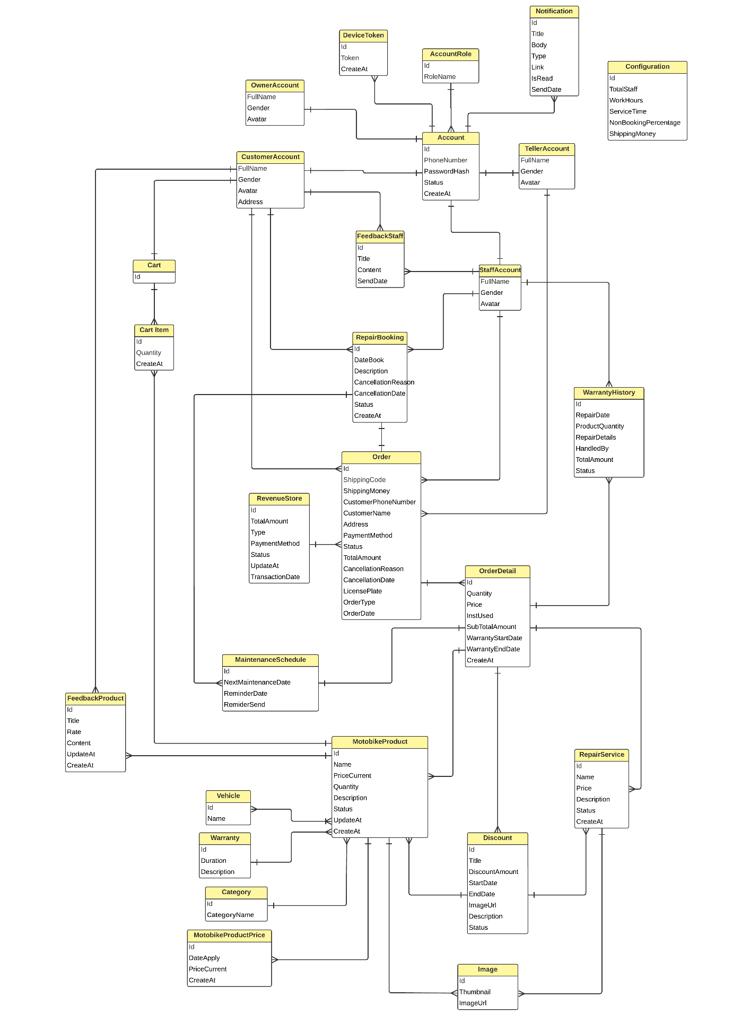

## 4. Non-Functional Requirements

### 4.1 External Interfaces

* **a. User Interfaces**
* UI-1: Language used in the application is Vietnamese.
* UI-2: GUI must be simple, friendly.
* UI-3: Icons used must be easy to recognize.
* **b. Software Interfaces**
* SI-1: Web application: Google Chrome browser and Firefox browser.
* SI-2: Mobile application: Android version 8.0 or higher.
* **c. Hardware Interfaces**
* HI-1: Mobile is use should support full-time internet connectivity
* **d. Communications Interfaces**
* CI-1: Mobile sends requests to the server through the HTTPs protocol.
* CI-2: Web application sends request to server through HTTPs protocol.

### 4.2 Quality Attributes

#### 4.2.1 Usability

* **Interface Intuitiveness:** The ARTHS system interface should be self-explanatory, allowing users to understand and navigate through primary functionalities without assistance.
* **Task Efficiency:** Users should be able to perform standard operations, such as querying a database or generating a report, within 5 minutes or less.
* **Consistency:** The interface should maintain consistency in its design, ensuring elements like buttons, icons, and menus are consistently placed and have uniform design patterns across all screens.
* **Usability Standards:** The system shall adhere to modern usability standards, aligning with guidelines like Microsoft's GUI standards, to guarantee a familiar and user-friendly environment.

#### 4.2.2 Reliability

* **Availability:** The ARTHS system must be available 99.95% of the time, allowing for brief periods of scheduled maintenance.
* **Mean Time Between Failures (MTBF):** The system should achieve an MTBF of at least 5000 hours.
* **Mean Time To Repair (MTTR):** If a failure occurs, the MTTR should not exceed 4 hours.
* **Accuracy:** All outputs from the system, particularly financial transactions, should be accurate with a precision of at least 99.9%.
* **Maximum Bugs or Defect Rate:** The system should have a defect rate of less than 0.1 bugs/KLOC.
* **Bugs Categorization:**
  + Minor: Cosmetic issues that do not impact system functionality.
  + Significant: Issues that may hinder some functionalities but do not stop the overall operations.
  + Critical: Issues that can cause data loss or make major functionalities unusable. There should be zero critical bugs post-launch.

#### 4.2.3 Performance

* **Response Time:** The average response time for a transaction should not exceed 2 seconds, with a maximum allowed response time of 5 seconds for peak loads.
* **Throughput:** The system should handle up to 100 transactions per second during peak business hours.
* **Capacity:** ARTHS should be capable of accommodating up to 10,000 simultaneous users.
* **Resource Utilization:**
  + Memory: Optimized to ensure the system runs smoothly on devices with standard RAM capacities.
  + Disk: Efficient disk space utilization, with transactions and data changes consuming minimal storage.
  + Communications: Minimal bandwidth consumption ensuring quick data transfers and updates.

#### 4.2.4 Dependability

* **Data Backup:** The system should have a dependable backup mechanism, ensuring data backups are taken daily and stored in a secure, geographically separate location.
* **Fail-Safe Mechanisms:** In the event of unexpected issues, the system should gracefully degrade its operations, ensuring data integrity and notifying the admin of the occurred fault.

***4.2.5 Support Document***

* **Documentation Clarity:** All provided documents should be written in clear, concise language, free from jargon unless terms are defined. Diagrams, flowcharts, and other visual aids should be incorporated where appropriate to further illustrate complex concepts.
* **User Manual:** The ARTHS system shall come with a comprehensive user manual detailing the system's functionality, setup, and common troubleshooting steps. This manual should be available both in print and digital formats, with a search function in the digital version.
* **Technical Documentation:** This will provide a deep dive into the system's architecture, database schemas, and codebase, meant for IT professionals and system administrators. It should include detailed information on system requirements, installation processes, and API references.
* **Training Materials:** Training guides or tutorials should be available to aid new users in understanding the system's primary functions. This may include step-by-step tutorials, video guides, and interactive sessions.
* **FAQs and Troubleshooting Guide:** A frequently asked questions (FAQ) section should be developed based on feedback and common challenges encountered during system testing. A troubleshooting guide, providing solutions to known issues, should accompany this.

Updates and Patch Notes: Whenever the system undergoes updates or patches, corresponding notes should be released to detail the changes, improvements, or fixes made. This ensures users are kept informed about the system's evolution and can adjust to any significant alterations.

## 5. Requirement Appendix

### 5.1 Business Rules

|  |  |
| --- | --- |
| **ID** | **Rule Definition** |
| BR-01 | If the account is correct, system redirect users to corresponding home page: - User logs in as role “admin”, the system will display admin Dashboard page - User logs in as role “Owner”, the system will display Owner dashboard page - User logs in as role “Teller”, the system will display Teller dashboard page - User logs in as role “Staff”, the system will display Staff dashboard page - User logs in as role “Customer”, the system will display HomePage screen |
| BR-02 | User can update their profile |
| BR-03 | User can change their password |
| BR-04 | Banned account cannot interact with the system until it is unbanned |
| BR-05 | Account profile can be updated by only it's owner |
| BR-06 | Only the admin role manages Customer accounts |
| BR-07 | admin and owner role manages staff and teller accounts |
| BR-08 | Only the admin role manages Owner account |
| BR-09 | PhoneNumber must be unique |
| BR-10 | The phone number must be a Vietnamese number |
| BR-11 | Password must be more than 6 characters |
| BR-12 | The address must be within the territory of HoChiMinh. |
| BR-13 | Gender: Only Male and Female are available options. |
| BR-14 | There is one admin account in system. |
| BR-15 | There is one owner account in system. |
| BR-16 | When logged out successfully, the system will redirect to the login page. |
| BR-17 | User can view profile after login to system |
| BR-18 | User can update profile after login to system |
| BR-19 | Id will be generated by the system |
| BR-20 | Id cannot change when updated |
| BR-21 | A login session with the web application lasts until the browser is closed and the users log out of the system |
| BR-22 | Do not leave it blank: Name Product, Quality, Price, Warranty, installation fee, category, vehicle, image, Description |
| BR-23 | The category can only be selected from the available data. |
| BR-24 | The discount can only be selected from the available data. |
| BR-25 | Warranty is valid from 1 to 12 months. |
| BR-26 | Currency denominations in Vietnamese dong |
| BR-27 | Images can be added from 1 to 4 |
| BR-28 | Status Product: "Đang hoạt động", "Không hoạt động", "Hết Hàng". |
| BR-29 | Do not leave it blank: Name Service, Price, image, Duration (minute), Description |
| BR-30 | Reminder time is valid from 1 to 12 months. |
| BR-31 | Reminder time is valid from 1 to 12 months. |
| BR-32 | Filter by name, status |
| BR-33 | Status Service: "Đang hoạt động", "Ngừng hoạt động". |
| BR-34 | Do not leave it blank: Name, discount amount (%), EndDate,Description |
| BR-35 | The start date is always set to the current date. |
| BR-36 | The end date cannot be set to a past date. |
| BR-37 | discount amount is valid from 1 to 100%. |
| BR-38 | Status discount: "Đang áp dụng", "Ngừng áp dụng". |
| BR-39 | fill information phoneNumber, customer Name, licensePlate |
| BR-40 | At least 1 product must be included in the order |
| BR-41 | If chose "chọn sửa chữa" add repair fees to the total price. |
| BR-42 | If in the offline order there is a repair service or "chọn sửa chữa" product to must add repair staff |
| BR-43 | Type order: "offline order" and "online order" |
| BR-44 | Status offline order: "Chờ xử lý", "Đang sửa chữa", "Chờ thanh toán", "Hoàn thành", "Đã thanh toán" |
| BR-45 | Only Teller Create Offline Order |
| BR-46 | Only Teller Update Offline Order |
| BR-47 | Teller update status order |
| BR-48 | Staff update status order |
| BR-49 | Offline Order payment by: Vnpay, Zalopay, Cash |
| BR-50 | 1 Offline order just add 1 staff |
| BR-51 | Only Customer Create Online order |
| BR-52 | Status Online order: "Chờ xử lý", "Đã xác nhận", "Đang giao", "Đã hủy", "Đã thanh toán", |
| BR-53 | do not cancel online order when order status is "Đang giao" |
| BR-54 | Online Order payment by: Vnpay, Cash |
| BR-55 | Enter the length, width, height, and weight information of the order before handing it over to the shipping carrier. |
| BR-56 | Fillter by name |
| BR-57 | Fillter by category |
| BR-58 | Fillter by Status |
| BR-59 | Fillter by Customer name |
| BR-60 | Fillter by Phone number |
| BR-61 | Fillter by date |
| BR-62 | cannot book a date in the past |
| BR-63 | Status Booking: "Chờ xác nhận", "Đã xác nhận", "Đã đến", "Đã hủy". |
| BR-64 | Only Teller udpate booking status. |
| BR-65 | Staff can view reservations if the customer adds that employee to the booking. |
| BR-66 | Only Teller udpate booking date. |
| BR-67 | Only customer add product to cart |
| BR-68 | Each product can only be added to the cart with a maximum quantity of 10 |
| BR-69 | Update to add a maximum quantity of 10 in the shopping cart |
| BR-70 | Customer can select products to put in the shopping cart for ordering. |
| BR-71 | Customers can submit feedback for a product only once, and the product must have been successfully ordered by the customer. |
| BR-72 | Customers can provide feedback for staff only when the repair order has been successfully paid |
| BR-73 | Rate from 1 to 5 stars |
| BR-74 | Type of date/datetime must be valid with format : dd/mm/yyyy |
| BR-75 | CreateAt date/datetime will be generated by the system |
| BR-76 | updateAt date/datetime will be generated by the system |
| BR-77 | User can’t login with account is banned |
| BR-78 | Admin create account for owner |
| BR-79 | Owner create account for Teller, Staff |

*Table 20 - Business Rules*

### 5.2 Common Requirements

**CR-1** Login: User can log in to the system

**CR-2** Logout: User can sign out of system

**CR-3** View profile: User can view information of profile

**CR-4** Update profile: User can update the information of profile

### 5.3 Application Messages List

|  |  |  |  |  |
| --- | --- | --- | --- | --- |
| **#** | **Message code** | **Message Type** | **Context** | **Content** |
| 1 | MSG01 | BadRequestException | A reason must be provided when canceling an appointment. | "Cần phải cung cấp lý do khi hủy lịch đặt." |
| 2 | MSG02 | BadRequestException | A maximum of 10 products is allowed in the cart. | Một sản phẩm chỉ được tối đa 10 trong giỏ hàng |
| 3 | MSG03 | BadRequestException | Please enter non-zero values for total staff, service time, workHours. | Vui lòng nhập các giá trị total staff, service time, workHours khác 0 |
| 4 | MSG04 | BadRequestException | Promotion time must be greater than the current time. | thời gian khuyến mãi phải lớn hơn hiện tại |
| 5 | MSG05 | BadRequestException | Incorrect promotion time. | thời gian khuyến mãi sai |
| 6 | MSG06 | BadRequestException | Please recheck the information. Currently, this order cannot be handed over or has already been handed over. | Vui lòng kiểm tra lại thông tin. Hiện tại chưa thể bàn giao đơn hàng này hoặc đơn hàng này đã được bàn giao rồi |
| 7 | MSG07 | BadRequestException | Error when updating order status. | Lỗi khi update trạng thái đơn |
| 8 | MSG08 | BadRequestException | Please recheck information such as phone number, address. | Vui lòng kiểm tra lại các thông tin như SĐT, địa chỉ |
| 9 | MSG09 | BadRequestException | At least one image is required to create, and no more than 4 images. | Phải có ít nhất một hình để tạo và không được quá 4 hình. |
| 10 | MSG10 | BadRequestException | File is not an image. | File không phải là hình ảnh |
| 11 | MSG11 | BadRequestException | Please re-enter vehicle id. | Vui lòng nhập lại vehicle id |
| 12 | MSG12 | BadRequestException | A reason must be provided when canceling an order. | Cần phải cung cấp lý do khi hủy đơn hàng. |
| 13 | MSG13 | BadRequestException | Please select a staff member. | Vui lòng chọn nhân viên |
| 14 | MSG14 | BadRequestException | Completed orders cannot be edited. | Đơn đã hoàn thành không thể chỉnh sữa |
| 15 | MSG15 | BadRequestException | There must be at least one product or service to order. | Phải có ý nhất một sản phẩm hoặc dịch vụ để order |
| 16 | MSG16 | BadRequestException | Each detail can only contain a product or repair service. | Mỗi detail chỉ chứa product hoặc repair service |
| 17 | MSG17 | BadRequestException | This order has already been successfully paid. | Đơn hàng này đã thanh toán thành công rồi |
| 18 | MSG18 | BadRequestException | The customer already has a reservation for that day. | Bạn đã có lịch hẹn cho ngày {dateBook.ToString("dd-MM-yyyy")} |
| 19 | MSG19 | ConflictException | Phone number has already been used. | Số điện thoại đã được sử dụng |
| 20 | MSG20 | ConflictException | Please enter the correct date format (yyyy-MM-dd). | Vui lòng nhập đúng định dạng ngày (yyyy-MM-dd). |
| 21 | MSG21 | ConflictException | This staff member already has 5 bookings for {dateBook:dd-MM-yyyy}. Please choose another date or another staff. | Nhân viên này đã đủ 5 đơn đặt hàng cho ngày {dateBook:dd-MM-yyyy}. Vui lòng chọn ngày khác hoặc nhân viên khá |
| 22 | MSG22 | ConflictException | The store has enough orders for the date you selected. Please choose another date. | Cửa hàng đã đủ đơn cho ngày bạn chọn. Vui lòng chọn ngày khác. |
| 23 | MSG23 | ConflictException | This category already exists! | Danh mục này đã tồn tại! |
| 24 | MSG24 | ConflictException | Each customer is only allowed to create one feedback. | Mỗi customer chỉ được tạo một feedback |
| 25 | MSG25 | ConflictException | You do not have permission to edit this feedback. | Bạn không có quyền chỉnh sửa feedback này |
| 26 | MSG26 | ConflictException | This order cannot be canceled. | Không thể hủy đơn hàng này |
| 27 | MSG27 | ConflictException | The staff member is busy, please choose another one. | Nhân viên đang bận vui lòng chọn nhân viên khác |
| 28 | MSG28 | ConflictException | This order cannot be canceled. | Không thể hủy đơn hàng này |
| 29 | MSG29 | ConflictException | This vehicle brand already exists! | Hãng xe đã tồn tại! |
| 30 | MSG30 | ConflictException | Vehicle name already exists | Tên phương tiện đã tồn tại |
| 31 | MSG31 | ConflictException | You did not use our installation service for this order. | Đơn hàng này bạn không dùng dịch vụ lắp đặt bên chúng tôi. |
| 32 | MSG32 | ConflictException | The number of warrantied products cannot exceed the number purchased. | Số lượng sản phẩm bảo hành không được lớn hơn số sản phẩm đã mua. |
| 33 | MSG33 | ConflictException | The booking did not select a specific staff member, and the store is fully booked on that day. | Cửa hàng đã đủ đơn cho ngày bạn chọn. Vui lòng chọn ngày khác. |
| 34 | MSG34 | ConflictException | When placing an order for a specific product in the store, it turns out that the store does not have a sufficient quantity available. | Sản phẩm {product.Name} hiện tại chỉ còn {product.Quantity} sản phẩm, vui lòng điều chỉnh lại số lượng. Cửa hàng xin lỗi về sự bất tiện này. |
| 35 | MSG35 | ConflictException | The product is no longer in stock or has been discontinued. | Sản phẩm {product.Name} hiện tại đã ngừng kinh doanh. Cửa hàng xin lỗi về sự bất tiện này. |
| 36 | MSG36 | ConflictException | The booking has selected a staff member, but that staff member has reached the maximum number of appointments for the day. | Nhân viên này đã đủ 5 đơn đặt hàng cho ngày {dateBook:dd-MM-yyyy}. Vui lòng chọn ngày khác hoặc nhân viên khác. |
| 37 | MSG37 | InvalidOldPasswordException | Old password is incorrect | Mật khẩu cũ không chính xác |
| 38 | MSG38 | NotFoundException | Role not found | Không tìm thấy role |
| 39 | MSG39 | NotFoundException | Incorrect account or password | Sai tài khoản hoặc mật khẩu |
| 40 | MSG40 | NotFoundException | Account not found. | Không tìm thấy account. |
| 41 | MSG41 | NotFoundException | Booking not found | Không tìm thấy booking |
| 42 | MSG42 | NotFoundException | Booking information not found | Không tìm thấy thông tin booking |
| 43 | MSG43 | NotFoundException | Cart information not found | Không tìm thấy thông tin của cart |
| 44 | MSG44 | NotFoundException | Product not found | Không tìm thấy product |
| 45 | MSG45 | NotFoundException | Cart not found | Không tìm thấy cart |
| 46 | MSG46 | NotFoundException | Customer not found | Không tìm thấy customer |
| 47 | MSG47 | NotFoundException | Promotion not found | Không tìm thấy khuyến mãi |
| 48 | MSG48 | NotFoundException | This product not found: | Không tìm thấy product này: |
| 49 | MSG49 | NotFoundException | This service not found: | Không tìm thấy dịch vụ này: |
| 50 | MSG50 | NotFoundException | Products and services with discount codes: | Các sản phẩm và dịch vụ đã có mã giảm giá: |
| 51 | MSG51 | NotFoundException | Feedback not found | Không tìm thấy feedback |
| 52 | MSG52 | NotFoundException | Staff not found | Không tìm thấy staff |
| 53 | MSG53 | NotFoundException | Order not found | Không tìm thấy order |
| 54 | MSG54 | NotFoundException | Image not found | Không tìm thấy image |
| 55 | MSG55 | NotFoundException | Notification not found. | Không tìm thấy thông báo. |
| 56 | MSG56 | NotFoundException | Employee not found | Không tìm thấy nhân viên |
| 57 | MSG57 | NotFoundException | Owner not found | Không tìm thấy owner |
| 58 | MSG58 | NotFoundException | Revenue information not found | Không tìm thấy thông tin của revenue |
| 59 | MSG59 | NotFoundException | Staff not found | Không tìm thấy staff |
| 60 | MSG60 | NotFoundException | Teller not found | Không tìm thấy teller |
| 61 | MSG61 | NotFoundException | Warranty History information not found | Không tìm thấy thông tin WarrantyHistory |

*Table 21 - Application Messages List*

# IV. Software Design Description

## 1. System Design

### 1.1 System Architecture

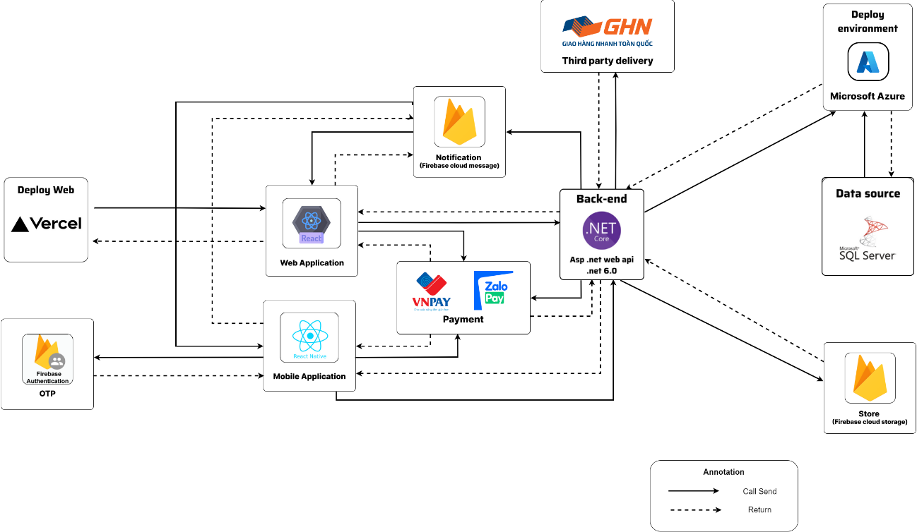

### 1.2 Package Diagram

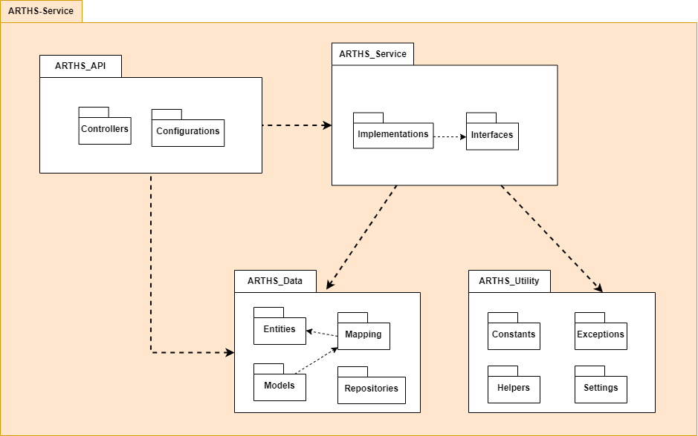

## 2. Database Design

***Table Descriptions:***

|  |  |  |
| --- | --- | --- |
| No | Table | Description |
| 1 | Account | Stores user account information including unique identifier, role, phone number for login, password hash for security, account status, and account creation date. |
| 2 | AccountRole | Defines the different roles that an account can have, such as Admin, Owner, Staff, Teller, and Customer, with a unique identifier and role name. |
| 3 | Cart | Holds the shopping cart details for each customer, including a unique identifier for the cart and a link to the customer's account. |
| 4 | CartItem | Contains items within a customer's shopping cart, with references to the cart and motorbike products, as well as the quantity of each item and the date the item was added. |
| 5 | Category | Categorizes motorbike products into different segments with a unique identifier and a name for each category. |
| 6 | Configuration | Configures system-wide settings such as total staff, work hours, service time allocation, non-booking percentages for walk-ins, and fixed shipping money charge. |
| 7 | CustomerAccount | Extends the Account table with customer-specific information such as full name, gender, avatar image, and address. |
| 8 | DeviceToken | Stores device tokens for push notifications, linked to user accounts, with each token having a unique identifier and creation date. |
| 9 | Discount | Details the discounts available for products or services, with information like title, discount amount, start and end dates, image URL, description, and status. |
| 10 | FeedbackProduct | Collects customer feedback on products with details like rating, content, and timestamps for creation and updates. |
| 11 | FeedbackStaff | Gathers customer feedback on staff performance, containing titles, content, and the date the feedback was sent. |
| 12 | Image | Maintains images for products or services, indicating if an image is a thumbnail and storing the image URL. |
| 13 | MaintenanceSchedule | Manages the scheduling of maintenance services for products, with dates for the next maintenance and reminders. |
| 14 | MotobikeProduct | Lists the products available for motorbikes, including details such as name, current price, installation fee, quantity available, description, status, and timestamps. |
| 15 | MotobikeProductPrice | Tracks the price history of motorbike products with dates when new prices are applied. |
| 16 | Notification | Sends notifications to user accounts, including title, body, type, link, read status, and date sent. |
| 17 | Order | Records details of customer orders, including unique identifiers, linked customer, staff, shipping details, payment method, status, total amount, and timestamps. |
| 18 | OrderDetail | Specifies the items or services within each order, including quantities, prices, installation usage, subtotal amounts, warranty dates, and the date of creation. |
| 19 | OwnerAccount | Stores account information specific to store owners, including full name, gender, and avatar image. |
| 20 | ProductVehicleType | Associates motorbike products with specific vehicle types, ensuring compatibility. |
| 21 | RepairBooking | Handles bookings for repair services, with details such as customer and staff IDs, order linkage, booking date, description, cancellation reasons, status, and creation date. |
| 22 | RepairService | Defines the repair services offered, including name, warranty duration, potential discounts, service duration, reminder intervals, price, description, status, and creation date. |
| 23 | RevenueStore | Monitors revenue generation, detailing order linkage, total amount, type of revenue, payment method, status, transaction date, and updates. |
| 24 | StaffAccount | Holds information specific to staff accounts, including full name, gender, and avatar image. |
| 25 | TellerAccount | Contains teller-specific account details such as full name, gender, and avatar image. |
| 26 | Vehicle | Defines different types of vehicles with unique identifiers and names. |
| 27 | Warranty | Specifies warranty terms for products or services, with a duration and description. |
| 28 | WarrantyHistory | Logs the warranty service history, including repair details, the staff who handled the service, total amount, and status. |

*Table 22 - Table Descriptions*

***Attribute Data Dictionary:***

|  |  |  |  |  |
| --- | --- | --- | --- | --- |
| Entity Name | Attributes | Description | Domain | Null |
| Account | Id | Unique identifier of the account | uniqueidentifier | No |
| RoleId | Foreign key, role identifier | uniqueidentifier | No |
| PhoneNumber | Phone number associated with the account | varchar(30) | No |
| PasswordHash | Hashed password for account security | varchar(255) | No |
| Status | Current status of the account | nvarchar(100) | No |
| CreateAt | Timestamp of account creation | datetime | No |
| AccountRole | Id | Unique identifier of the account role | uniqueidentifier | No |
| RoleName | Name of the role | nvarchar(50) | No |
| Cart | Id | Unique identifier of the cart | uniqueidentifier | No |
| CustomerId | Foreign key, customer account identifier | uniqueidentifier | No |
| CartItem | CartId | Foreign key, identifier of the cart | uniqueidentifier | No |
| MotobikeProductId | Foreign key, identifier of the motorbike product | uniqueidentifier | No |
| Quantity | Number of items of the product | int | No |
| CreateAt | Date and time the item was added to the cart | datetime | No |
| Category | Id | Unique identifier of a category | uniqueidentifier | No |
| CategoryName | Name of the category | nvarchar(100) | No |
| Configuration | TotalStaff | Total number of staff | int | No |
| WorkHours | Number of work hours | int | No |
| ServiceTime | Time allocated for a service | int | No |
| NonBookingPercentage | Percentage of non-booked services | int | No |
| ShippingMoney | Shipping charges | int | No |
| CustomerAccount | AccountId | Unique identifier of the customer account | uniqueidentifier | No |
| FullName | Full name of the customer | nvarchar(255) | No |
| Gender | Gender of the customer | nvarchar(10) | No |
| Avatar | URL link to the customer's avatar image | varchar(max) | Yes |
| Address | Physical address of the customer | nvarchar(255) | No |
| DeviceToken | Id | Unique identifier of the device token record | uniqueidentifier | No |
| AccountId | Identifier of the account associated with the device token | uniqueidentifier | No |
| Token | Token string for the device | varchar(max) | Yes |
| CreateAt | The date and time the device token was created | datetime | No |
| Discount | Id | Unique identifier for each discount | uniqueidentifier | No |
| Title | Title or name of the discount | nvarchar(255) | No |
| DiscountAmount | Monetary amount of the discount | int | No |
| StartDate | Starting date when the discount becomes valid | datetime | No |
| EndDate | Ending date when the discount expires | datetime | No |
| ImageUrl | URL of the image representing the discount | varchar(max) | No |
| Description | Detailed description of the discount | nvarchar(max) | No |
| FeedbackProduct | Id | Unique identifier for each piece of feedback | uniqueidentifier | No |
| CustomerId | Reference to the customer who provided the feedback | uniqueidentifier | Yes |
| MotobikeProductId | Reference to the motorbike product the feedback is for | uniqueidentifier | No |
| Title | Title or subject of the feedback | nvarchar(255) | Yes |
| Rate | Rating given to the product | int | No |
| Content | Full text content of the feedback | nvarchar(max) | No |
| UpdateAt | Date when the feedback was last updated | datetime | Yes |
| CreateAt | Date when the feedback was initially created | datetime | No |
| FeedbackStaff | Id | Unique identifier of the feedback record | uniqueidentifier | No |
| CustomerId | Foreign key identifier for the customer | uniqueidentifier | Yes |
| StaffId | Foreign key identifier for the staff member | uniqueidentifier | No |
| Title | Title of the feedback provided by the customer | nvarchar(255) | Yes |
| Content | Content of the feedback | nvarchar(max) | No |
| SendDate | Date and time when the feedback was sent | datetime | No |
| Image | Id | Unique identifier of the image record | uniqueidentifier | No |
| MotobikeProductId | Foreign key identifier for the motobike product | uniqueidentifier | Yes |
| RepairServiceId | Foreign key identifier for the repair service | uniqueidentifier | Yes |
| MaintenanceSchedule | Id | Unique identifier of the maintenance schedule | uniqueidentifier | No |
| OrderDetailId | Foreign key reference to the OrderDetail | uniqueidentifier | No |
| CustomerId | Foreign key reference to the CustomerAccount | uniqueidentifier | No |
| NextMaintenanceDate | Scheduled date for the next maintenance | datetime | No |
| ReminderDate | Date on which reminder for maintenance is sent | datetime | No |
| ReminderSend | Flag to determine if reminder was sent | bit | No |
| MotobikeProduct | Id | Unique identifier of the motorbike product | uniqueidentifier | No |
| DiscountId | Foreign key reference to the Discount | uniqueidentifier | Yes |
| WarrantyId | Foreign key reference to the Warranty | uniqueidentifier | Yes |
| CategoryId | Foreign key reference to the Category | uniqueidentifier | Yes |
| Name | Name of the motorbike product | nvarchar(255) | No |
| MotobikeProductPrice | Id | Unique identifier of the motorbike product price | uniqueidentifier | No |
| MotobikeProductId | Foreign key, identifier of the motorbike product | uniqueidentifier | No |
| DateApply | The date when the product price is applied | datetime | No |
| PriceCurrent | The current price of the motorbike product | int | No |
| CreateAt | The creation date of the product price record | datetime | No |
| Notification | Id | Unique identifier of the notification | uniqueidentifier | No |
| AccountId | Foreign key, identifier of the user account | uniqueidentifier | No |
| Title | The title of the notification | nvarchar(255) | No |
| Body | The body content of the notification | nvarchar(255) | No |
| IsRead | Flag indicating whether the notification has been read | bit | No |
|  |
|  |
| Order | Id | Unique identifier for the order | varchar(255) | No |  |
| CustomerId | Reference to the customer account | uniqueidentifier | Yes |  |
| TellerId | Reference to the teller account managing the order | uniqueidentifier | Yes |  |
| StaffId | Reference to the staff account associated with the order | uniqueidentifier | Yes |  |
| ShippingCode | Code used for shipping tracking | varchar(100) | Yes |  |
| ShippingMoney | Cost associated with shipping | int | Yes |  |
| CustomerPhoneNumber | Phone number of the customer | varchar(30) | No |  |
| CustomerName | Name of the customer | nvarchar(255) | Yes |  |
| Address | Shipping address for the order | nvarchar(255) | Yes |  |
| PaymentMethod | Method of payment used | nvarchar(50) | Yes |  |
| Status | Current status of the order | nvarchar(100) | No |  |
| TotalAmount | Total cost of the order | int | No |  |
| CancellationReason | Reason for order cancellation | nvarchar(max) | Yes |  |
| CancellationDate | Date when the order was cancelled | datetime | Yes |  |
| LicensePlate | License plate number for service orders | varchar(50) | Yes |  |
| OrderType | Type of order (e.g., online purchase, in-store service) | nvarchar(100) | No |  |
| OrderDate | Date when the order was placed | datetime | No |  |
| OrderDetail | Id | Unique identifier for the order detail | uniqueidentifier | No |  |
| OrderId | Reference to the order | varchar(255) | No |  |
| MotobikeProductId | Reference to the motorbike product | uniqueidentifier | Yes |  |
| RepairServiceId | Reference to the repair service | uniqueidentifier | Yes |  |
| Quantity | Quantity of the product or service | int | No |  |
| Price | Price of the product or service | int | No |  |
| InstUsed | Flag to indicate if installation was used | bit | No |  |
| SubTotalAmount | Subtotal amount for this detail line | int | No |  |
| WarrantyStartDate | Start date of warranty for the product | datetime | Yes |  |
| WarrantyEndDate | End date of warranty for the product | datetime | Yes |  |
| CreateAt | Date when the order detail was created | datetime | No |  |
| OwnerAccount | AccountId | Unique identifier for the owner account | uniqueidentifier | No |  |
| FullName | Full name of the store owner | nvarchar(255) | No |  |
| Gender | Gender of the store owner | nvarchar(10) | No |  |
| Avatar | Link to the avatar image of the store owner | varchar(max) | Yes |  |
| ProductVehicleType | MotobikeProductId | Foreign key to the motorbike product | uniqueidentifier | No |  |
| VehicleId | Foreign key to the type of vehicle | uniqueidentifier | No |  |
| RepairBooking | Id | Unique identifier of the repair booking | uniqueidentifier | No |  |
| CustomerId | Foreign key, customer identifier | uniqueidentifier | No |  |
| StaffId | Foreign key, staff identifier (nullable for no assigned staff) | uniqueidentifier | Yes |  |
| OrderId | Foreign key, order identifier (nullable if not linked to an order) | varchar(255) | Yes |  |
| DateBook | The date and time the repair service is booked for | datetime | No |  |
| Description | Description of the repair booking | nvarchar(max) | No |  |
| CancellationReason | Reason for cancellation of the booking (nullable if not canceled) | nvarchar(max) | Yes |  |
| CancellationDate | Date the booking was canceled (nullable if not canceled) | datetime | Yes |  |
| Status | Current status of the booking | nvarchar(100) | No |  |
| CreateAt | Timestamp when the booking was created | datetime | No |  |
| RepairService | Id | Unique identifier of the repair service | uniqueidentifier | No |  |
| Name | Name of the repair service | nvarchar(255) | No |  |
| WarrantyDuration | Duration of warranty for the repair service | int | No |  |
| DiscountId | Foreign key, discount identifier (nullable if no discount is applied) | uniqueidentifier | Yes |  |
| Duration | The duration required to complete the repair service | int | No |  |
| ReminderInterval | Interval to remind the customer of the service (nullable if no reminder set) | int | Yes |  |
| Price | Price of the repair service | int | No |  |
| Description | Description of the repair service | nvarchar(max) | No |  |
| Status | Current status of the service | nvarchar(100) | No |  |
| CreateAt | Timestamp when the service was created | datetime | No |  |
| RevenueStore | Id | Unique identifier of the revenue entry | varchar(100) | No |  |
| OrderId | Identifier of the order generating revenue | varchar(255) | Yes |  |
| TotalAmount | Total amount of revenue generated | int | No |  |
| Type | Type of revenue | nvarchar(255) | No |  |
| PaymentMethod | Method through which payment was made | nvarchar(50) | No |  |
| Status | Status of the revenue entry | nvarchar(100) | No |  |
| TransactionDate | Date when the transaction occurred | datetime | No |  |
| StaffAccount | AccountId | Unique identifier of the staff account | uniqueidentifier | No |  |
| FullName | Full name of the staff member | nvarchar(255) | No |  |
| Gender | Gender of the staff member | nvarchar(10) | No |  |
| Avatar | URL of the staff member's avatar image | varchar(max) | Yes |  |
| TellerAccount | AccountId (PK) | Unique identifier of the teller account, a foreign key referencing the Account table | uniqueidentifier | No |  |
| FullName | The full name of the teller | nvarchar(255) | No |  |
| Gender | The gender of the teller | nvarchar(10) | No |  |
| Avatar | URL to the avatar image of the teller | varchar(max) | Yes |  |
| Vehicle | Id (PK) | Unique identifier of the vehicle type | uniqueidentifier | No |  |
| VehicleName | The name of the vehicle type | nvarchar(100) | No |  |
| Warranty | Id | Unique identifier for the warranty | uniqueidentifier | No |  |
| Duration | Length of the warranty period in days | int | No |  |
| Description | Detailed description of the warranty terms | nvarchar(max) | No |  |
| WarrantyHistory | Id | Unique identifier for the warranty history record | uniqueidentifier | No |  |
| OrderDetailId | Foreign key to the order detail | uniqueidentifier | No |  |
| RepairDate | Date when the repair was made | datetime | No |  |
| ProductQuantity | Quantity of products under warranty service | int | No |  |
| RepairDetails | Details of the repair actions taken | nvarchar(max) | Yes |  |
| HandledBy | Account identifier of the staff who handled the repair | uniqueidentifier | Yes |  |
| TotalAmount | Total amount spent for the warranty service | int | Yes |  |
| Status | Current status of the warranty service | nvarchar(100) | No |  |

*Table 23 - Attribute Data Dictionary*

## 3. Detailed Design

### 3.1 Authentication feature.

3.1.1 Class Diagram

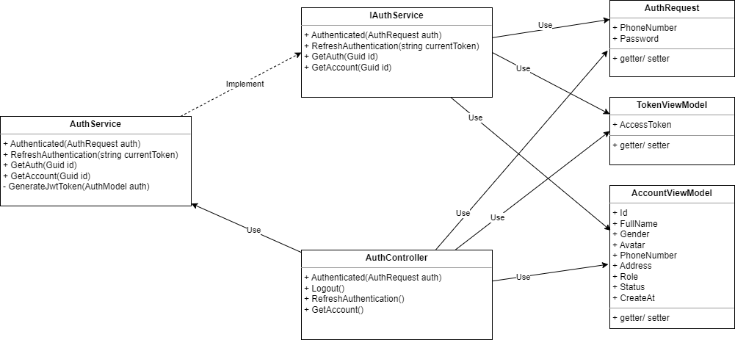

* + - Class Diagram Specification:

|  |  |  |
| --- | --- | --- |
| **No** | **Method** | **Description** |
| 1 | Authenticated | Authentication account admin, owner, teller, staff, customer |
| 2 | Logout | Logout account |
| 3 | RefreshAuthentication | Refresh token |
| 4 | GetAccount | Retrieve logged-in account details |

*Table 24 -* Class Diagram Specification Authentication feature

***3.1.2 Sequence Diagram Login***

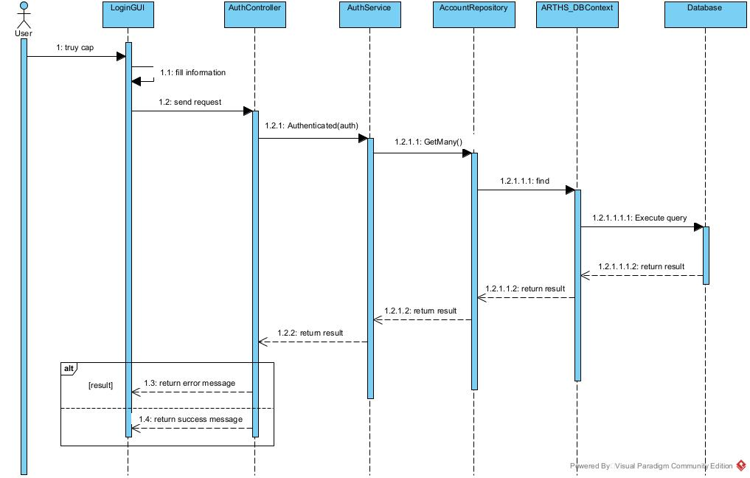

### 3.2 Owner Manage Product

3.2.1 Class Diagram

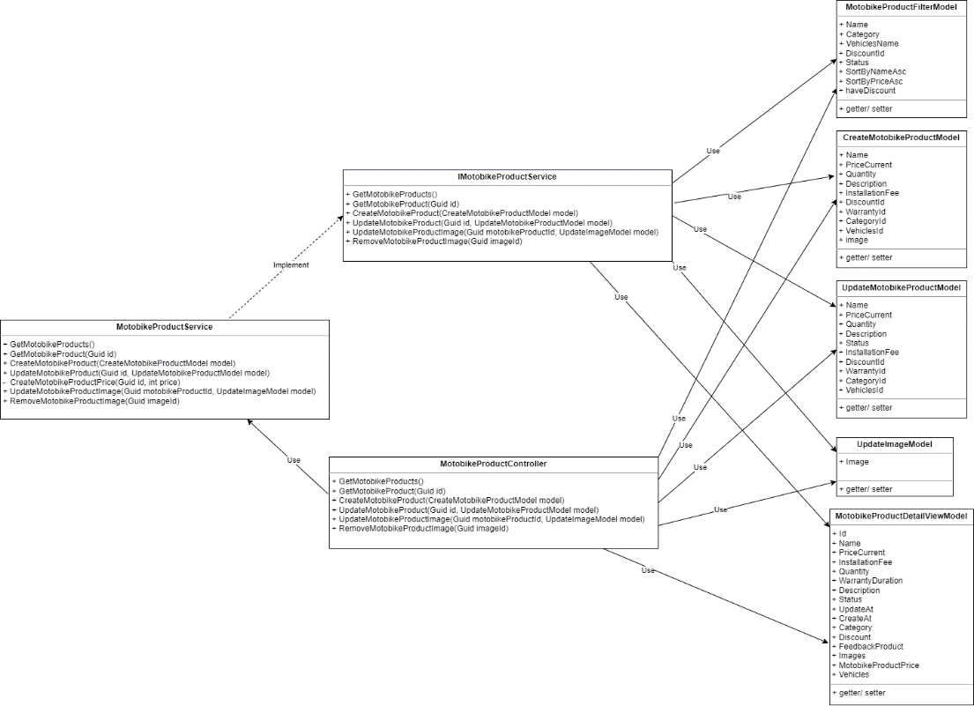

* + - Class Diagram Specification:

|  |  |  |
| --- | --- | --- |
| **No** | **Method** | **Description** |
| 1 | GetMotobikeProducts | Get all motobike products |
| 2 | GetMotobikeProduct | Get motobike product by id |
| 3 | CreateMotobikeProduct | Create Motobike Product |
| 4 | UpdateMotobikeProduct | Update Motobike Product |
| 5 | UpdateMotobikeProductImage | Update Motobike Product Image |
| 6 | RemoveMotobikeProductImage | Remove Motobike Product Image |

*Table 25 -* Class Diagram Specification Manage Product

***3.2.2 Sequence Diagram Create Product***

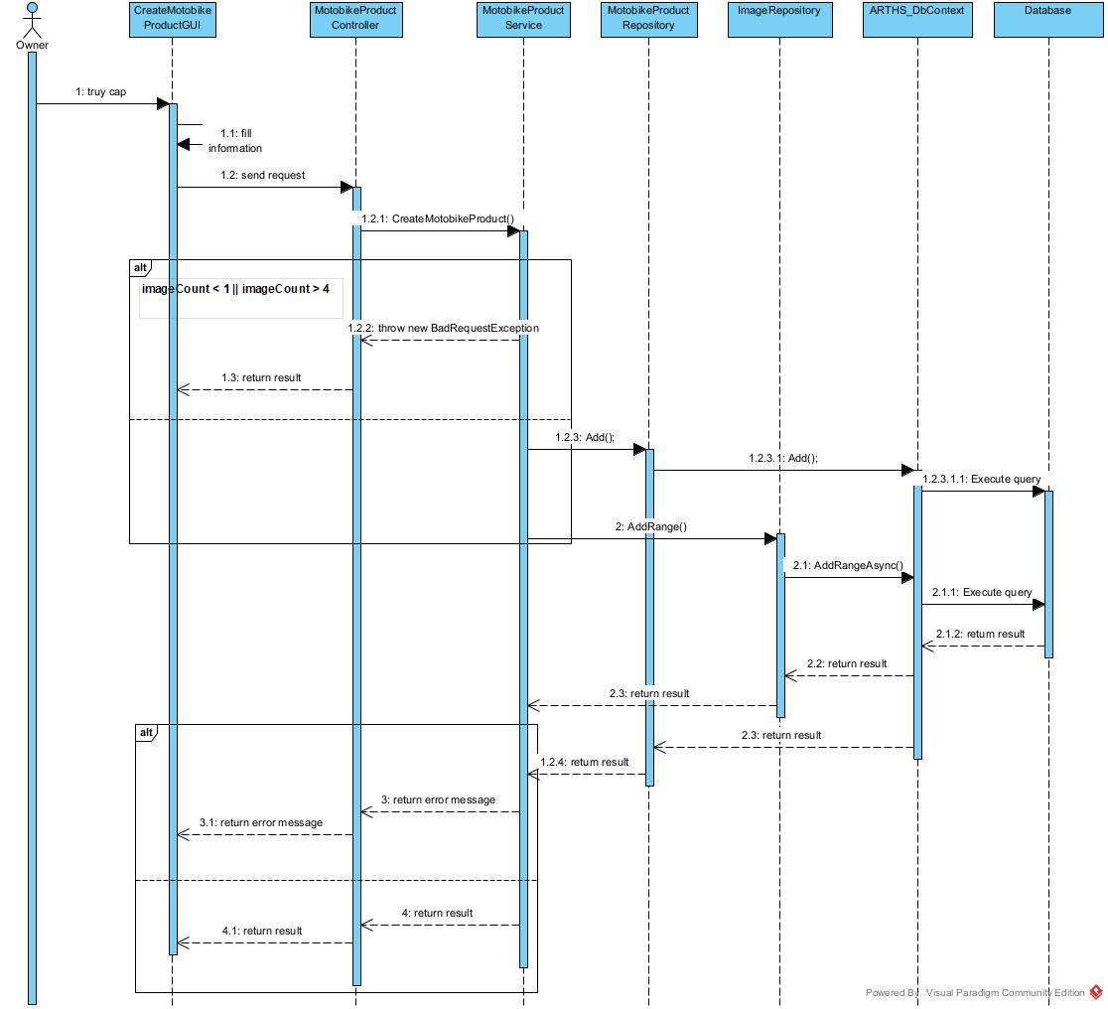

### 3.3 Owner Manage Service

3.3.1 Class Diagram

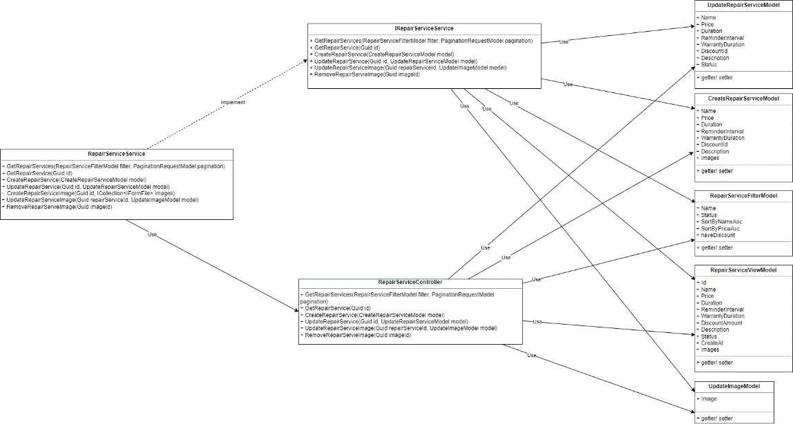

* + - Class Diagram Specification:

|  |  |  |
| --- | --- | --- |
| **No** | **Method** | **Description** |
| 1 | GetRepairServices | Get all Repair Services |
| 2 | GetRepairService | Get Repair Service by id |
| 3 | CreateRepairService | Create Repair Service |
| 4 | UpdateRepairService | Update Repair Service |
| 5 | UpdateRepairServiceImage | Update Repair Service Image |
| 6 | RemoveRepairServieImage | Remove Repair Service Image |

*Table 26 -* Class Diagram Specification Manage Service

***3.3.2 Sequence Diagram Create Service***

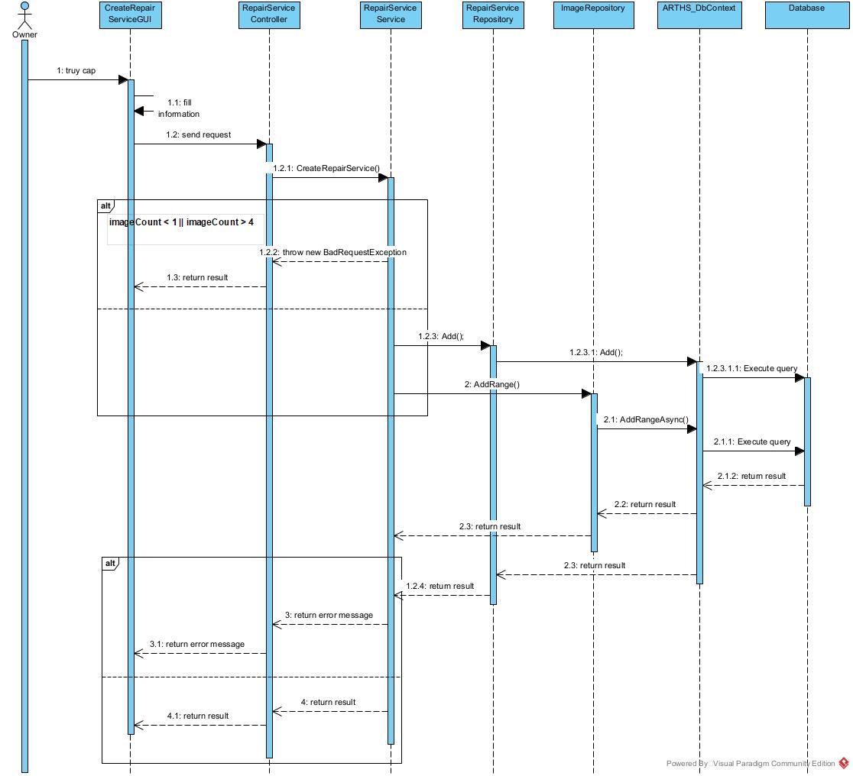

### 3.4 Owner Manage Discount

3.4.1 Class Diagram

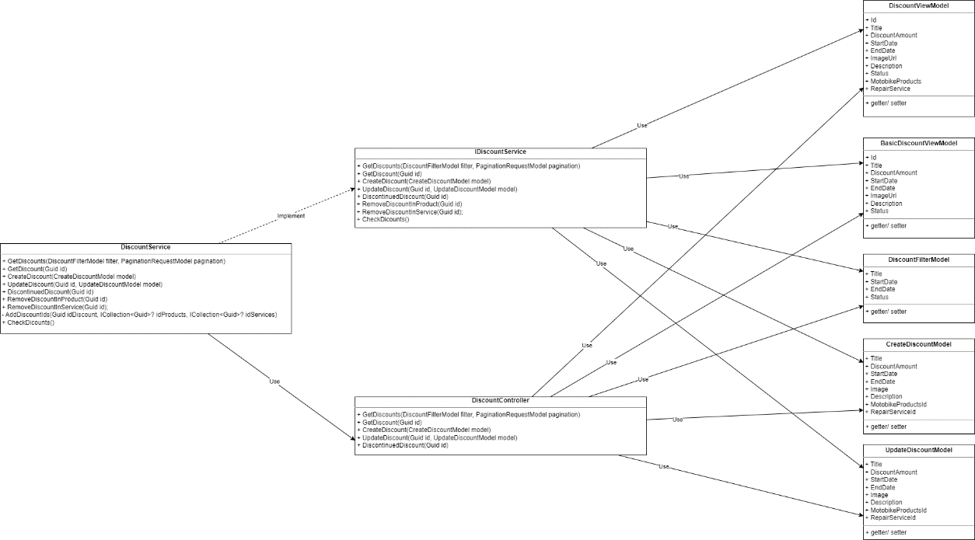

* + - Class Diagram Specification:

|  |  |  |
| --- | --- | --- |
| **No** | **Method** | **Description** |
| 1 | GetDiscounts | Get all Discounts |
| 2 | GetDiscount | Get Discount by id |
| 3 | CreateDiscount | Create Discount |
| 4 | UpdateDiscount | Update Discount |
| 5 | DiscontinuedDiscount | Discontinued Discount |

*Table 27 -* Class Diagram Specification Manage Discount

***3.4.2 Sequence Diagram Create Discount***

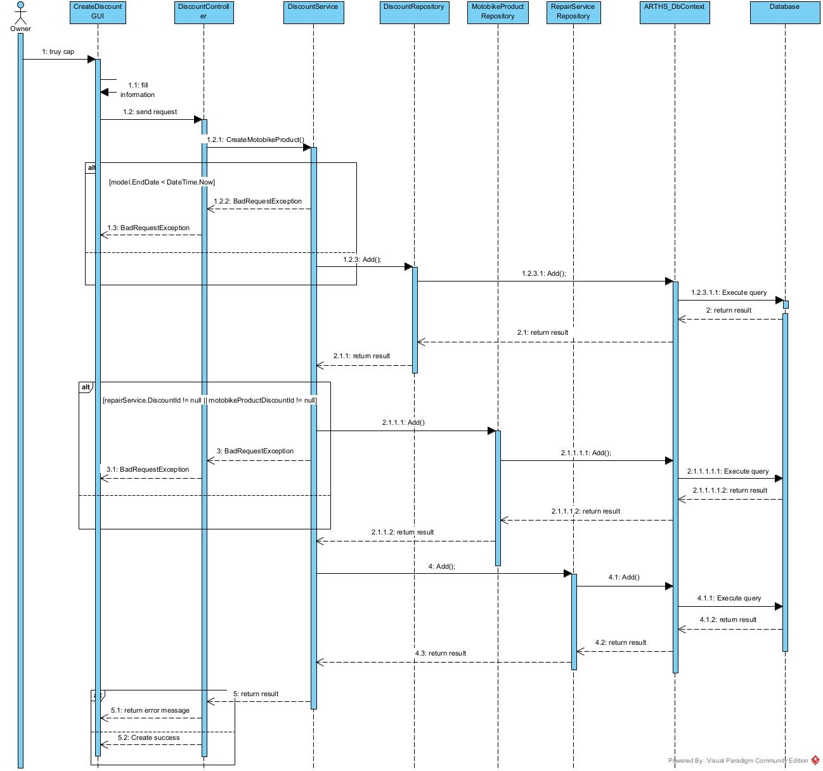

### 3.5 Manage Staff/ Teller

3.5.1 Class Diagram

- *Staff class diagram*

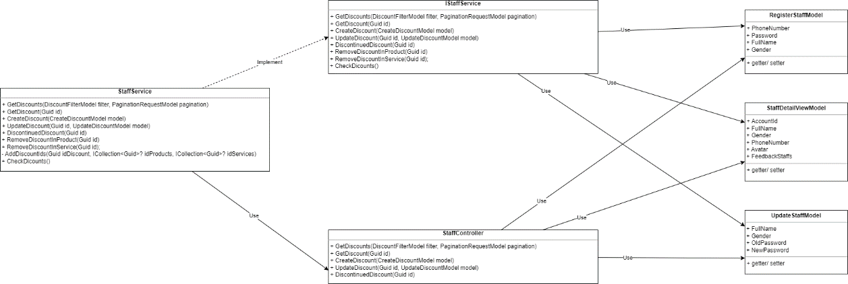

* + - Class Diagram Specification:

|  |  |  |
| --- | --- | --- |
| **No** | **Method** | **Description** |
| 1 | GetStaffs | Get all Staffs |
| 2 | GetStaff | Get Staff by id |
| 3 | CreateStaff | Create Staff |
| 4 | UpdateStaff | Update Staff |
| 5 | UploadAvatar | Upload new Avatar |

*Table 28 -* Class Diagram Specification Manage Staff

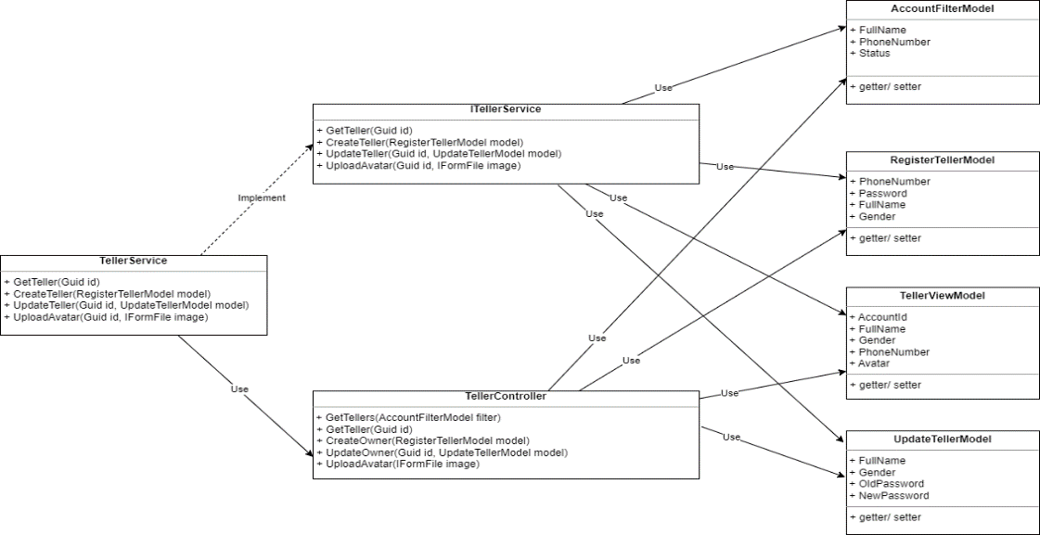- *Teller class diagram*

* + - Class Diagram Specification:

|  |  |  |
| --- | --- | --- |
| **No** | **Method** | **Description** |
| 1 | GetTellerss | Get all Tellerss |
| 2 | GetTellers | Get Tellers by id |
| 3 | CreateTellers | Create Tellers |
| 4 | UpdateTellers | Update Tellers |
| 5 | UploadAvatar | Upload new Avatar |

*Table 29 -* Class Diagram Specification ManageTeller

***3.5.2 Sequence Diagram Create Staff/ Teller***

- *Staff Sequence Diagram*

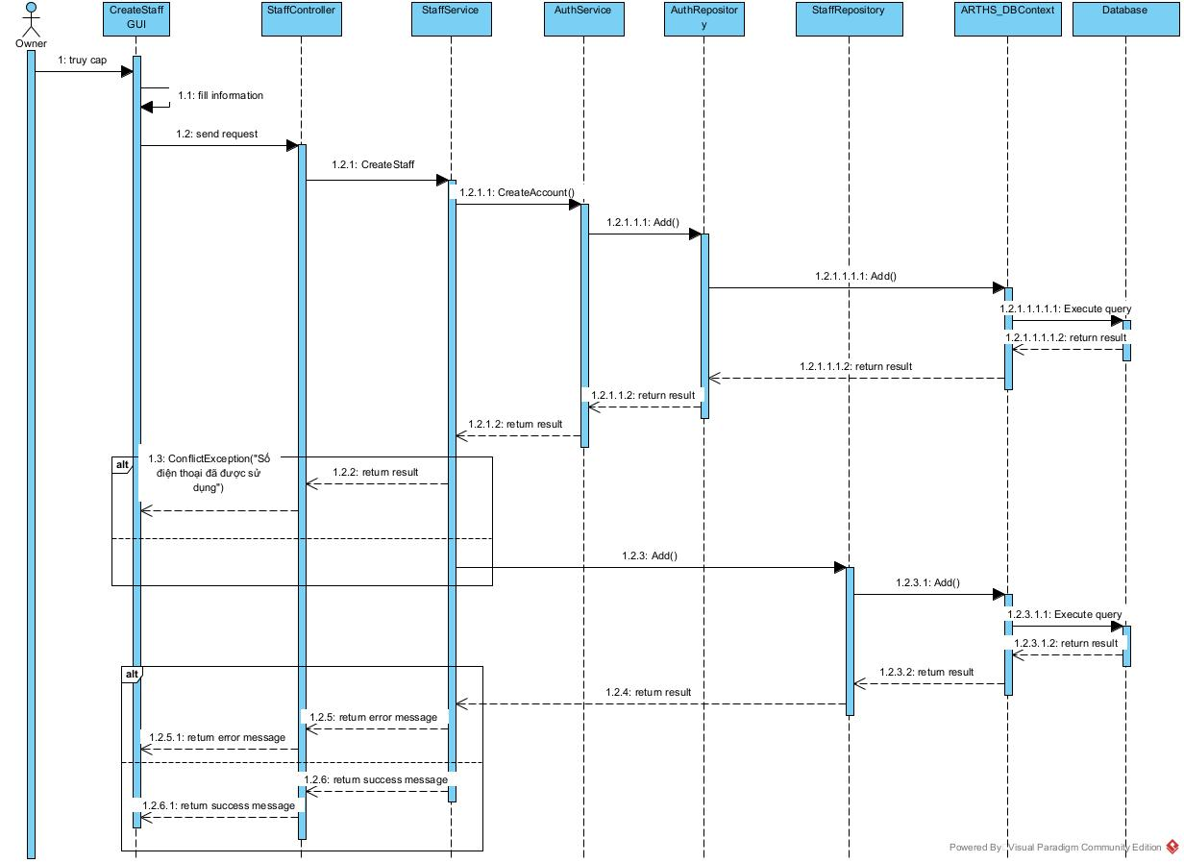

- *Teller Sequence Diagram*

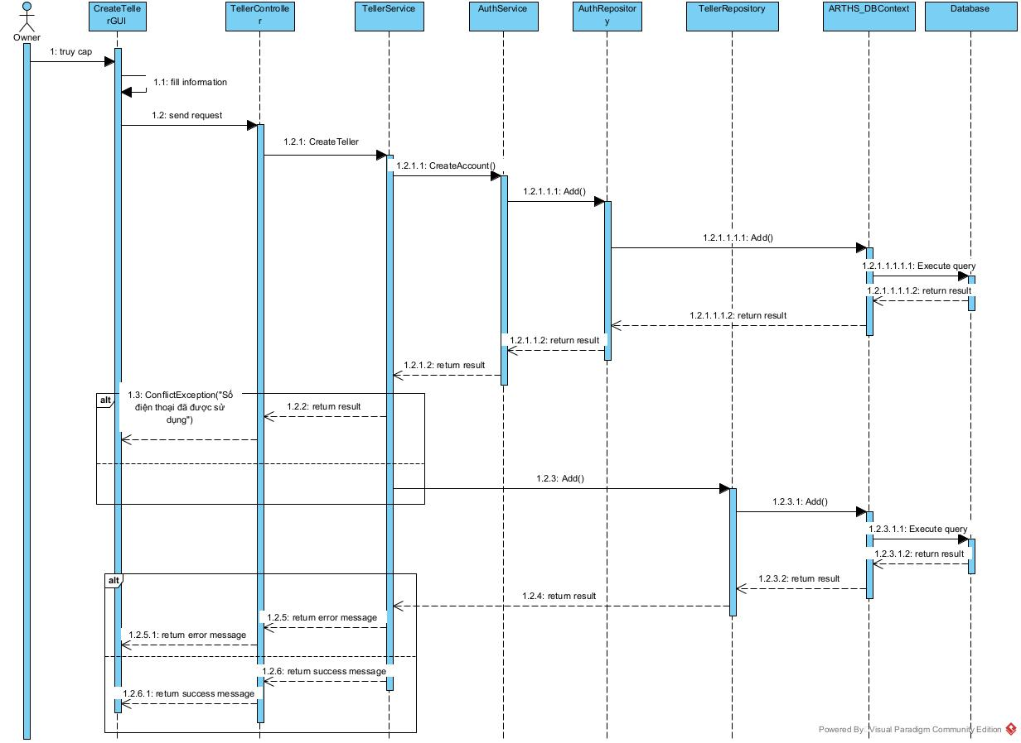

### 3.6 Manage Order

3.6.1 Class Diagram

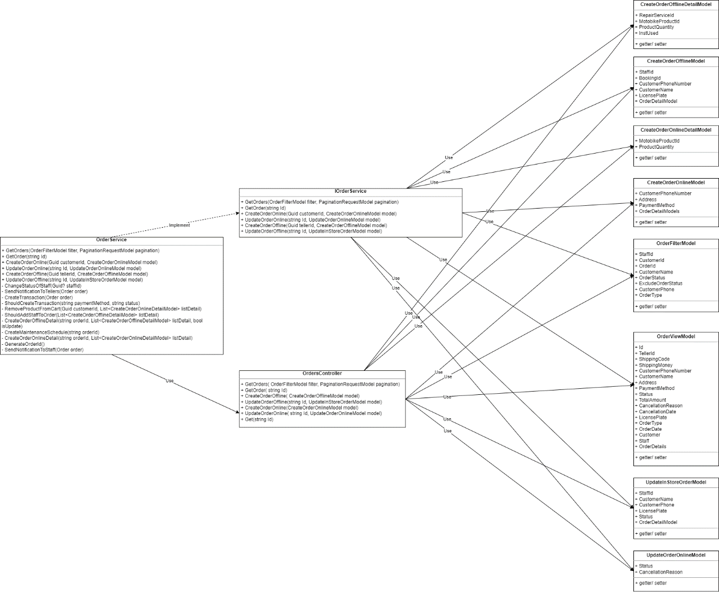

* + - Class Diagram Specification:

|  |  |  |
| --- | --- | --- |
| **No** | **Method** | **Description** |
| 1 | GetOrders | Get all Orders |
| 2 | GetOrder | Get Order by id |
| 3 | CreateOrderOffline | Create in store Order |
| 4 | UpdateOrderOffline | Update in store Order |
| 5 | CreateOrderOnline | Create Order Online |
| 6 | UpdateOrderOnline | UpdateOrderOnline |
| 7 | GetBill | Export Bill |

*Table 30 -* Class Diagram Specification Manage Order

***3.6.2 Sequence Diagram Create Order***

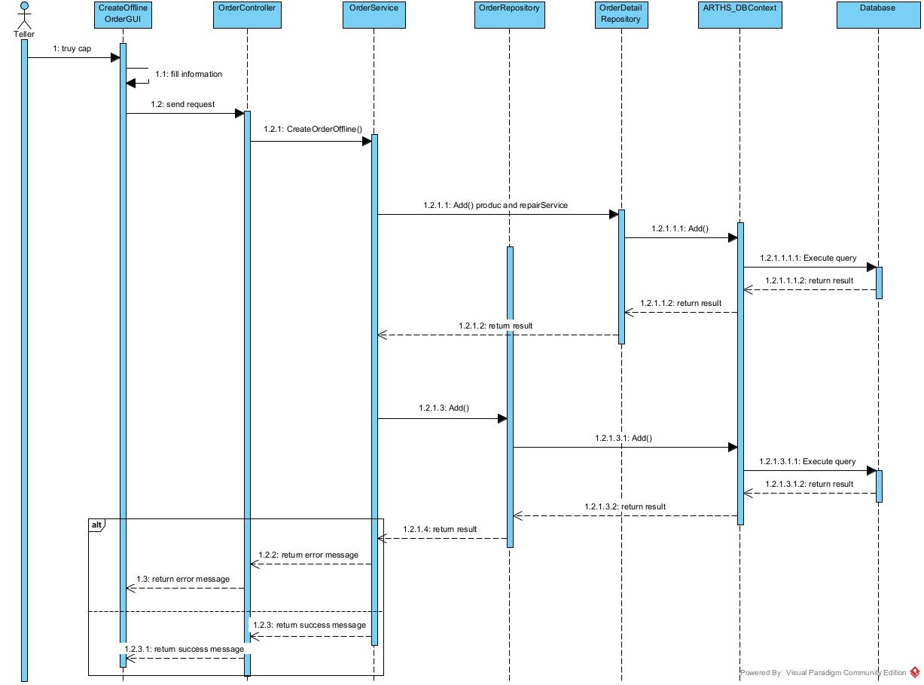

### 3.7 Manage Cart

3.7.1 Class Diagram

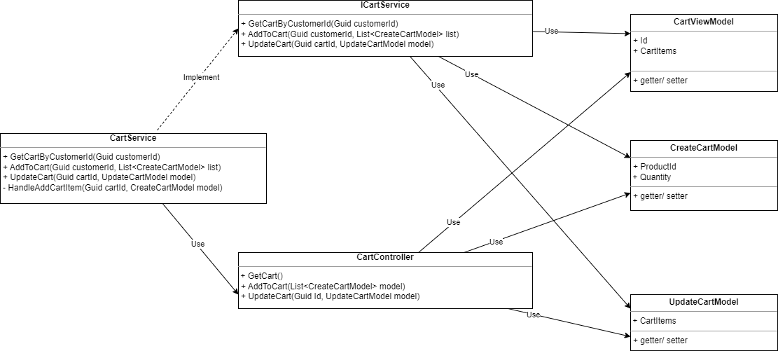

* + - Class Diagram Specification:

|  |  |  |
| --- | --- | --- |
| **No** | **Method** | **Description** |
| 1 | GetCart | Get product list in Cart |
| 2 | AddToCart | Add product To Cart |
| 3 | UpdateCart | Update product in Cart |

*Table 31 -* Class Diagram Specification Cart

***3.7.2 Sequence Diagram Add Product to Cart***

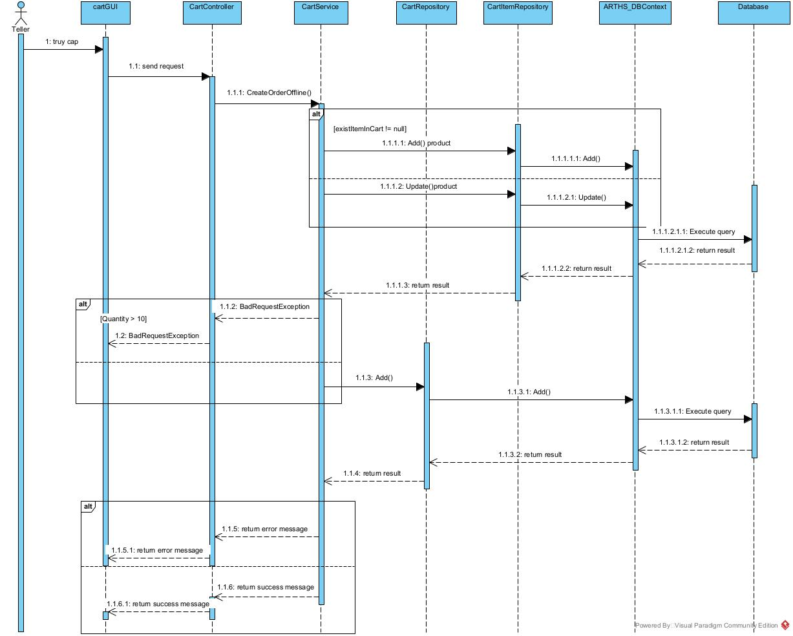

### 3.8 Manage booking

3.8.1 Class Diagram

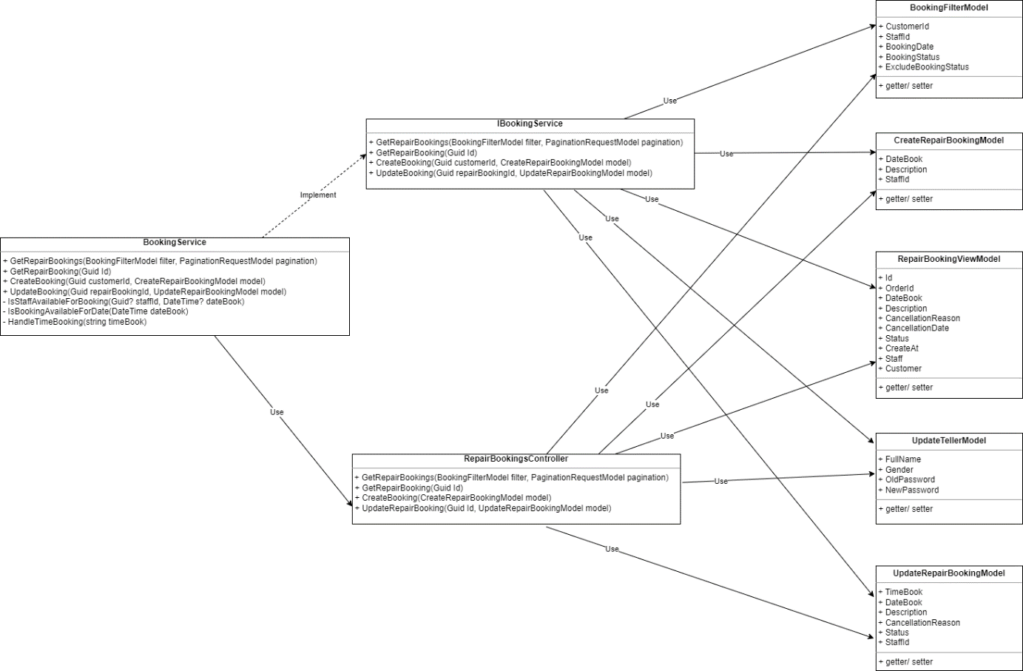

* + - Class Diagram Specification:

|  |  |  |
| --- | --- | --- |
| **No** | **Method** | **Description** |
| 1 | GetRepairBookings | Get all Repair Bookings |
| 2 | GetRepairBooking | Get Repair Booking detail |
| 3 | CreateBooking | Create Booking |
| 4 | UpdateRepairBooking | Update date time and status Repair Booking |

*Table 32 -* Class Diagram Specification Manage booking

***3.8.2 Sequence Diagram Create Booking***

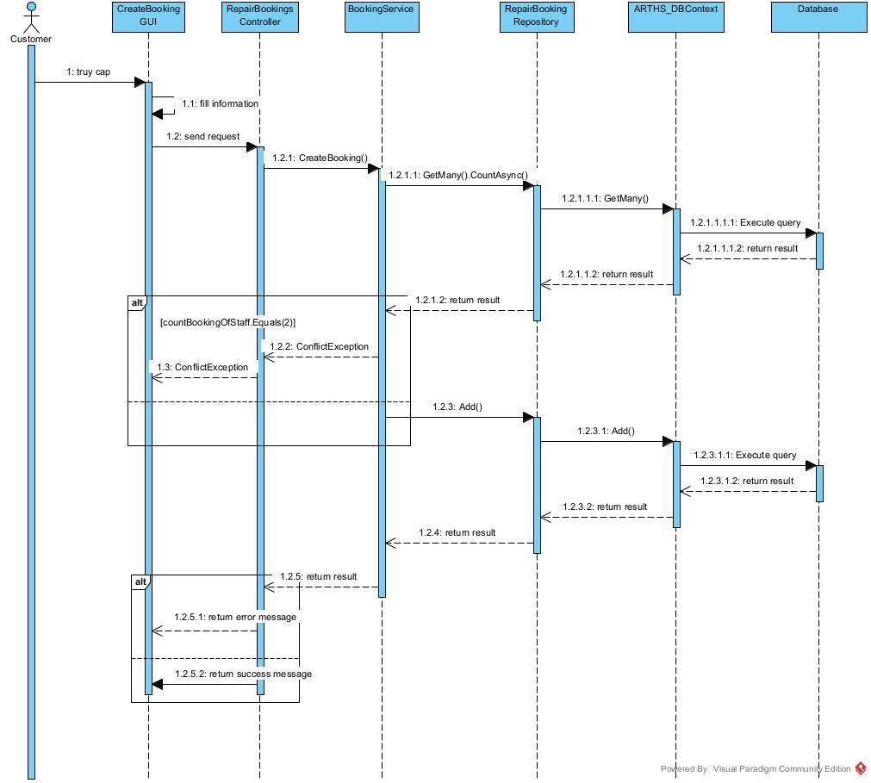

### 3.9 Notification

**3.9.1 Class Diagram**

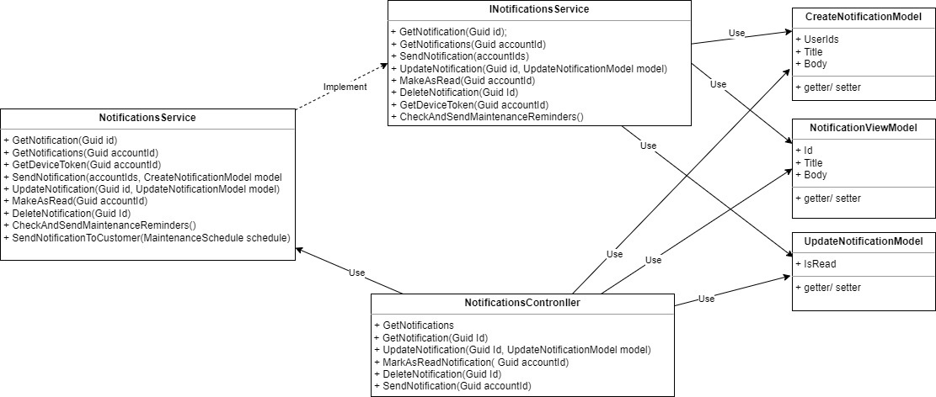

* + - Class Diagram Specification:

|  |  |  |
| --- | --- | --- |
| **No** | **Method** | **Description** |
| 1 | GetNotifications | Get all notifications of logged in account. |
| 2 | GetNotification | Get notification by id. |
| 3 | UpdateNotification | Update notification. |
| 4 | MarkAsReadNotification | Mark as read all notification. |
| 5 | DeleteNotification | Delete notification |
| 6 | SendNotification | Send notification. |

*Table 33 -* Class Diagram Specification notification

**3.9.2 Sequence Diagram Send notification**

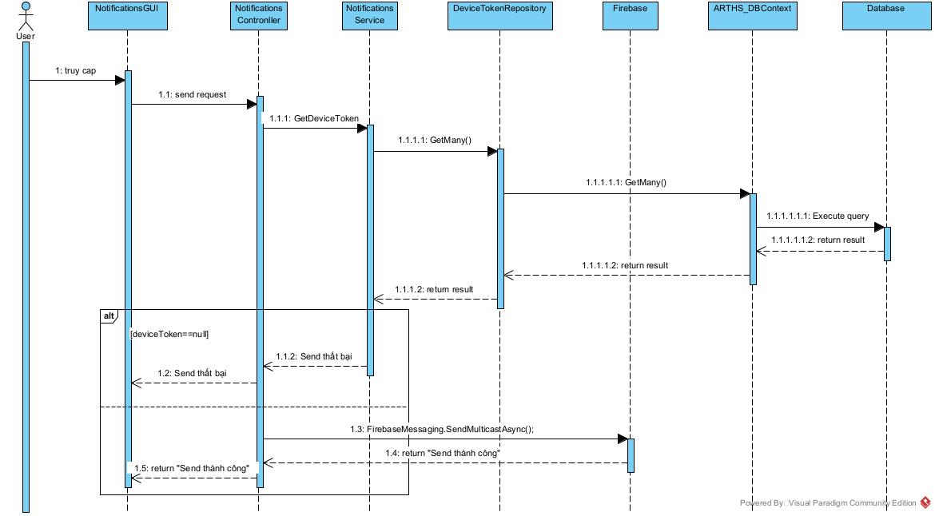

### 3.10 Ghn service

**3.10.1 Class Diagram**

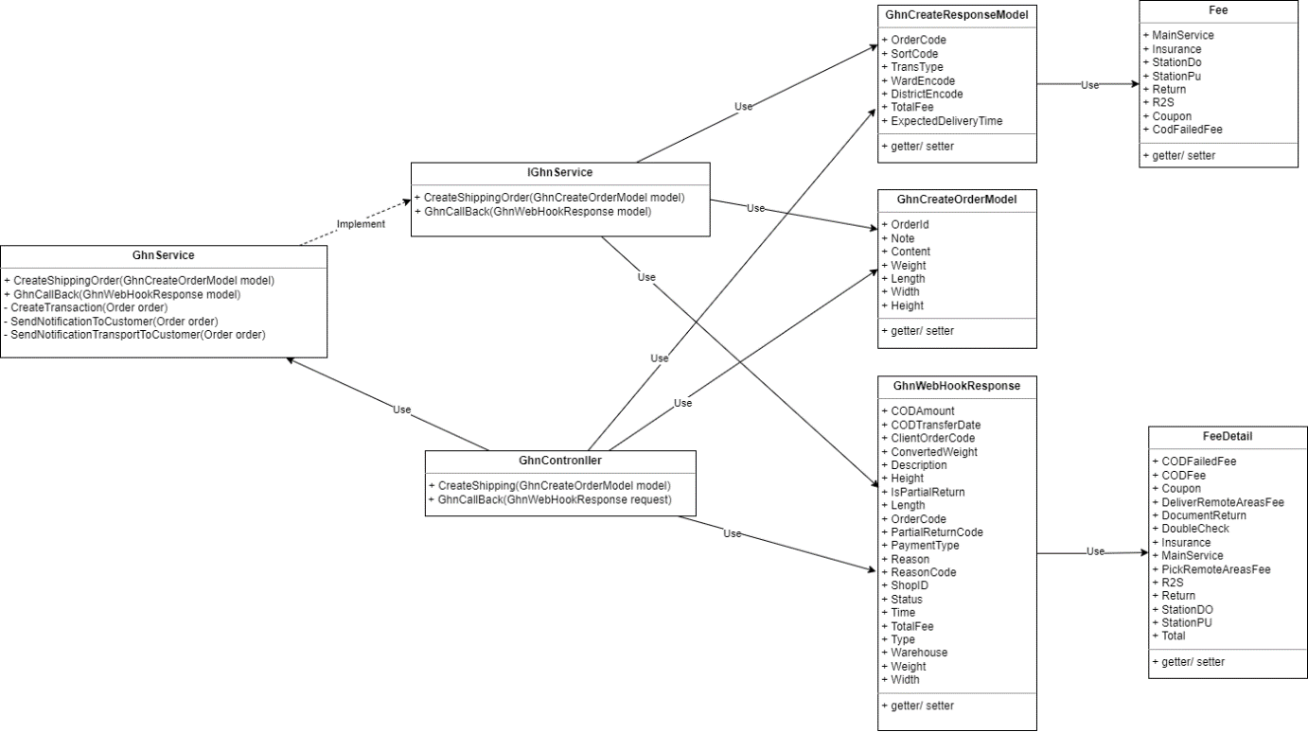

* + - Class Diagram Specification:

|  |  |  |
| --- | --- | --- |
| No | Method | Description |
| 1 | CreateShipping | Transfer of an order to GHN for shipping. |
| 2 | GhnCallBack | Webhook callback from GHN for order updates. |

*Table 34 -* Class Diagram Specification Ghn service

**3.10.2 Sequence Diagram Transfer-order**

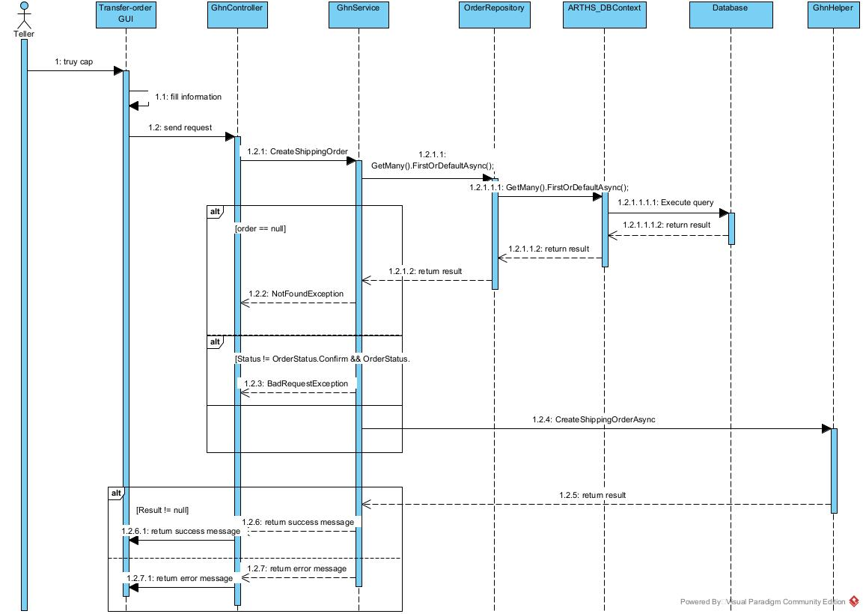

### 3.11 Activity Diagram

3.9.1 Login Activity Diagram

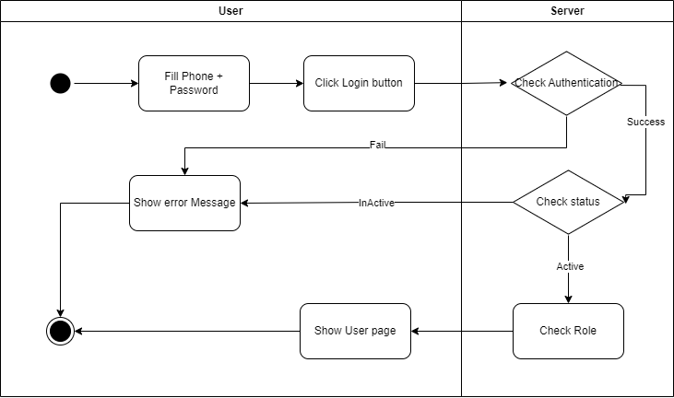

3.9.2 Online Order Activity Diagram

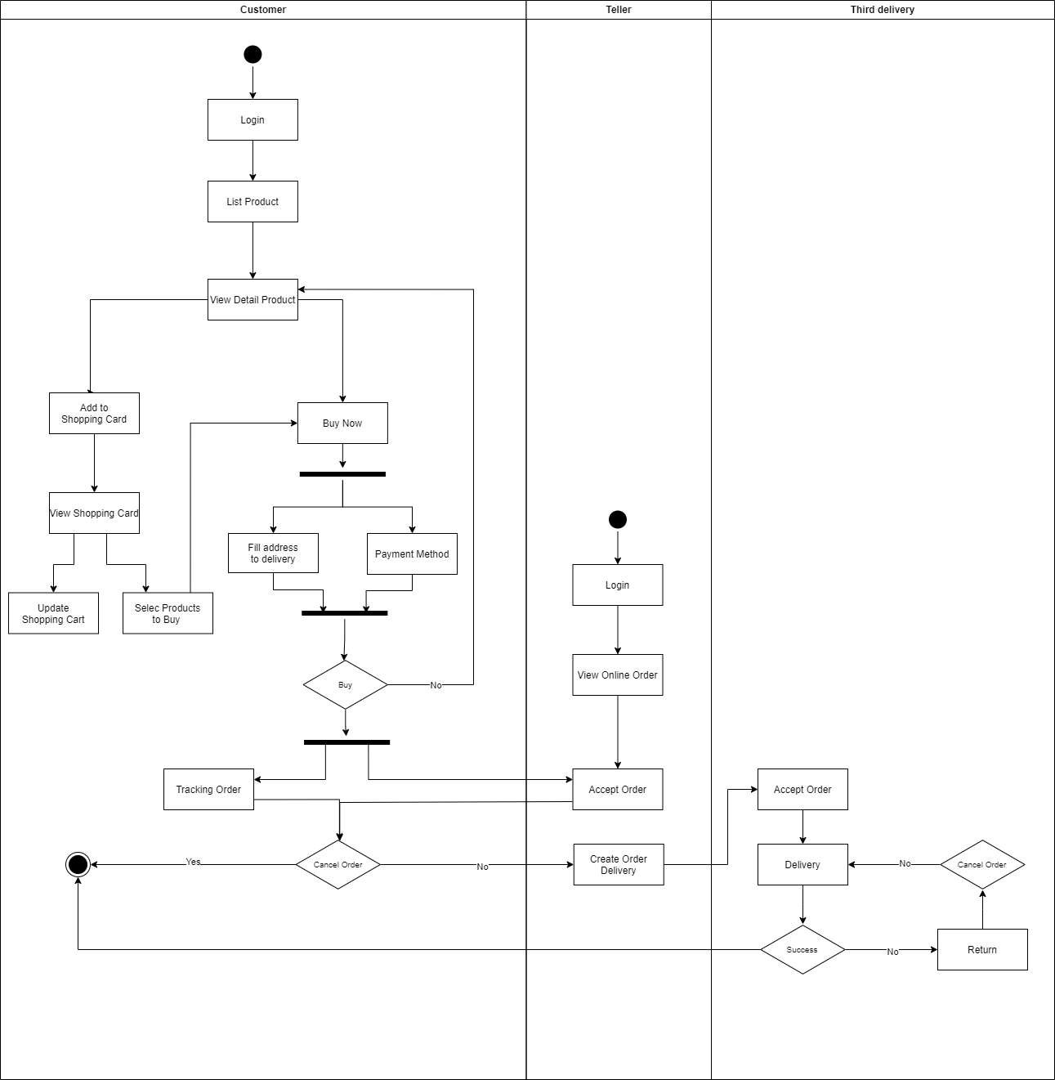

3.9.3 Offline Order Activity Diagram

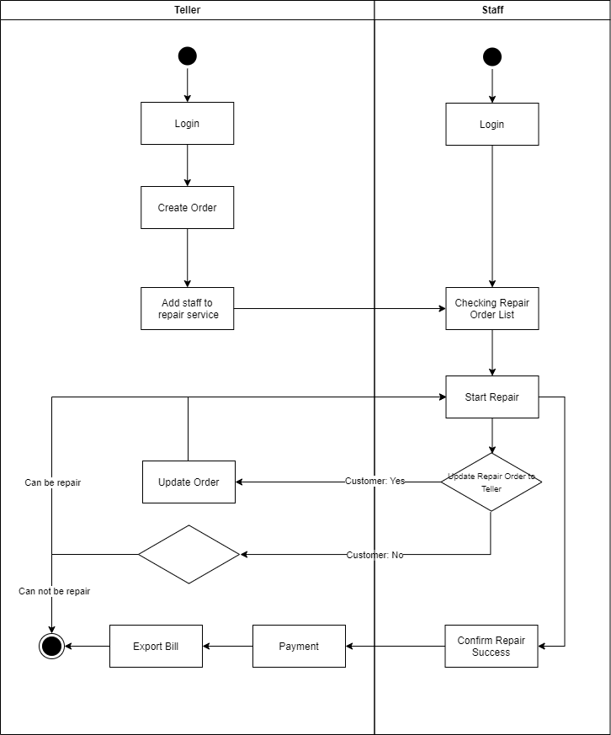

3.9.3 Booking Activity Diagram

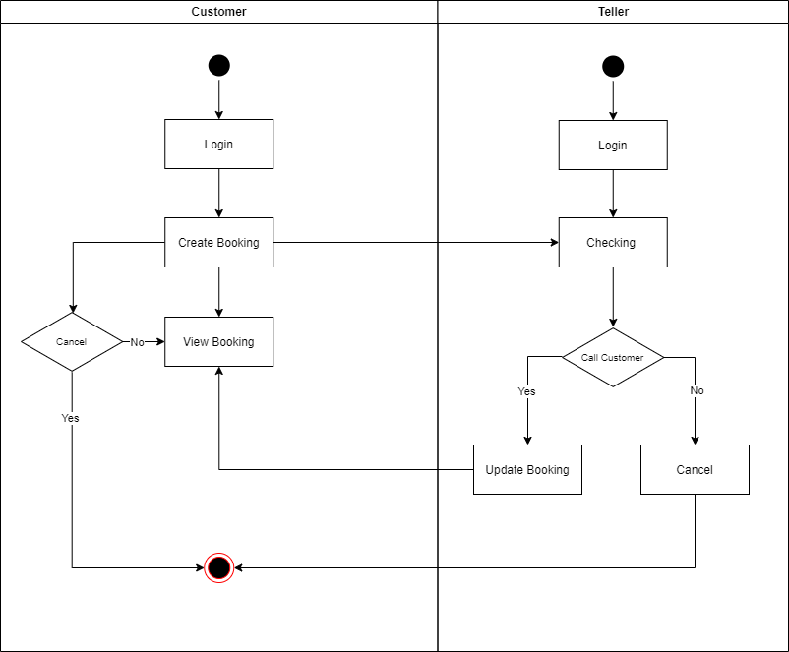

### 3.12 State Machine Diagram

3.10.1 State Online Order Diagram

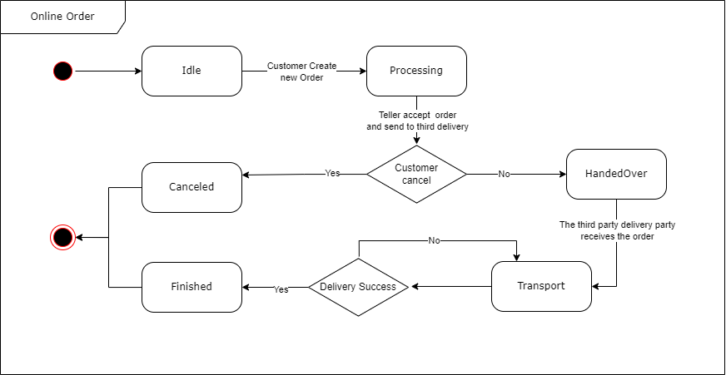

3.10.2 State Offline Order Diagram

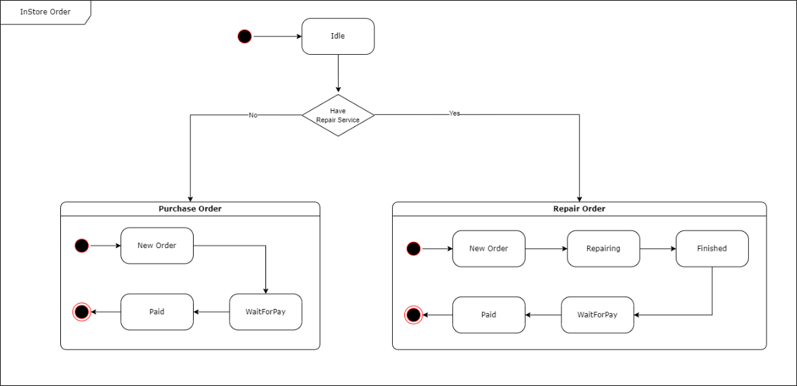

3.10.2 State Booking Diagram

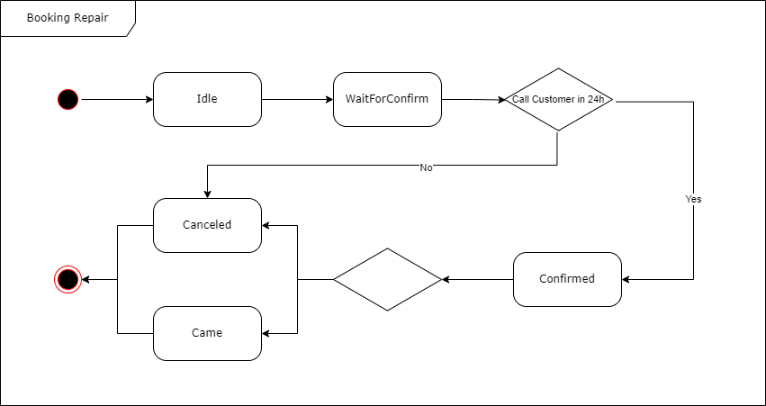

# V. Software Testing Documentation

## 1. Scope of Testing

Tests at different scopes complement each other’s strengths and weaknesses. A good mix of tests can

create an excellent testing plan that allows us to make changes confidently and catches actual bugs

quickly and efficiently.

* With the backend API, we applied Unit Testing and then Integration Testing.
* With the Front-End and Mobile, we applied System Testing with functional requirements.

## 2. Test Strategy

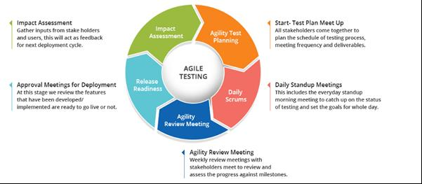

Since the CREL project team uses the Scrum workflow, the Agile testing approach is suitable for changing requirements with each cycle. It is an entirely new test phase, allows the testing team to spot bugs

quickly, and prevents the development team from repeating a bug type too many times. Additionally, the Agile

testing model has the following advantages:

* Suitable in small or medium projects.
* Provide a common ground for stakeholders to communicate incrementally.

### 2.1 Testing Types

* **Functional testing:** Ensure the system’s functionalities follow business functional requirements.
* **Non-functional testing:** To ensure the system’s user interface, performance, and user

experience follow the business non-functional requirements with the provided hardware and internet transmission speed.

### 2.2 Test Levels

|  |  |  |  |  |
| --- | --- | --- | --- | --- |
| **Type of test** | **Test Level** | | | |
| **Unit** | **Integration** | **System** | **Acceptance** |
| Function Testing | **x** | **x** | **x** |  |
| User interface testing |  |  | **x** |  |

*Table 35 - Test Levels*

### 2.3 Supporting Tools

|  |  |  |  |
| --- | --- | --- | --- |
| **Purpose** | **Tool** | **Vendor/In-house** | **Version** |
| View logs of web application | Chrome DevTools | Chrome | 116.0.5845.97 |
| Backend IDE | Visual Studio | Microsoft | 1.81 |
| Web application | Visual Studio Code | Microsoft | 1.81 |
| Mobile application | Visual Studio Code | Microsoft | 1.81 |
| Communication | Google Meet, Messenger | Microsoft, Facebook |  |

*Table 36 - Supporting Tools*

## 3. Test Plan

### 3.1 Human Resources

|  |  |  |
| --- | --- | --- |
| **Worker/Doer** | **Role** | **Specific Responsibilities/Comments** |
| Bui Hung Trong Nghia | Leader | Planning. Verify test deliverables. |
| Tran Quang Truong | Member | Execute test and report as planned. |
| Nguyen Nguyen An | Member | Execute test and report as planned. |
| Nguyen Tan Trung | Member | Execute test and report as planned. |

*Table 37 - Human Resources*

### 3.2 Test Environment

|  |  |  |
| --- | --- | --- |
| **Purpose** | **Tool** | **Provider** |
| View logs of web application | Chrome DevTools | Chrome |
| Test case management | Microsoft Excel | Microsoft |
| UI for Unit test and Integration test | Postman | Postman |
| Backend IDE | Visual Studio | Microsoft |
| Web application IDE | Visual Studio Code | Microsoft |
| Mobile application IDE | Visual Studio Code | Microsoft |
| Execution hardware | Testing is implemented  on computers with the  following specifications:  · CPU: Intel i7  · RAM: 16GB  · Storage device: HDD or  SSD | Any providers |
| Communication | Online meeting,  Messenger | Google Meet,  Facebook |

*Table 38 - Test Environment*

### 3.3 Test Milestones

|  |  |  |  |
| --- | --- | --- | --- |
| **Milestone Task** | **Effort (md)** | **Start Date** | **End Date** |
| **Iteration 1: Test planning for web**  **application** | 6 | 05/10/2023 | 27/10/2023 |
| Create test plan | 1 | 21/10/2023 | 22/10/2023 |
| Review test plan | 1 | 22/10/2023 | 23/10/2023 |
| Create unit test | 2 | 23/10/2023 | 25/10/2023 |
| Create test case | 2 | 25/10/2023 | 27/10/2023 |
| **Iteration 2: Test planning for mobile application** | 6 | 27/10/2023 | 02/11/2023 |
| Create test plan | 1 | 27/10/2023 | 28/10/2023 |
| Review test plan | 1 | 28/10/2023 | 29/10/2023 |
| Create unit test | 2 | 29/10/2023 | 31/10/2023 |
| Create test case | 2 | 31/10/2023 | 02/11/2023 |
| **Iteration 3: Execute tests for mobile**  **and web applications** | 4 | 02/11/2023 | 06/11/2023 |
| Execute test for mobile application | 2 | 02/11/2023 | 04/11/2023 |
| Execute test for web application | 2 | 04/11/2023 | 06/11/2023 |
| System test | 4 | 06/11/2023 | 10/11/2023 |
| Acceptance test | 2 | 10/112023 | 12/11/2023 |
| Write final report | 1 | 12/11/2023 | 18/11/2023 |

## 4. Test Cases

|  |  |
| --- | --- |
| **Unit Test Cases** | **Test Report** |
| <Report5_Unit-Test.xlsx> | <FA23SE058_Test_Report.xlsx> |

## 5. Test Reports

*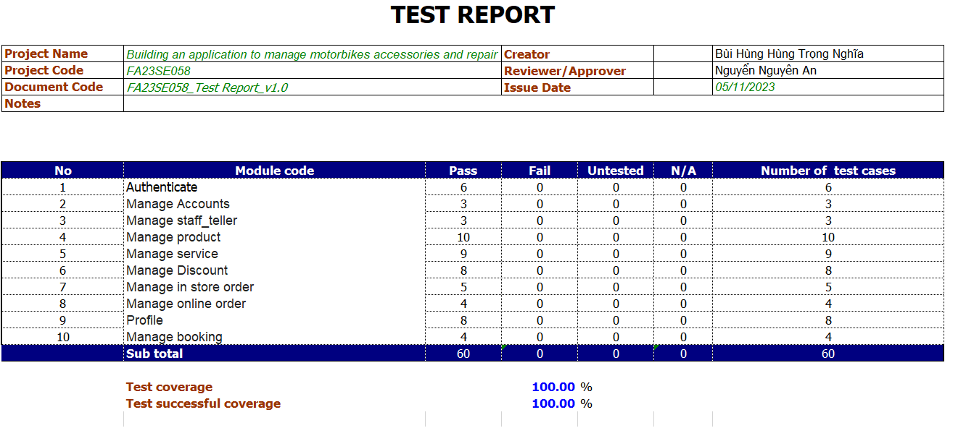*

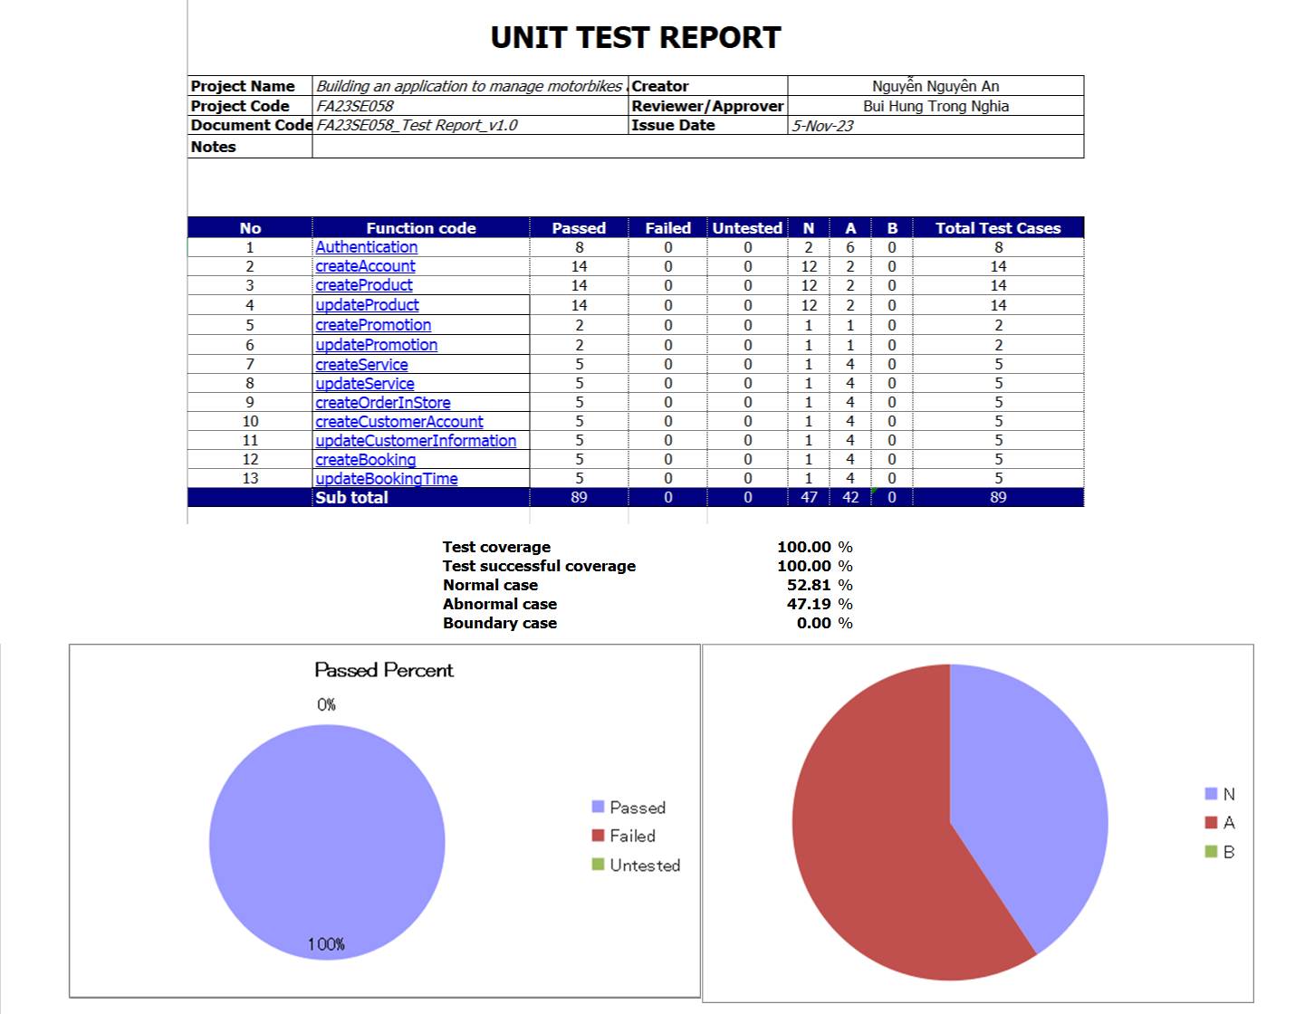

# VI. Release Package & User Guides

## 1. Deliverable Package

| **No.** | **Deliverable Item** | **Description** |
| --- | --- | --- |
| 1 | Schedule/Task Tracking | Drive: [Report Of Capstone](https://drive.google.com/drive/folders/1VCy6LMOJR79ktQNb8whV6UlKGX6wCXKJ?usp=sharing) |
| 2 | Project Backlog |  |
| 3 | Source Codes | Web-API: [ARTHS-Service](https://github.com/ARTHS-Service-v2/ARTHS-Service-v2.git)  Website-Application: [ARTHS-Website-Application](https://github.com/ARTHS-Website-Application/Website-Aplication.git)  Mobile-Application: [MobileApps-Fall](https://github.com/sozux/MobileApps-Fall.git) |
| 4 | Database Script(s) | [script\_arths\_db\_final](https://drive.google.com/file/d/15JNGAZK5FPpvJZ5odTBM0SDHBU5nqqYF/view?usp=sharing) |
| 5 | Final Report Document | [Report7\_Final Project Report.docx](Report7_Final%20Project%20Report.docx) |
| 6 | Test Cases Document | <FA23SE058_Test_Report.xlsx> |
| 9 | Slide | [Thanh Huy store slide](https://www.canva.com/design/DAFzLFFggRg/k80J0h0l4E3DNPEr1OI1ww/edit?utm_content=DAFzLFFggRg&utm_campaign=designshare&utm_medium=link2&utm_source=sharebutton) |

## 2. Installation Guides

### 2.1 System Requirements

**2.1.1** **Hardware Requirements**

**For Mobile Application**

|  |  |
| --- | --- |
| **Operating system** | Android 9.0 or higher |
| **Processor** | Exynos 9820 8 nhân |
| **Storage** | Minimum 850MB, 32GB is recommended |
| **RAM** | Minimum of 2GB, 8GB is recommended |
| **Hard Disk** | 2 GB of available hard-disk space for installation |

**For Web Application**

|  |  |  |
| --- | --- | --- |
| **PC / Laptop** | **Minimum Requirements** | **Recommended** |
| Internet Connection | Cable, Wi-Fi (4 Mbps) | Cable, Wi-Fi (8 Mbps) |
| Operating System | Windows 10 | Windows 11 |
| Computer Processor | Intel® Core i5 | Intel® Core i7 |
| Computer Memory | 4GB RAM | 8GB RAM or more |
| Web Browser | Chromes (v69 or higher) | Chrome latest stable version |

### 2.2 Installation Instruction

Setup and start a Windows OS (Windows 10 or Windows Server 2016):

**2.2.1 Set up Environment**

**2.2.1.1 Back-end:**

**2.2.1.1.1 Setup Database**

Install Sql Server 2019 by following guidelines link:

<https://www.thegioididong.com/game-app/huong-dan-cai-dat-sql-server-2019-cuc-don-gian-chi-1312926>

**2.2.1.1.2 Setup Backend API**

1. Install Visual Studio by following guidelines link:

<https://thuthuatphanmem.vn/huong-dan-tai-va-cai-dat-visual-studio/>

2. Extracting: ARTHS-Service-master.zip

*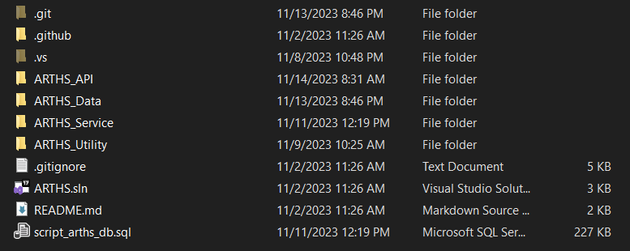*

3. Open ARTHS.sln file with Visual Studio

4. Config your database connection

*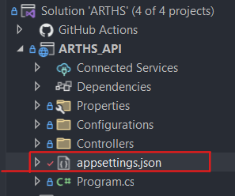*

5. Run project

*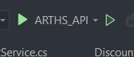*

6. Test project in browser by go to url: <https://localhost:7235>

*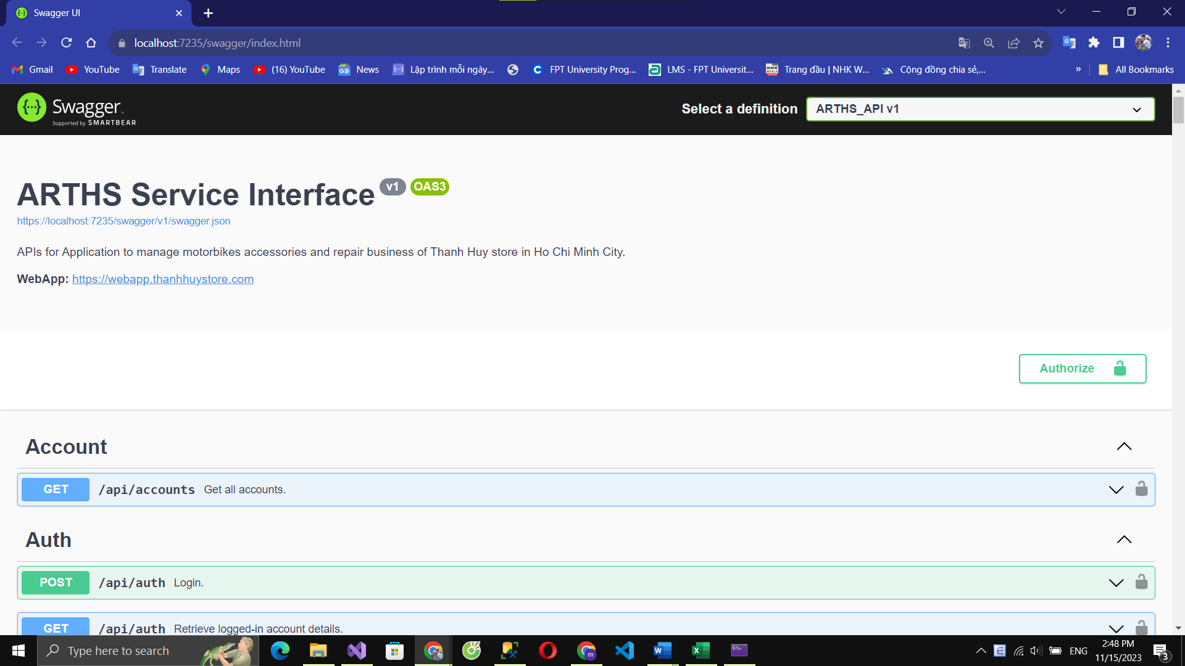*

**2.2.1.1 Front-end:**

**2.2.1.1.1 Web application**

1. Install Visual Studio Code by following guidelines link:

<https://thaynhuom.edu.vn/cai-visual-studio-code-lap-trinh-c-c/>

1. Install npm through Visual Studio Code or you can install npm via NodeJS <https://nodejs.org/en/>
2. Extract Website-Aplication.zip and open folder with Visual Studio Code
3. Open terminal and enter npm i:

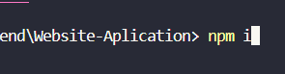

1. Change BASE\_URL = <https://localhost:7235>

*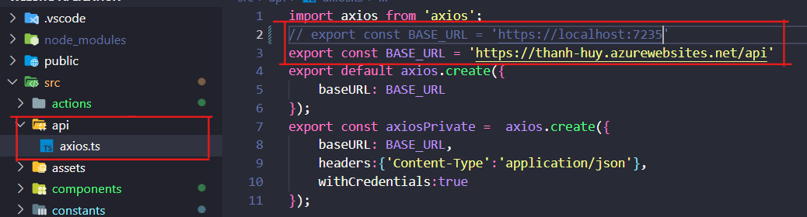*

1. In terminal, enter npm run dev

**

**2.2.1.1.2 Mobile application**

1. Download and install [Android Studio setup file](https://developer.android.com/studio).
2. Start Android Studio and go through the “Android Studio Setup Wizard”. This installs the latest Android SDK, Android SDK Command-line Tools, and Android SDK Build-Tools

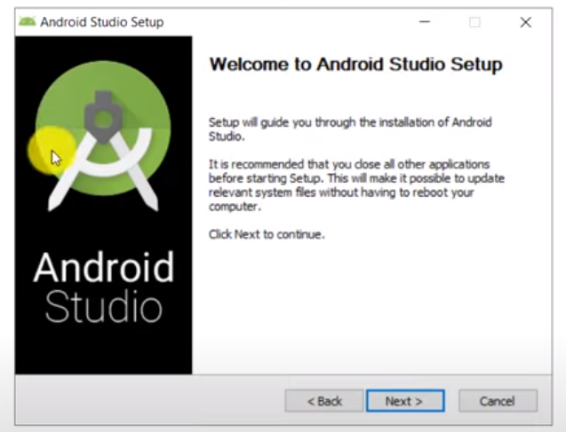

For more detail, see [here](https://developer.android.com/studio/install?gclid=Cj0KCQjw_r6hBhDdARIsAMIDhV_B_vKDuHIELlDD7-C3NW-63mwsPO2EzOpy9uvsM6aMHLjZJWlHEUEaAhF3EALw_wcB&gclsrc=aw.ds).

1. Download Android SDK
   1. Open Android Studio

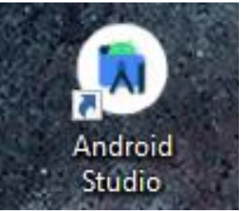

* 1. Open window

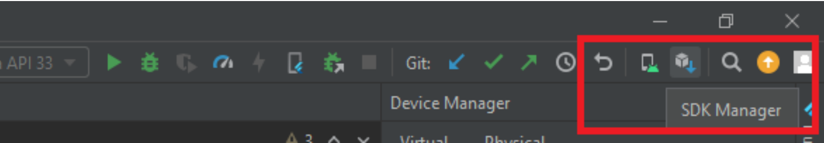

* 1. Choose SDK version (minium 20) and click the download button

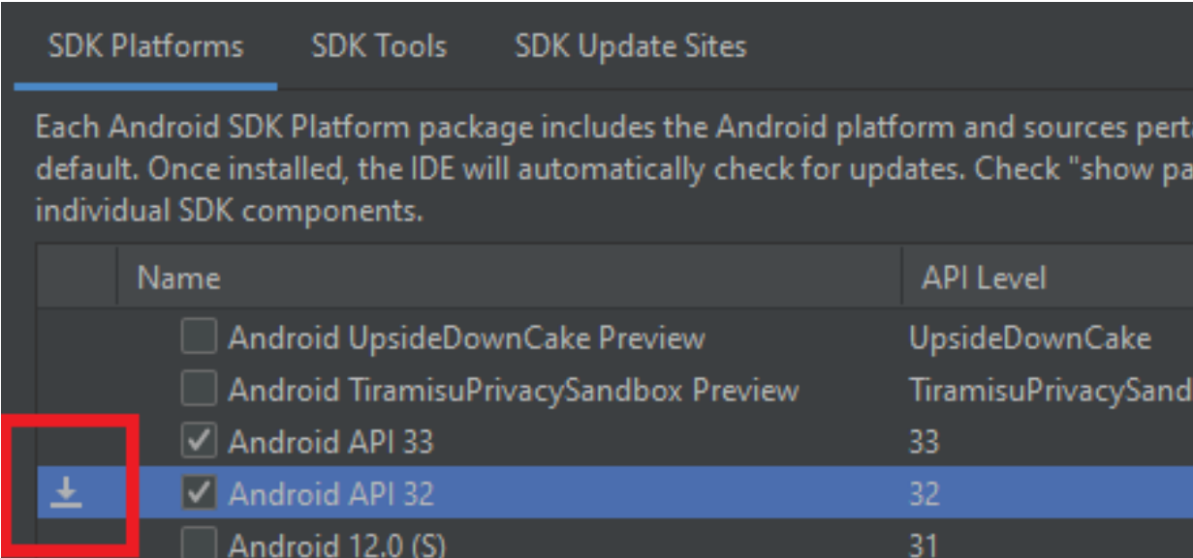

* 1. Click Ok and wait for the download to complete

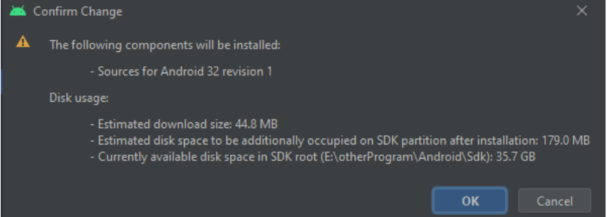

1. Download Virtual Device
   1. Open Device Manager and click Create New Device

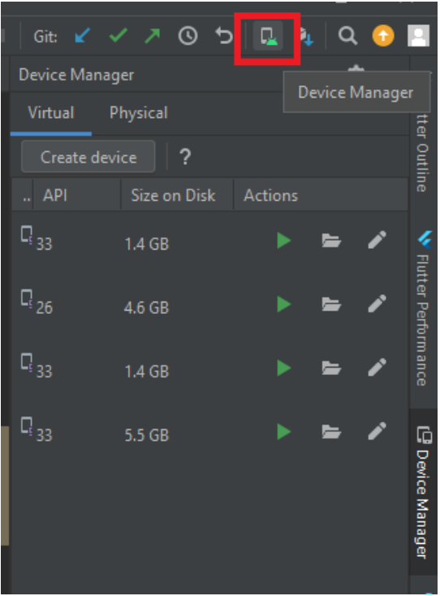

* 1. Choose Phone Device and click next

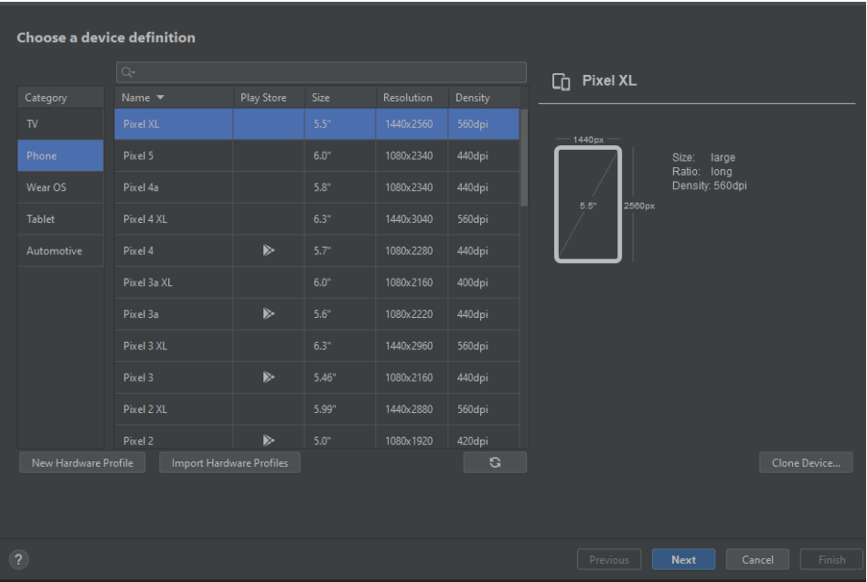

* 1. Choose a system image and click next

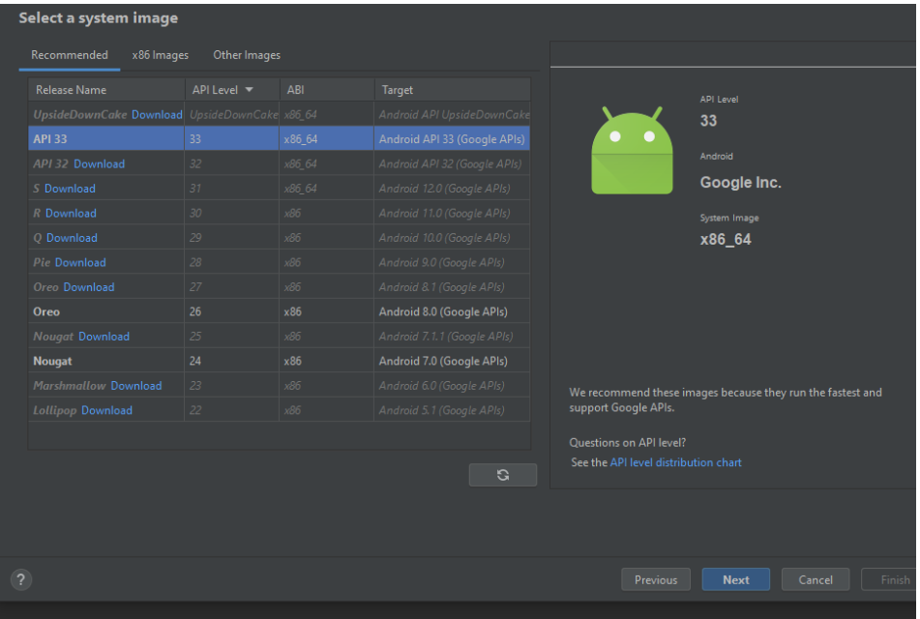

If there is no available system image, click download and wait till the download is finneshed

* 1. Custom some configuration if needed and click Finnish

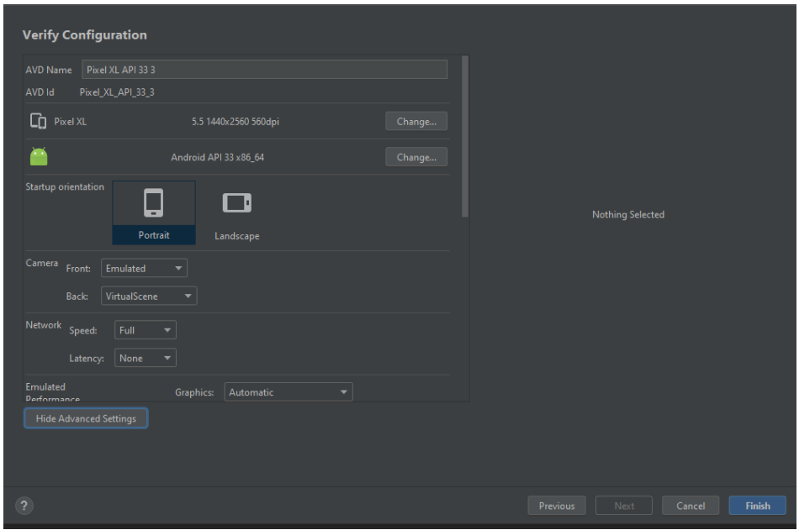

1. Select file and run

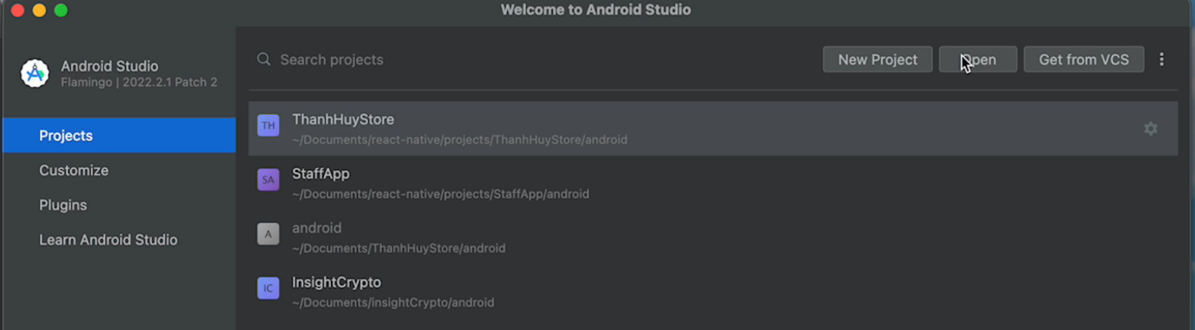

* + - Open Android Studio and click “Open”

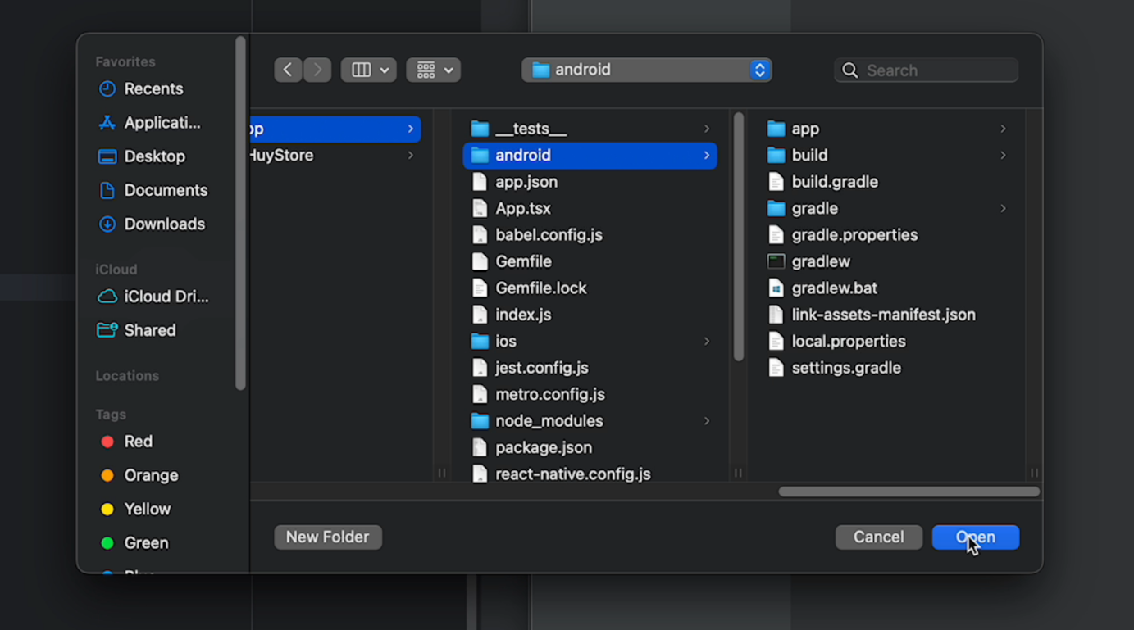

* + - Select file android in project

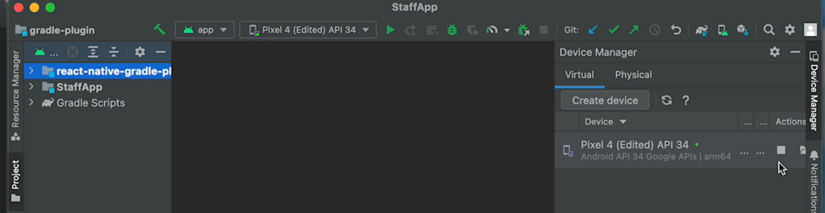

* + - Run android device

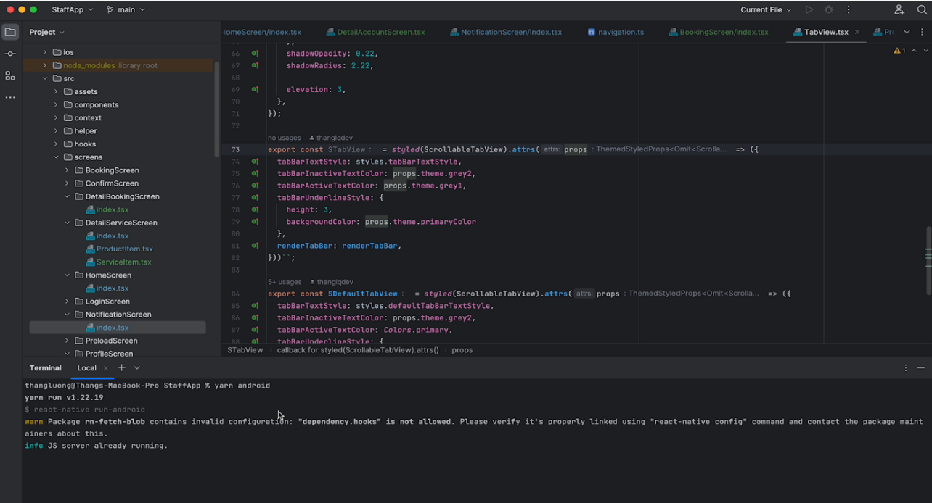

* + 1. Add file project to VS code
    2. Open terminal and enter “yarn android” or “npm android”:

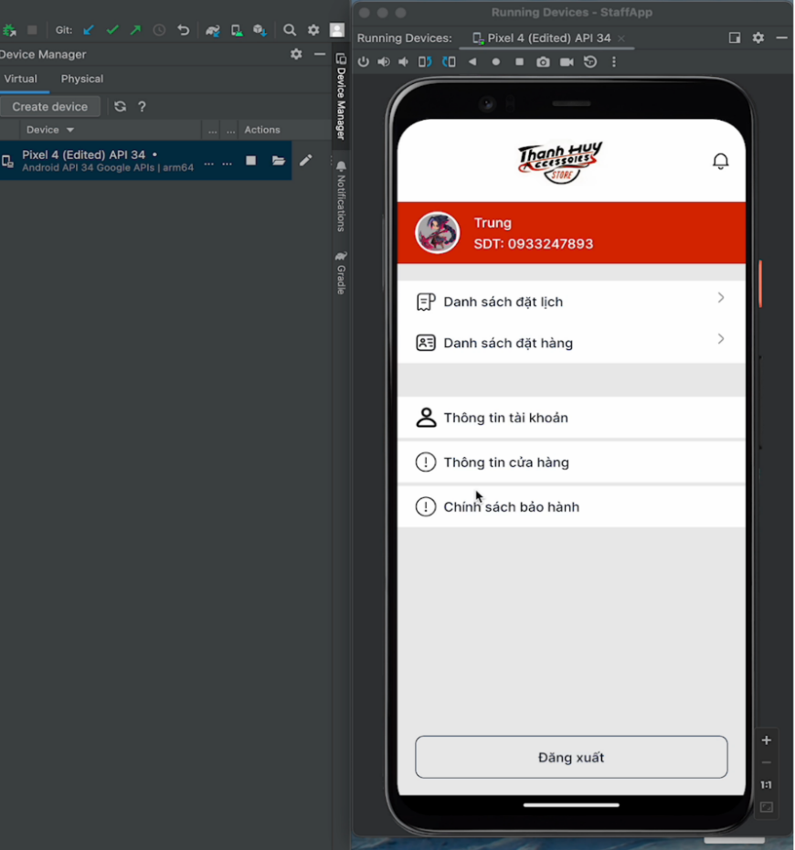

## 3. User Manual

### 3.1 Overview

* Admin manage account
* Owner manage staff/ teller, product, service, discount
* Teller manage online/ offline order, booking
* Staff view repair order, booking order
* Customer create order, create repair booking

### 3.2 Application Usage

**3.2.1 login into system**

**- Login Website(Admin, Owner, Teller)**

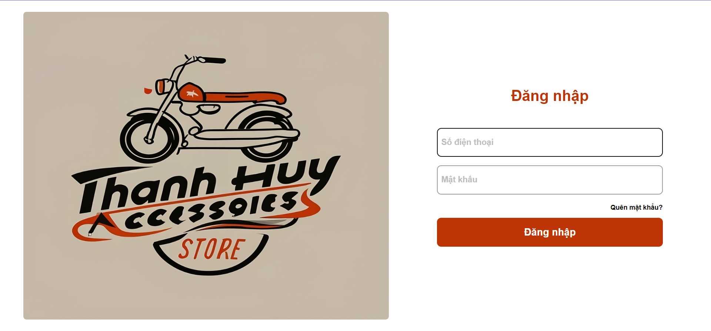

* + - Login role owner:

1. Enter phone number: 0972707132
2. Enter password: string
3. Click “đăng nhập”

**- Login Mobile(Customer, Staff)**

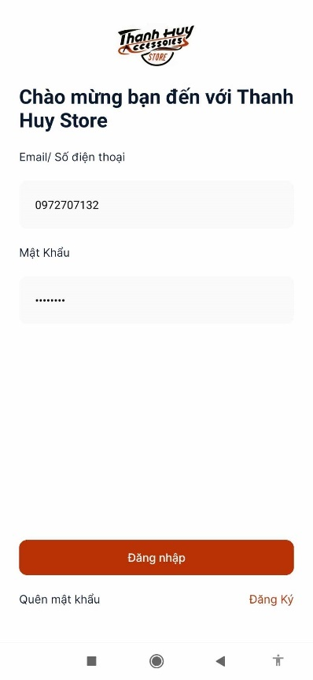

**3.2.2 Admin Manage Account**

- view account list

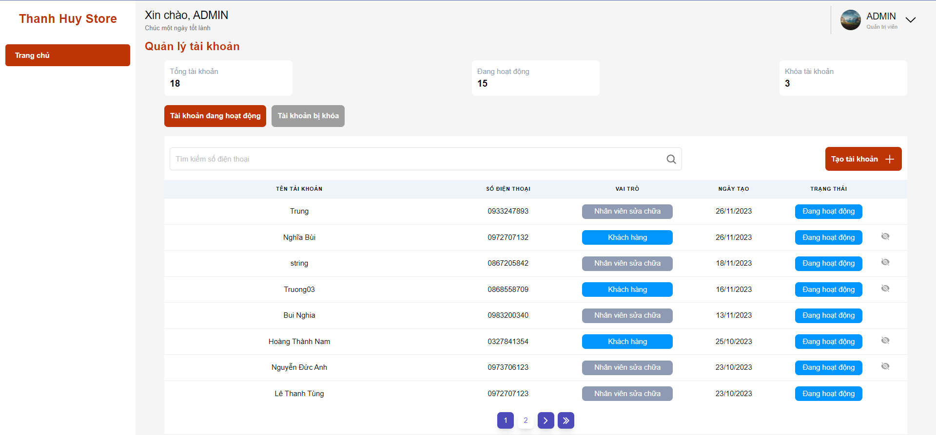

- create account

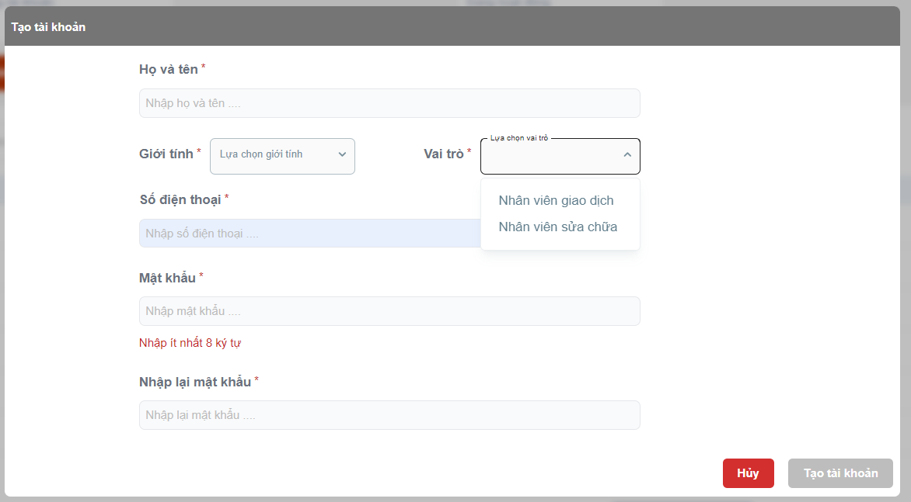

**3.2.3 Owner View Revenue Statistics**

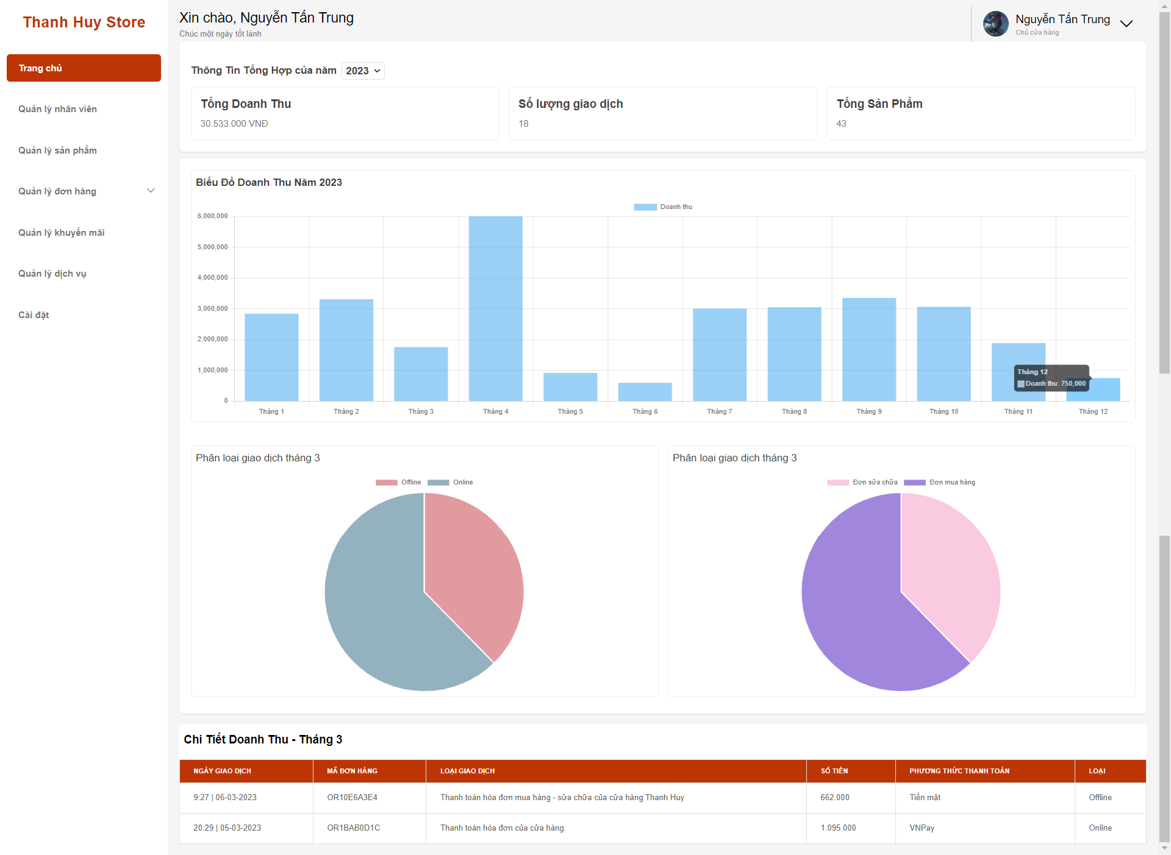

**3.2.4 Owner Manage Product**

*- View product list*

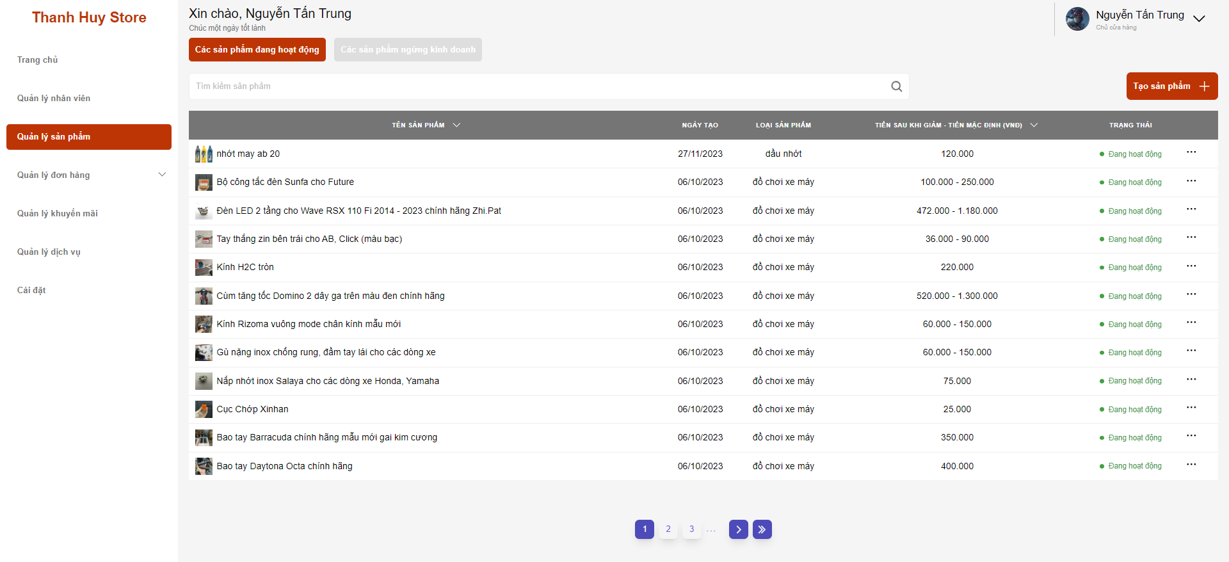

Click “Quản lý sản phẩm”

**-** *Create new product*

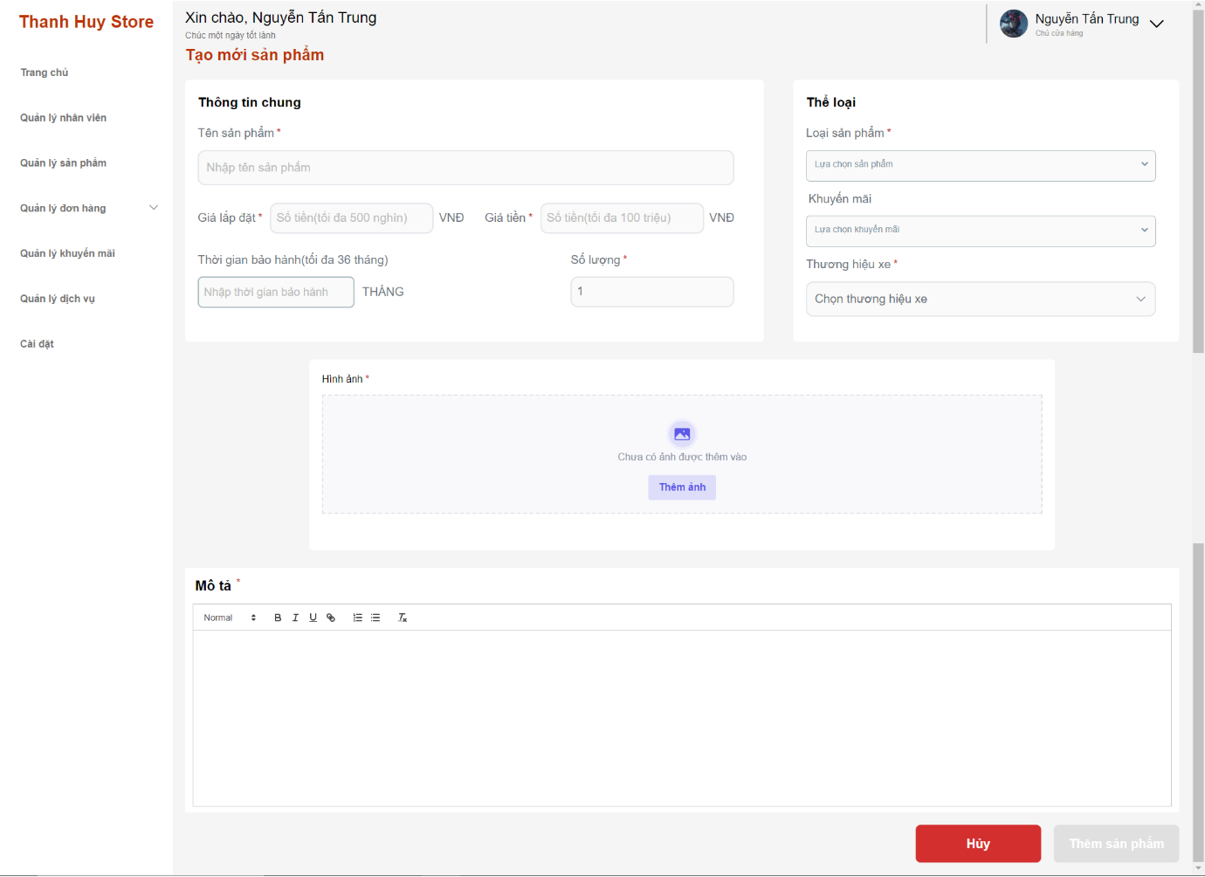

1. Click “Quản lý sản phẩm”
2. Click “Tạo sản phẩm” button
3. Fill information
4. Click “Thêm sản phẩm”

*- Update product*

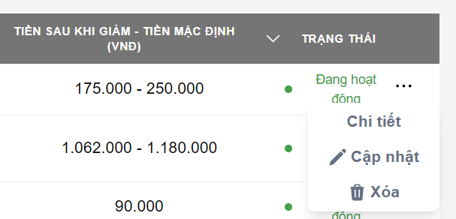

1. Click icon “…”
2. Click “Cập nhật”

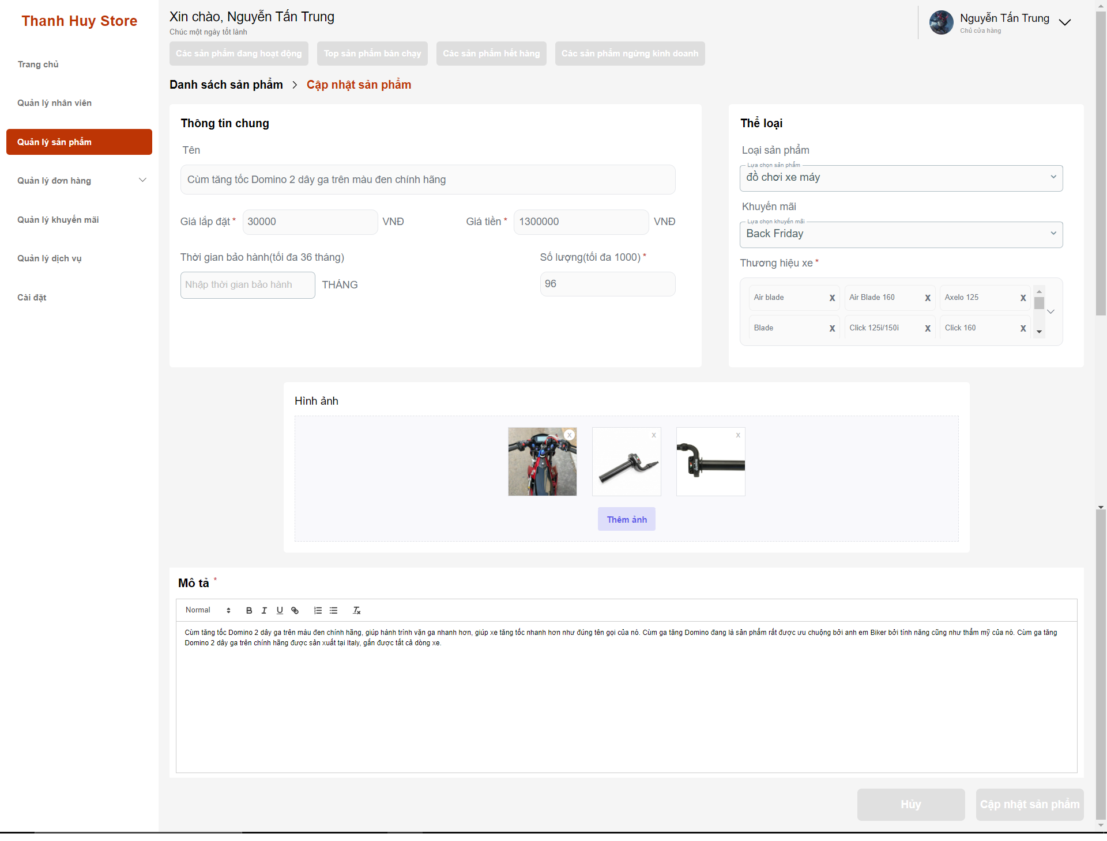

1. Edit information
2. Click “Cập nhật sản phẩm”

**3.2.5 Owner Manage Service**

*- View list service*

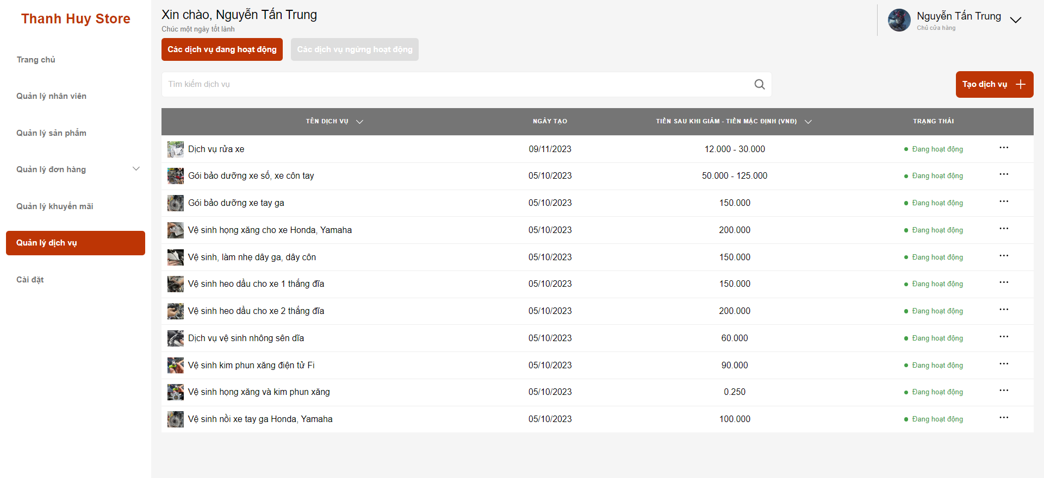

1. Click “Quản lý dịch vụ”

*- Create new service*

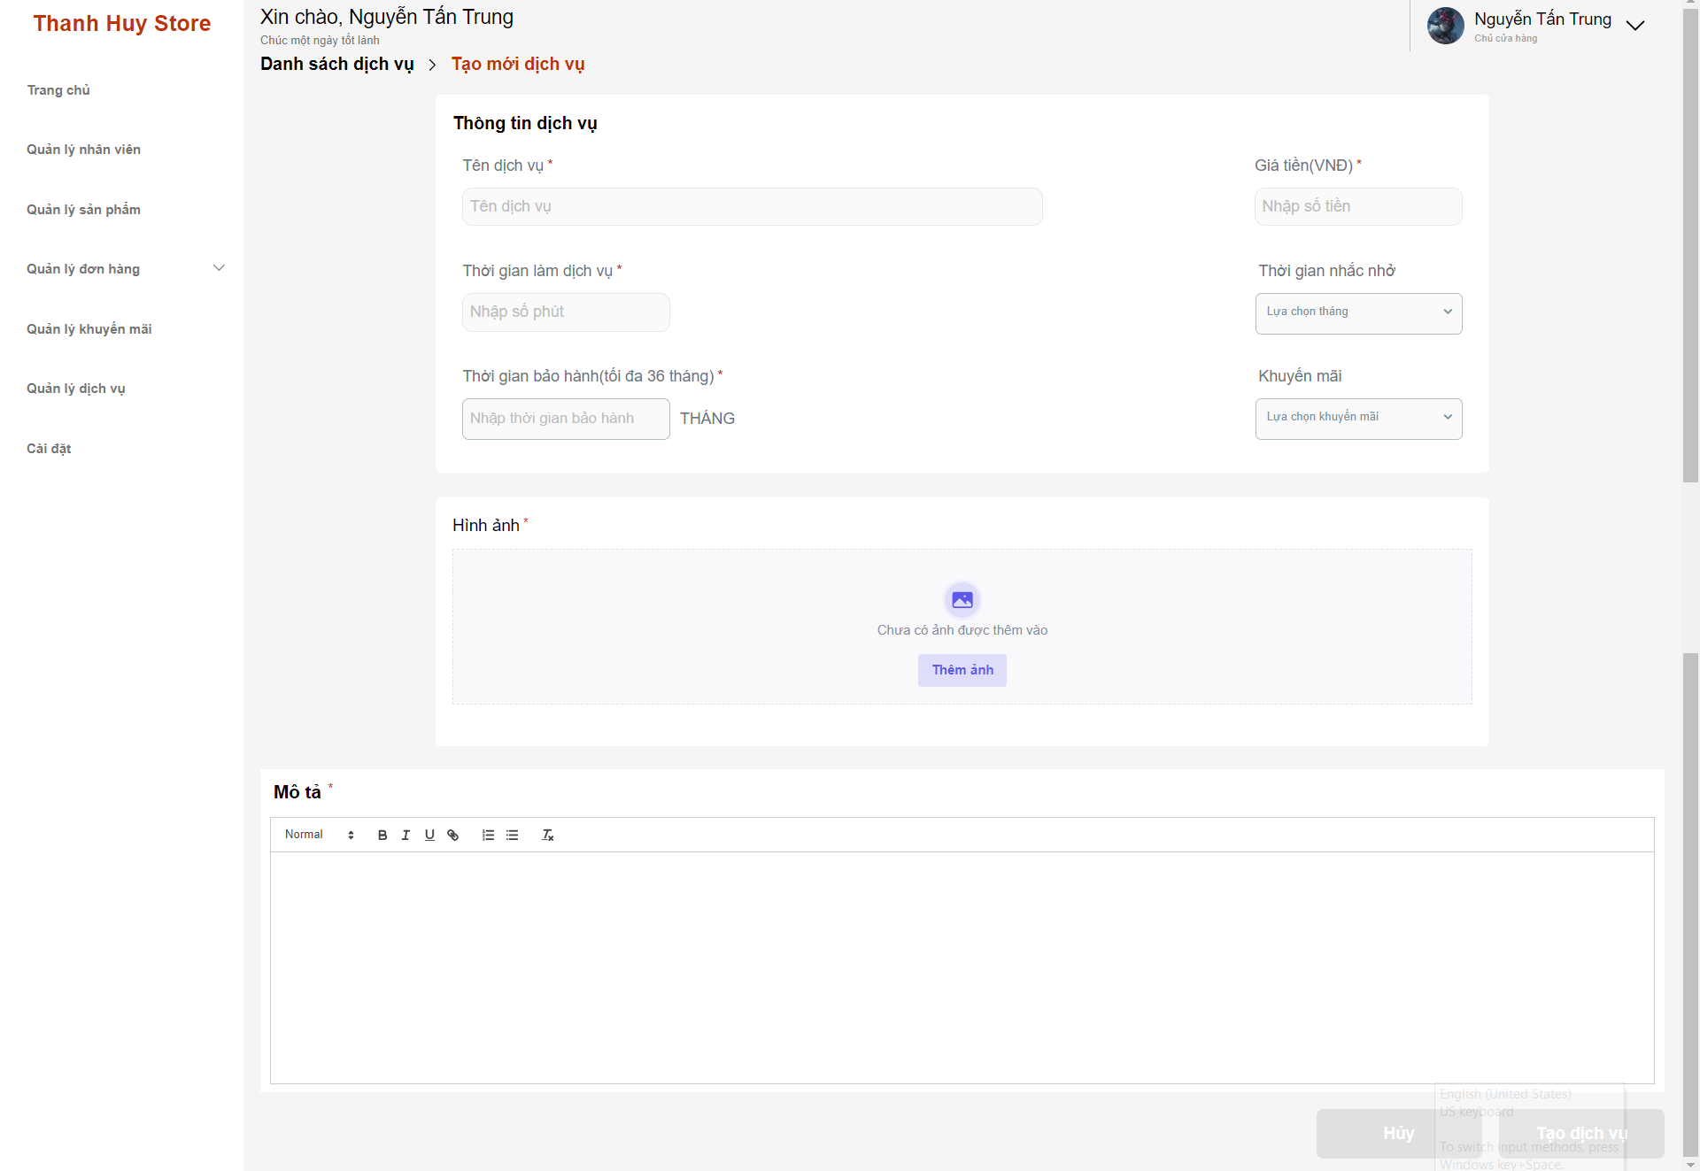

1. Click “Quản lý dịch vụ”
2. Click “Tạo dịch vụ” button
3. Fill information
4. Click “Tạo dịch vụ” button

*- Update Service*

*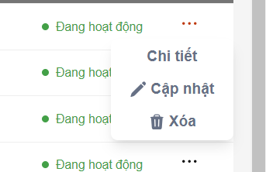*

1. Click icon “…”
2. Click “Cập nhật”

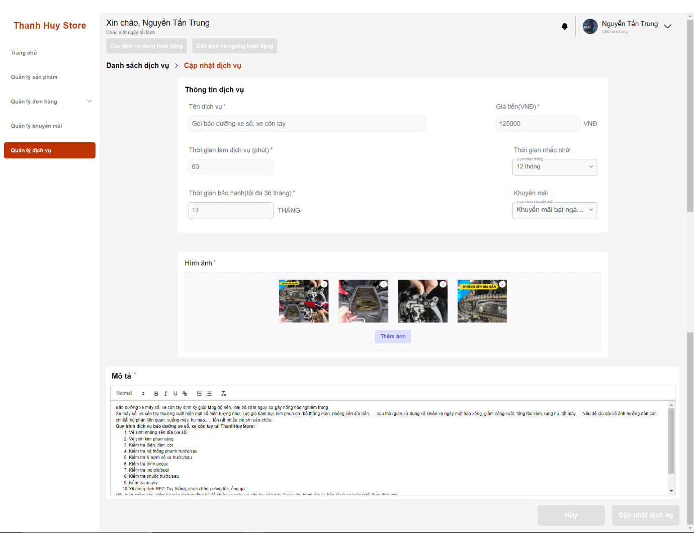

1. Edit information
2. Click “Cập nhật sản phẩm”

**3.2.6 Owner Manage Discount**

- Create discount

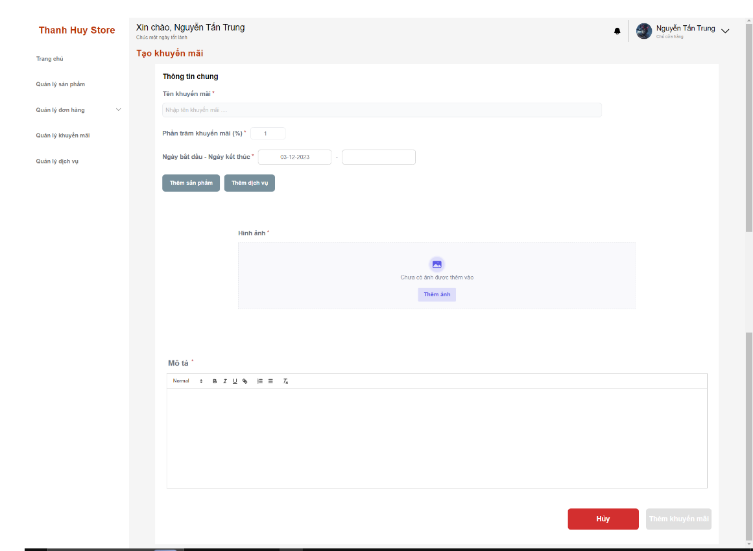

1. Click “Quản lý khuyến mãi”
2. Click “Tạo khuyến mãi”
3. Fill information
4. Click “Thêm khuyến mãi” button

*- View discount list*

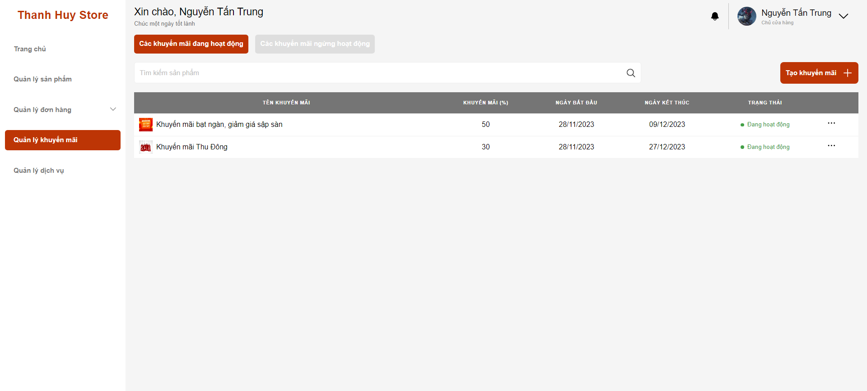

1. Click “Quản lý khuyến mãi”

*- Update discount*

**

1. Click icon “…”
2. Click “Cập nhật”

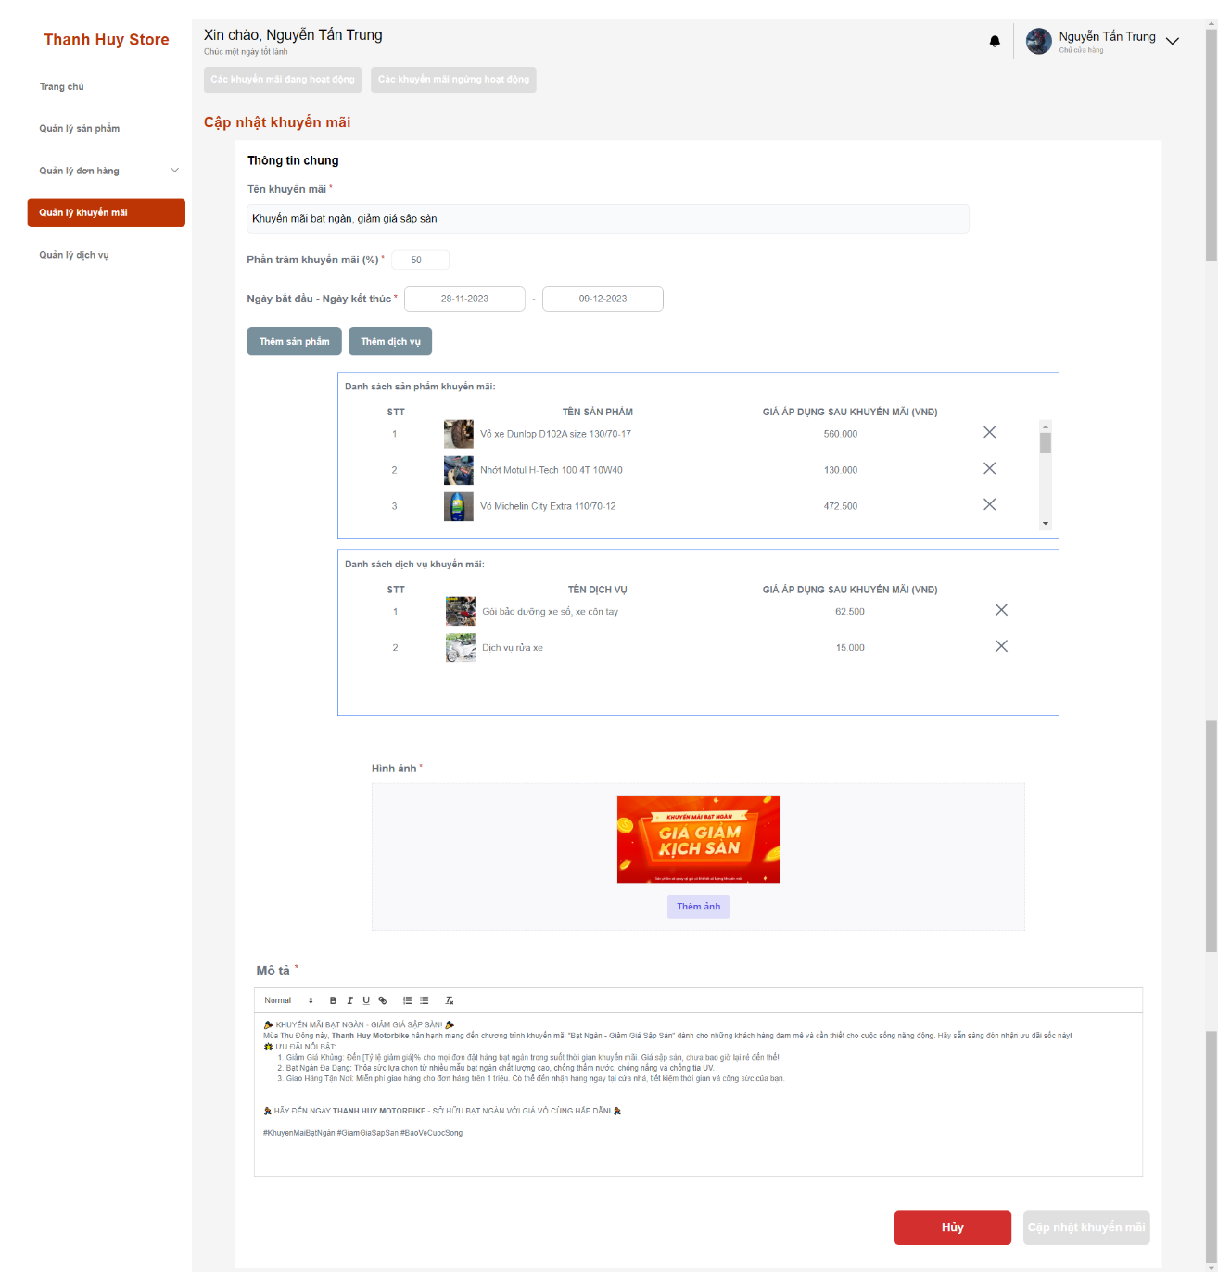

1. Edit information
2. Click “Cập nhật khuyến mãi”

**3.2.7 Owner Manage Staff/Teller**

**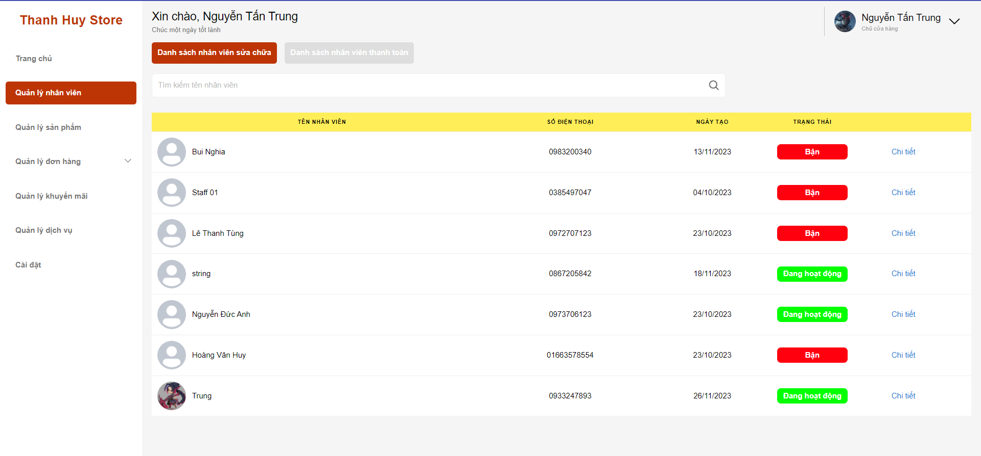**

**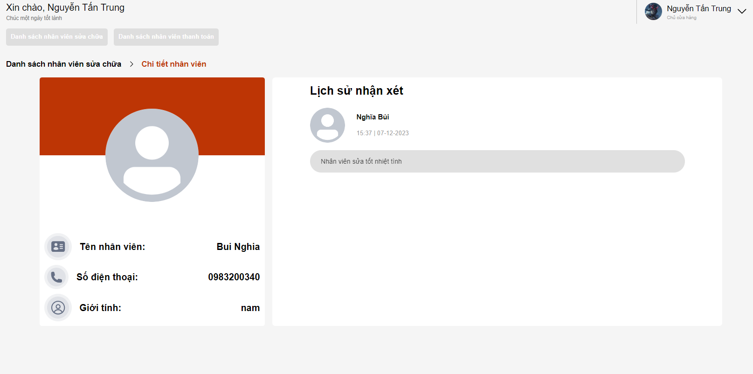**

**3.2.8 Owner View Order**

**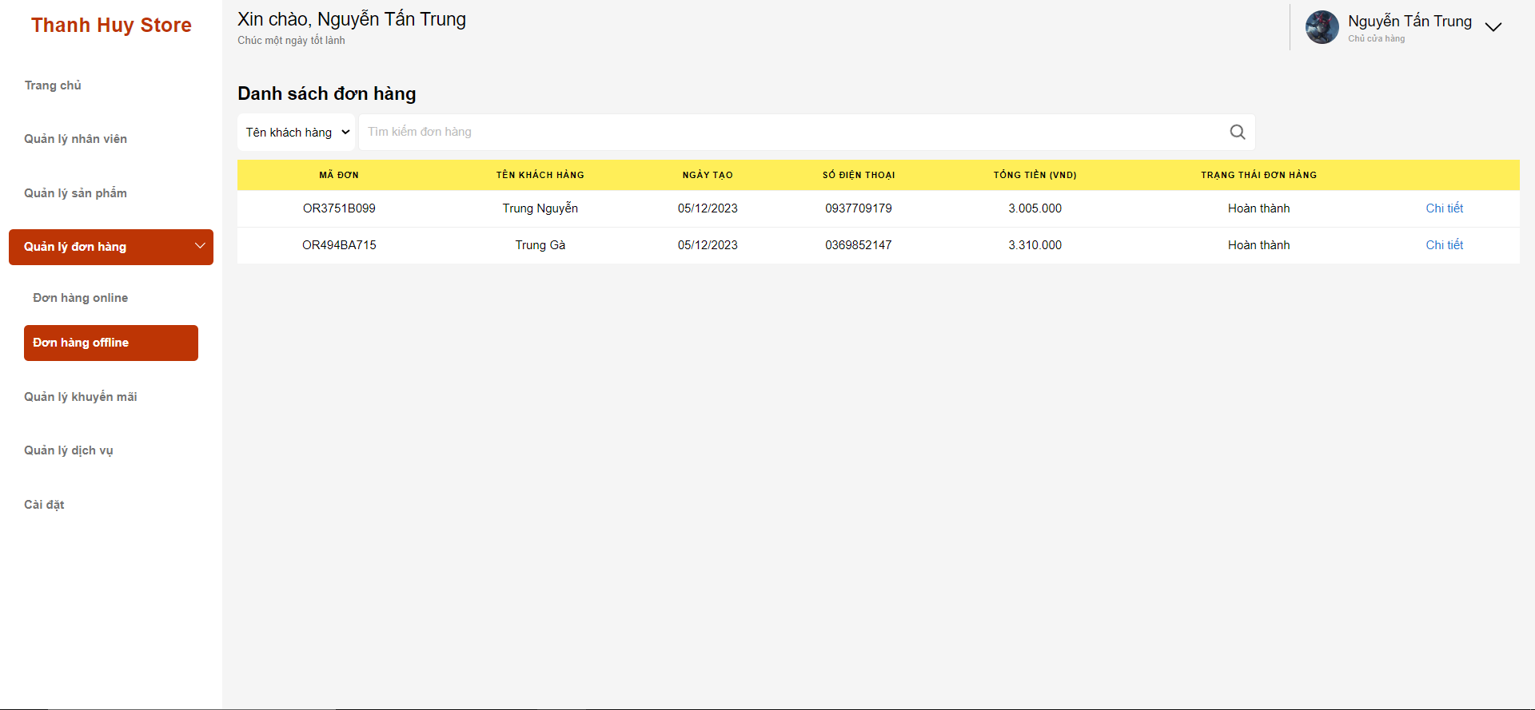**

**3.2.9 Owner setting store**

**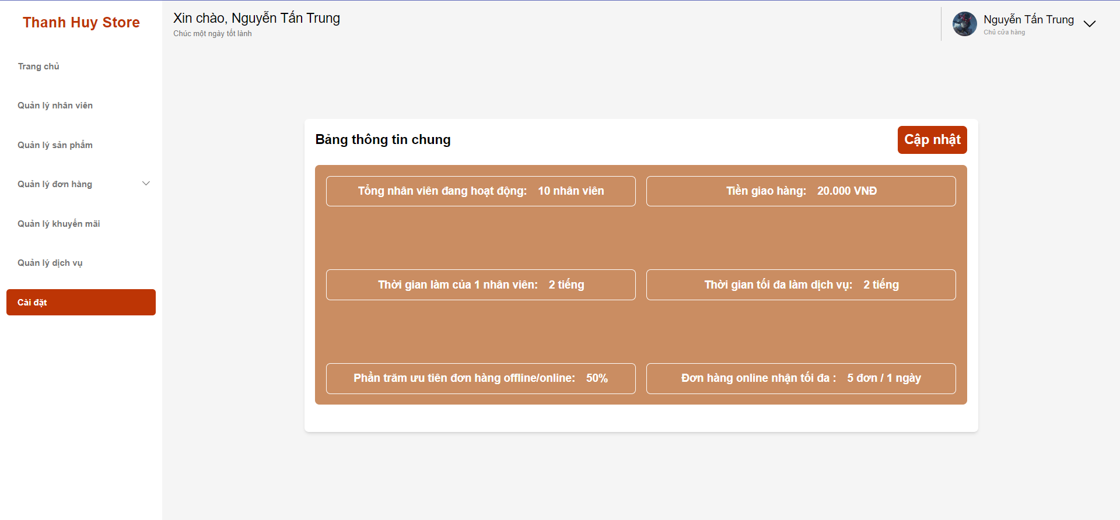**

**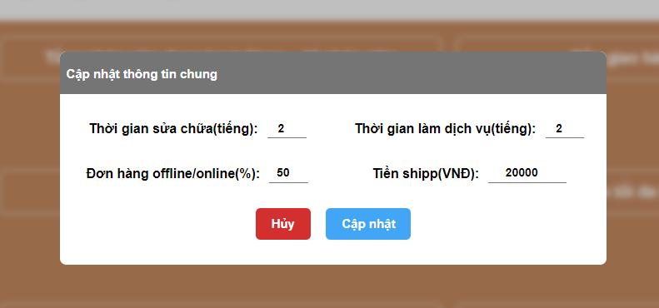**

**3.2.10 Teller create order**

**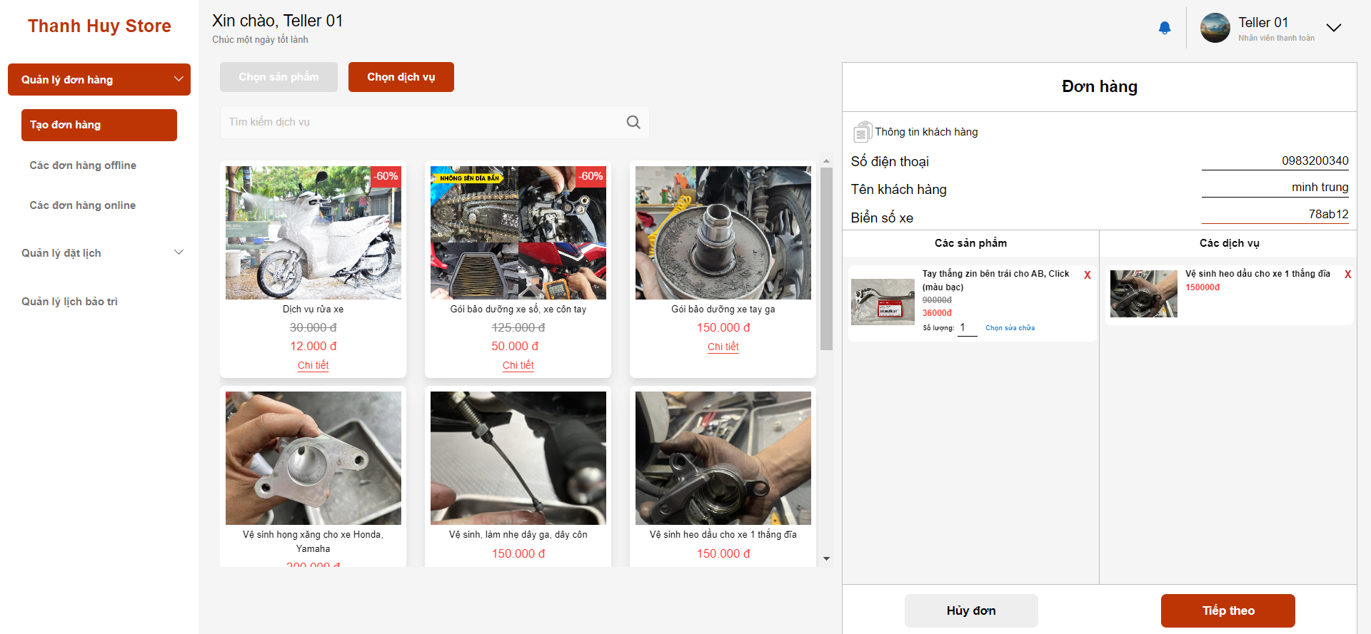**

**3.2.11 Teller view order list**

**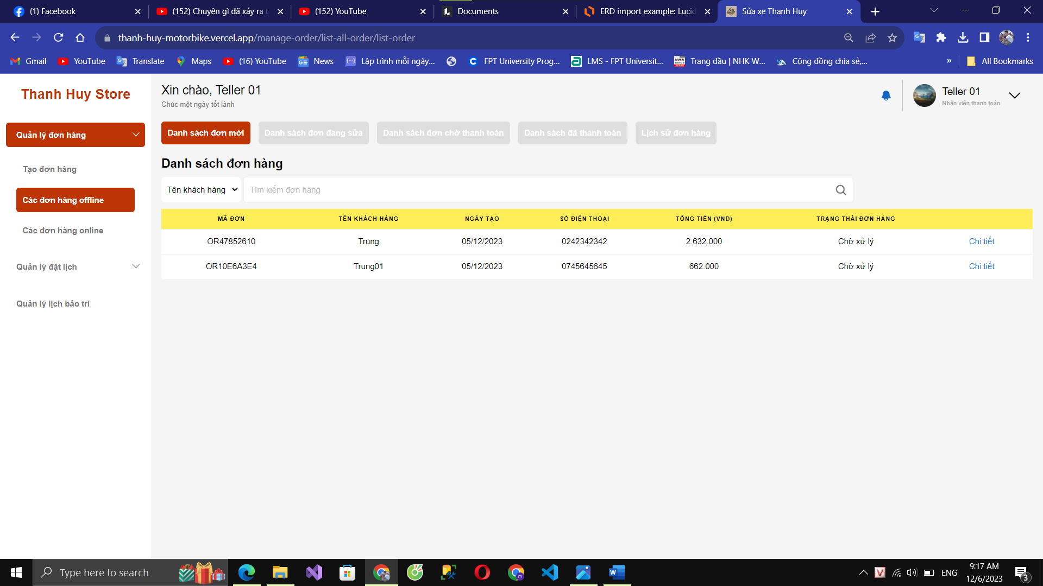**

**3.2.12 Teller order detail and payment**

**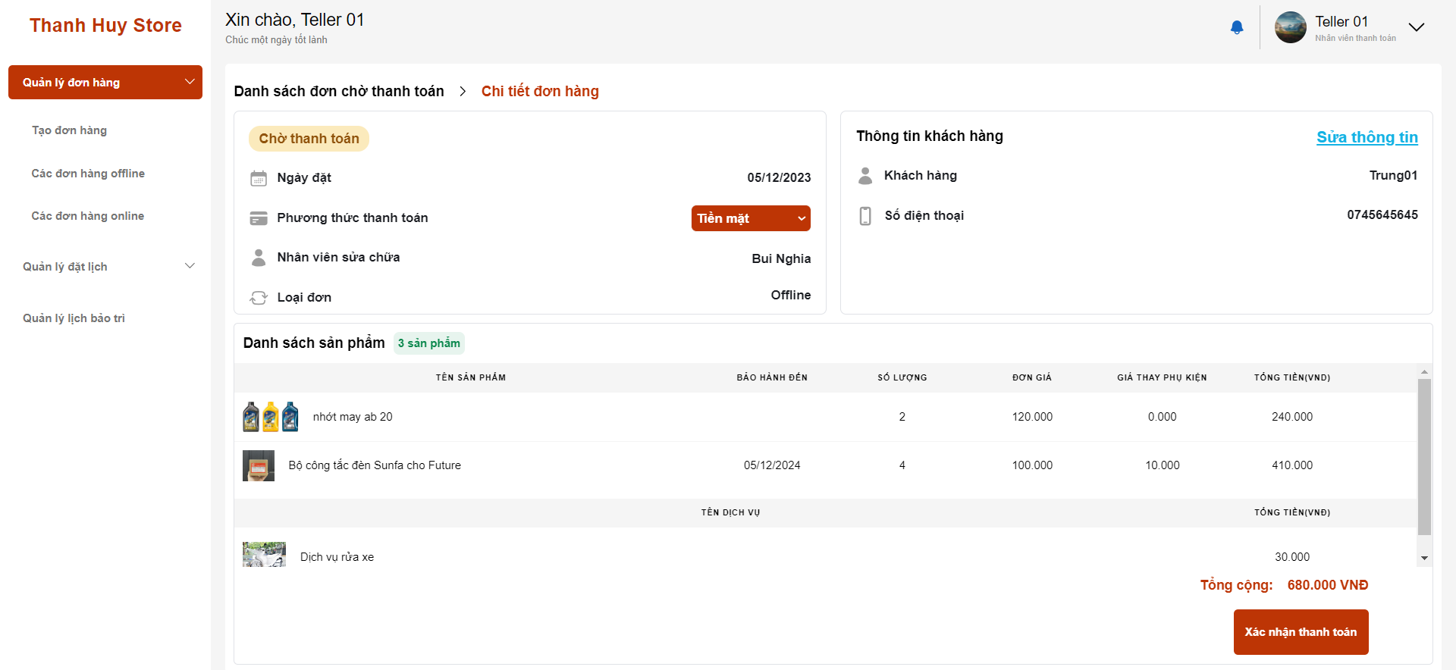**

* + - Export bill:

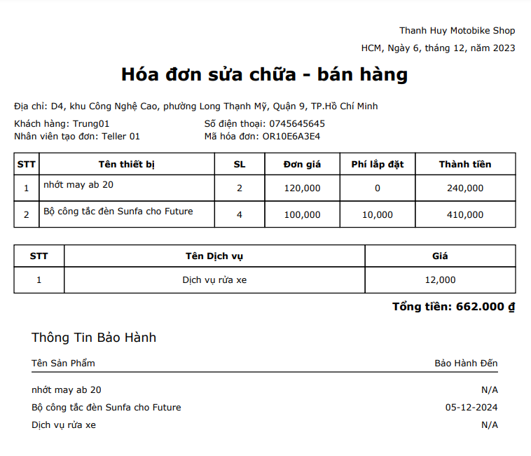

**3.2.13 Teller view booking and update**

**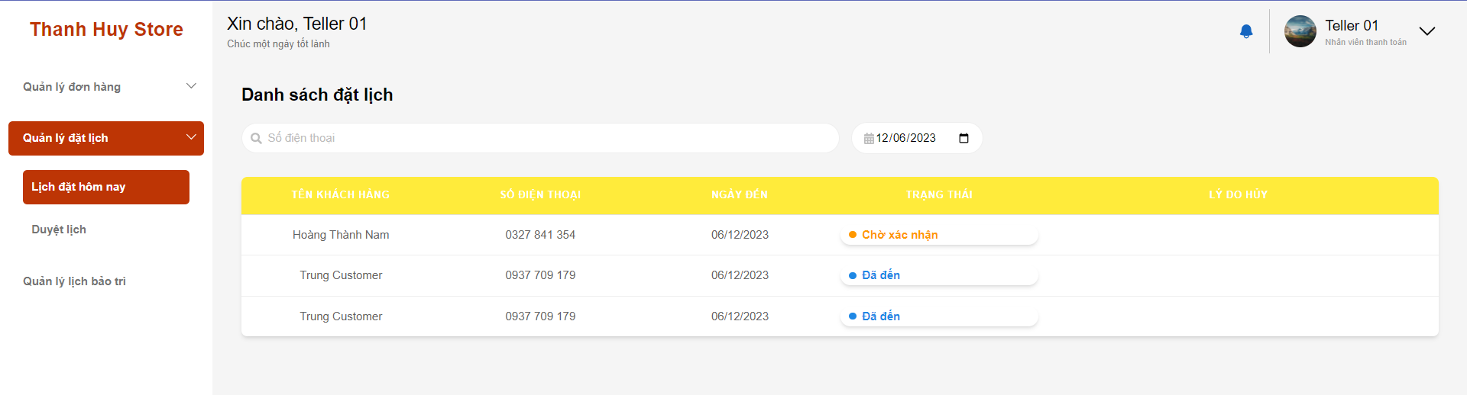**

* + - Update booking

**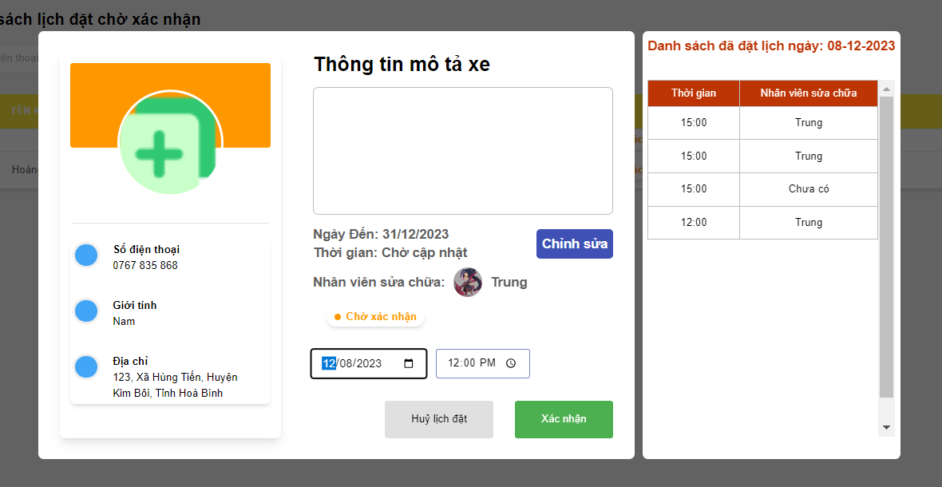**

**3.2.14 Teller manage maintenance schedules 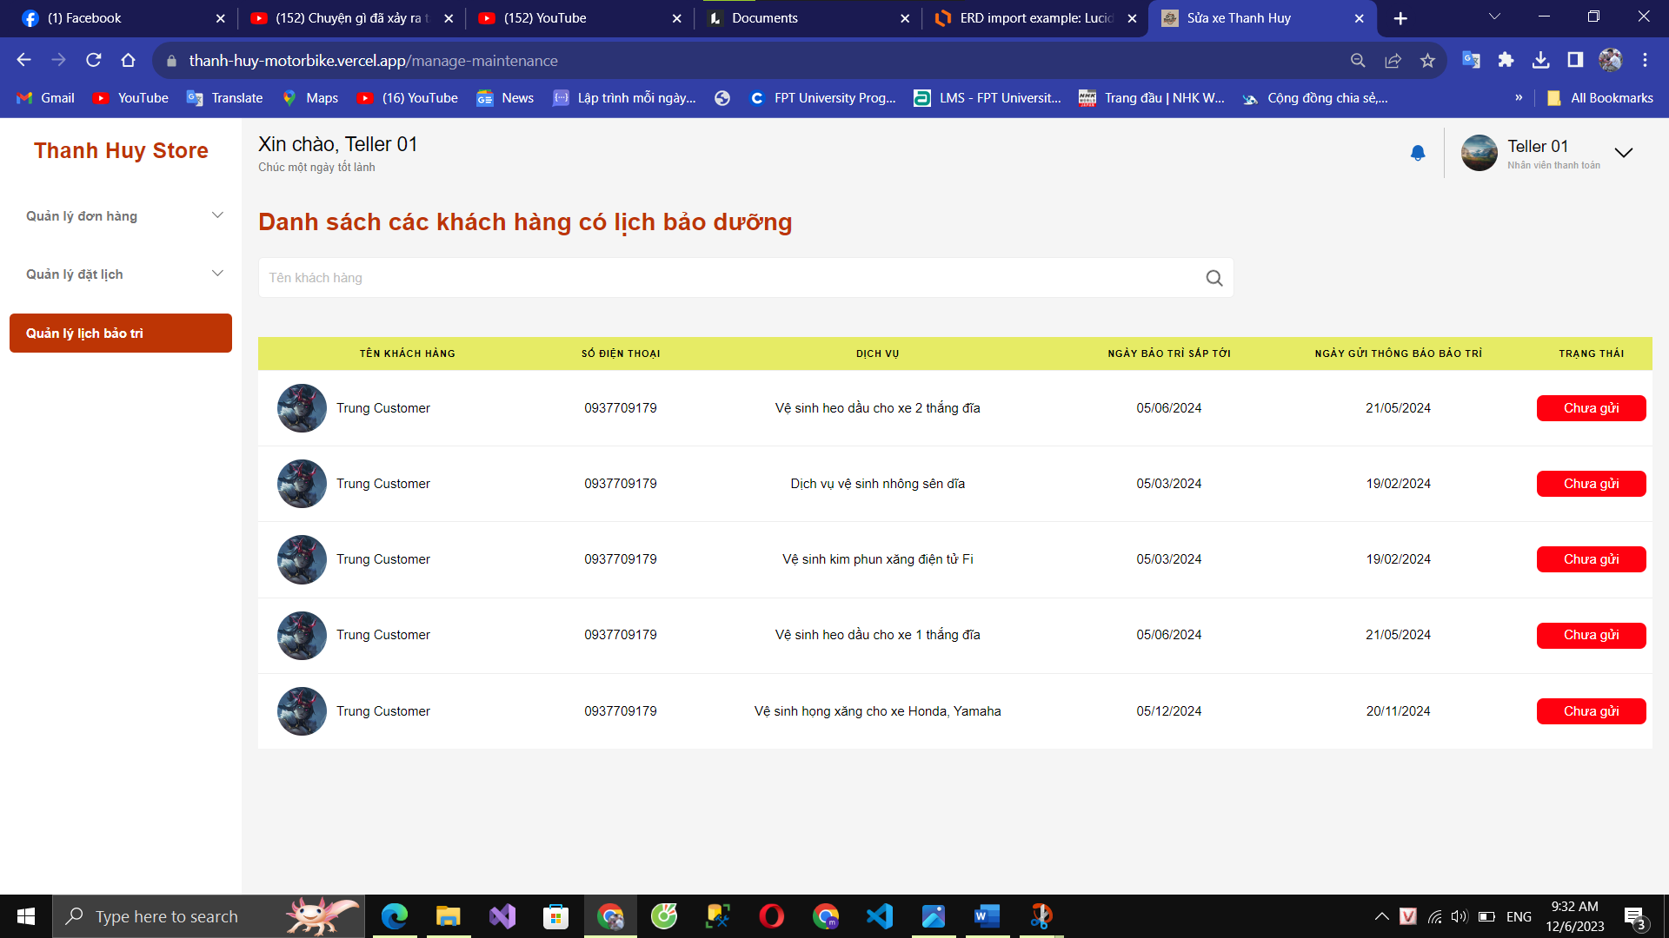**

**3.2.12 Staff accept repair order**

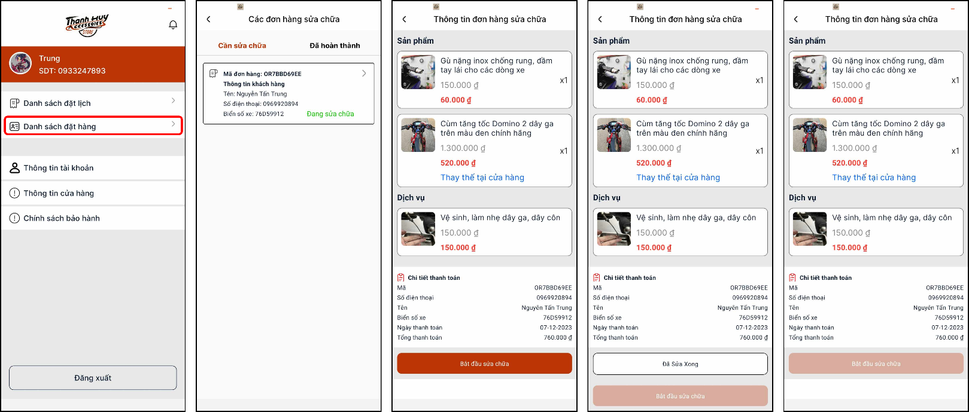

**3.2.15 Customer create order**

- Add product to cart:

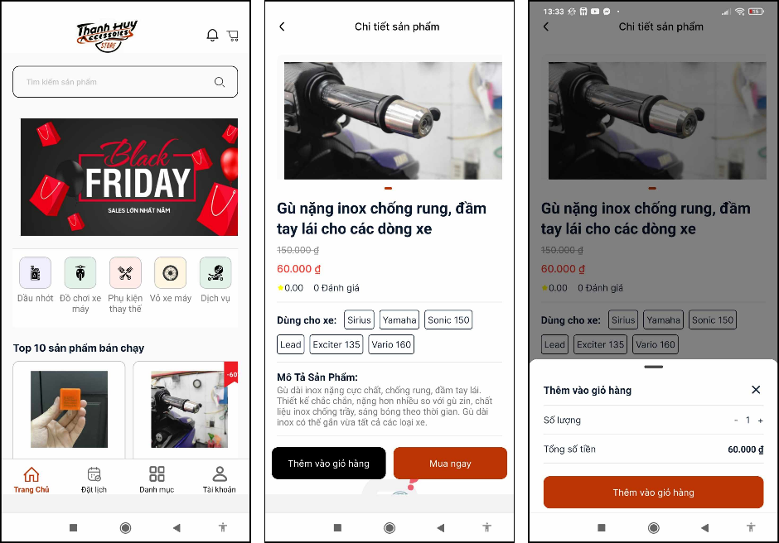

- Go to cart and create order:

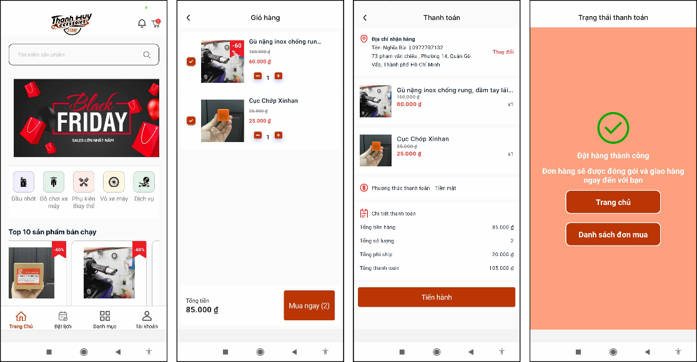

- Tracking order

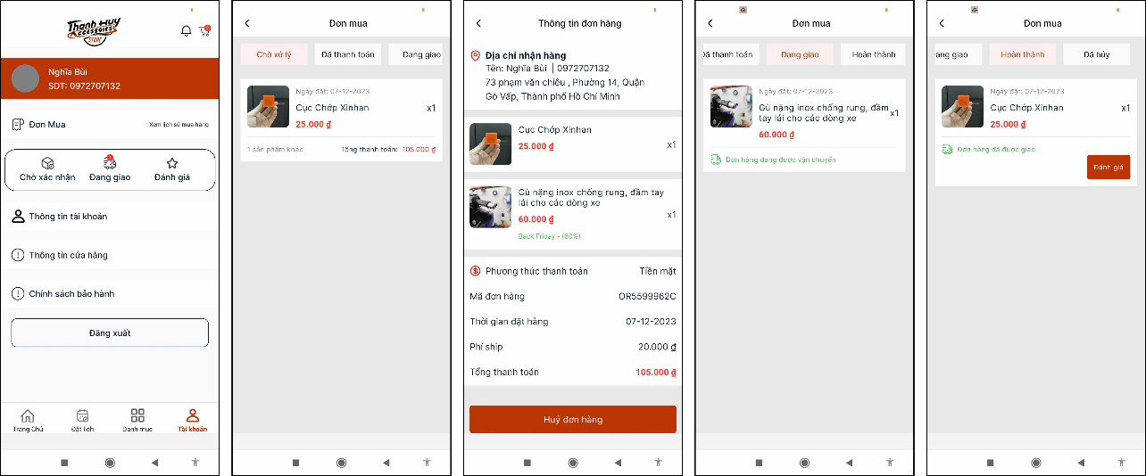

**3.2.16 Customer create booking**

- Create booking:

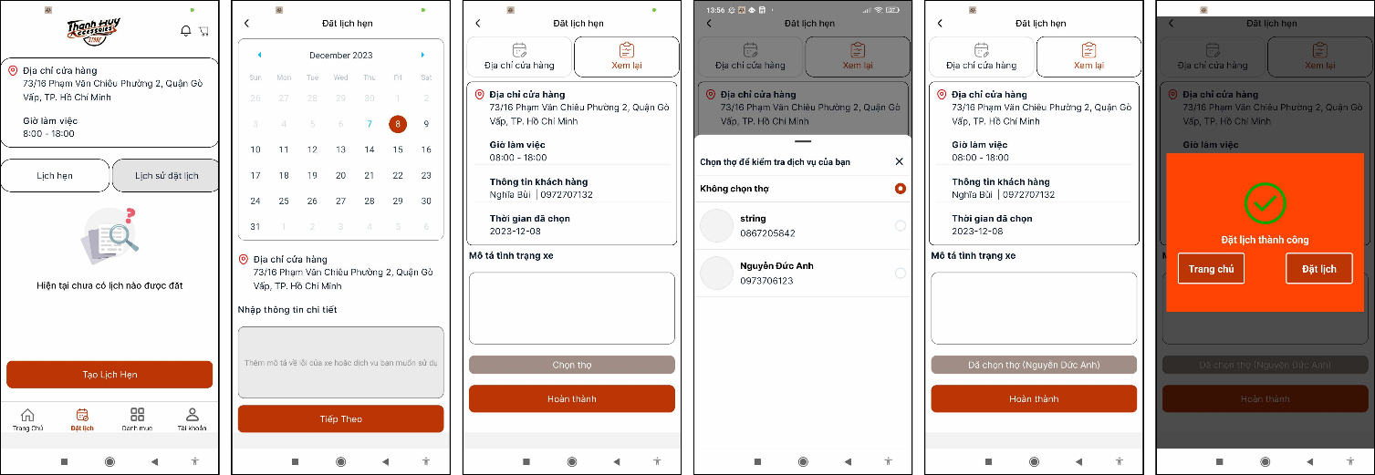

- Tracking booking:

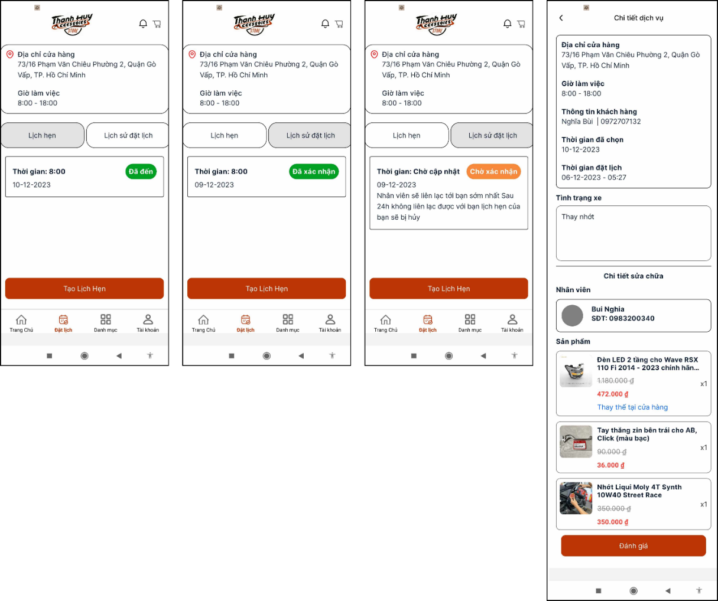

**3.2.17 Payment Screen:**

- For Website payment QR Zalopay:

1. Go to order offline watining payment

2. Select order and go to order detail

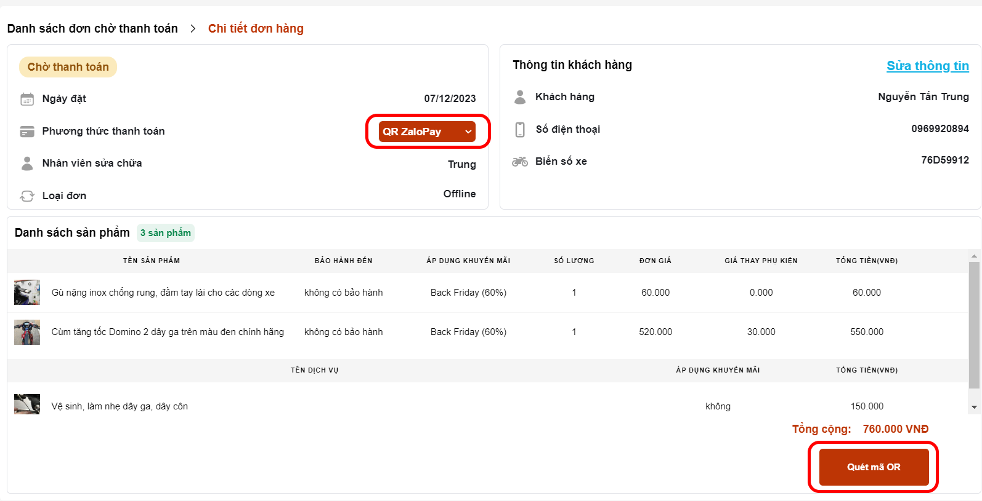

3. Select order type is QR ZaloPay

4. Click “Quét mã QR”

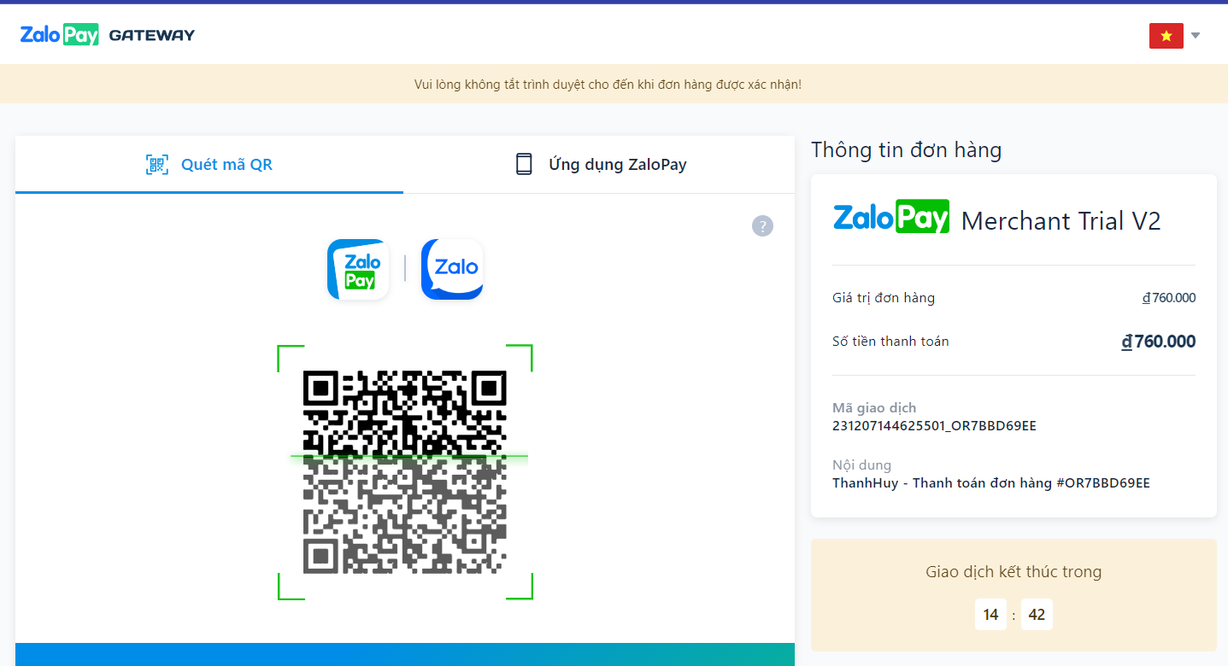

- For Website payment Vnpay:

1. Go to order offline watining payment

2. Select order and go to order detail

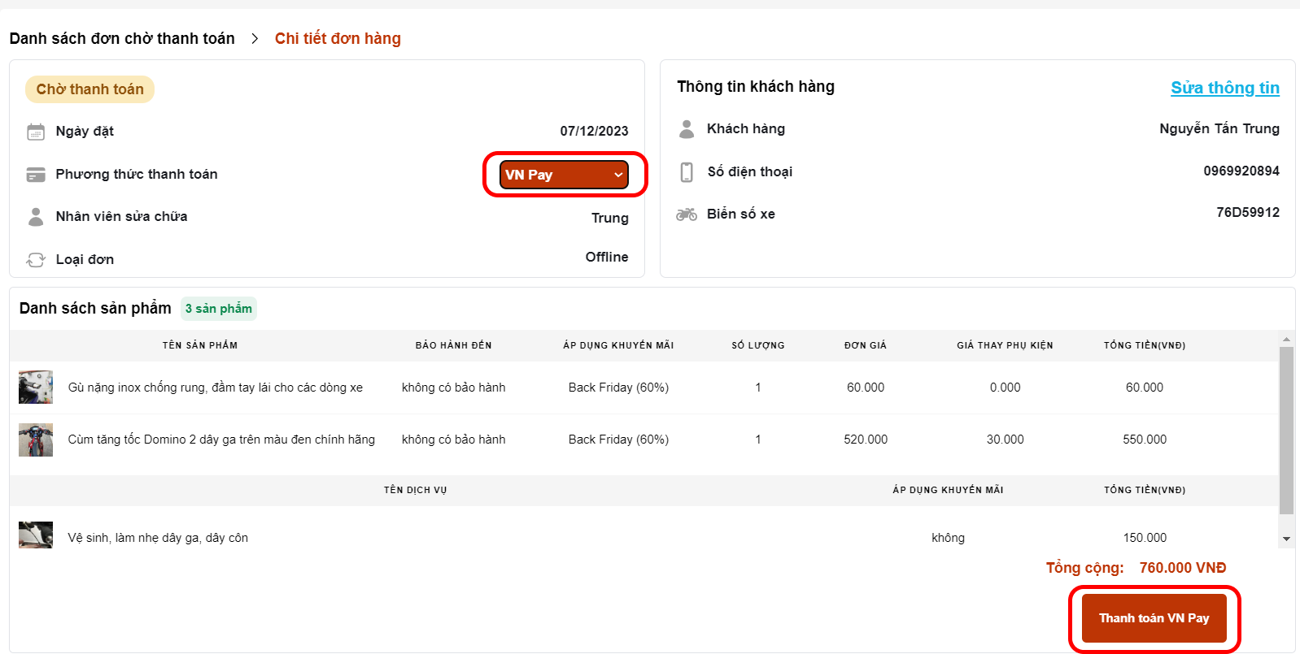

3. Select order type is VN Pay

4. Click “Thanh toán VN Pay”

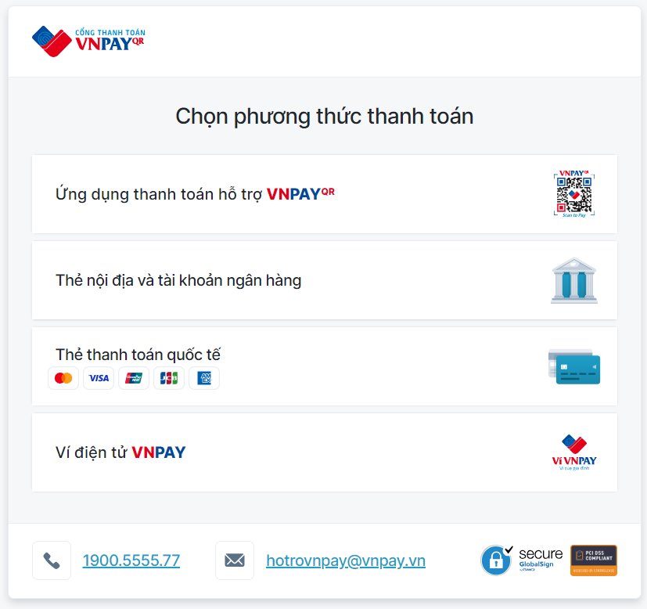

**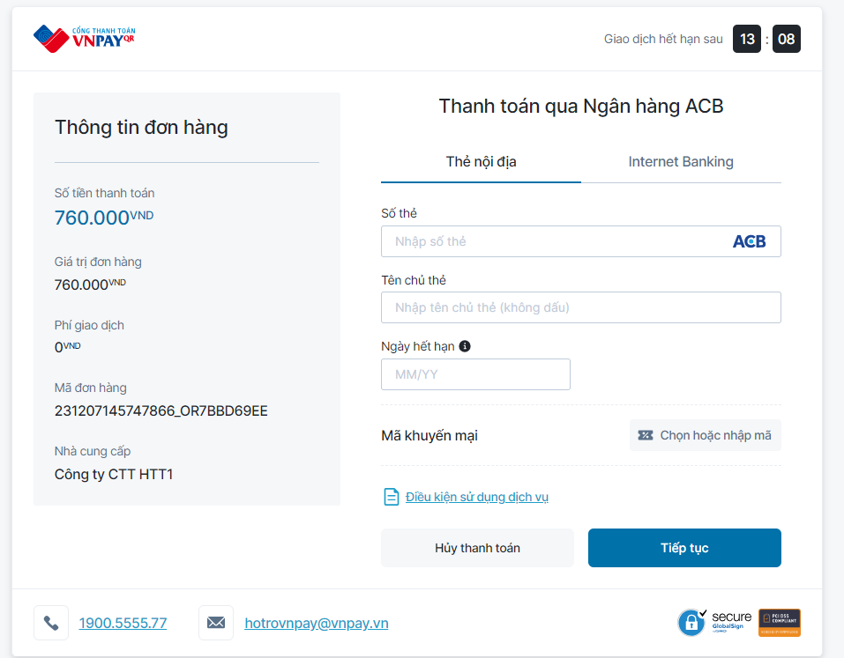**

- For mobile payment Vnpay:

